Family and MWR Business Operations

INTERNAL CONTROLS MANUAL


Installation Management Command 
Family and MWR Command
TABLE OF CONTENTS

1. Current FY Benchmarks and Standards

2. Bar Regulations

3. Beverage Controls
- Cash Controls
- Sales Accountability
- How to Take a Bar Inventory
- Physical Security

4. Breakage/Spoilage Accountability

5. Cash Deposits and Safe Security

6. Cash Register Operation
- DA Form 4082
- Change Fund Issue and Turn In
- Coverage and Shortage Logs

7. Document Control

8. Draft Beer Accountability
- Sales Accountability
- Expected Sales Method
- Keg Scales
- Draft Beer Control Meters
- Flow Meters
- Beer Foam Control Devices
- Cooperage

9. Employee Meals

10. Fixed Assets

11. Inventory Control
- Physical Inventories
- Perpetual Inventories
- Sensitive Item Inventories
- Central Storeroom Requisition
- Stock Record Cards/Bin Cards
- Inventory Turnover Rate

12. Key Control
- Key and Lock Custodian
- Key Depository
- Master Inventory List
- Key Control Register
- Permanently Issued Keys
- Inventories
- Forms

13. The Operational Data Collection and Flash Reports

14. Petty Cash

15. Quick Shot Bingo

16. Retail Merchandise (Other than Food and Beverage) Inventories

17. Sales Accountability
- Sales Accountability Tests
- Variances
- Scatter Sheets
- Bar Sales Accountability
- Food Sales Accountability
- Cover Charge Accountability

18. Surprise Inventory/Cash Counts

19. Standardized recipes and Cost Cards

20. Catering Operations

21. Tip Reporting/Allocation

22. Vending and Amusement Machines

23. Program Evaluation – Food, Beverage and Entertainment/ Catering Facilities

24. Program Evaluation - Bowling

25. Program Evaluation - Golf

26. Form Index
Chapter 1

Army Benchmarks and Standards

Category C Activities

ARMY BENCHMARKS AND STANDARDS CATEGORY C ACTIVITIES
FOOD AND BEVERAGE |  | FY 15 |  | BOWLING |  | FY 15
COST OF GOODS SOLD (COGS) |  |  |  | COST OF GOODS SOLD (COGS)
 | Family and MWR Food & Beverages All | 35% |  |  | PRO SHOP | 75%
 | Bar | 28%
 | Dining Room | 38% |  | LABOR
 | Catering | 28% |  | KA | Bowling (Cat B) | 50%
 |  |  |  | LE | Bowling (Cat C) | 50%
 |  |  |  | Average Lineage Revenue per Line Bowled |  | $2.25
LABOR |  |  |  | Lines per Lane per Day |  | 17
KM | Food, Beverage and Entertainment | 42% |  | Pro Shop Inventory Turnover per Year |  | 2
KL | Branded Restaurants | 42% |  | Pr Shop Inventory Levels |  | 50% of PY Sales
KL | Branded - Java Cafes | 35% |  |  |  | 50% of PY Sales
KG | Community Club | 42%
KE | Officers' Club | 42% |  | GOLF
LT | Free Standing Snack Bars | 35%
 |  |  |  | COST OF GOODS SOLD (COGS)
OTHER OPERATING EXPENSES (OOE) |  |  |  |  | PRO SHOP | 72%
 | Family and MWR Food & Beverages All | 15%
 | Bar | 10% |  | LABOR |  | 50%
 | Dining Room | 12%
 | Catering | 10% |  | OTHER OPERATING EXPENSES (OOE) |  | 20%
 |  |  |  | Pro Shop Inventory Turnover per Year |  | 2
 |  |  |  | Pro Shop Inventory Levels |  | 50% of PY Sales
NIBD |  |  |  |  |  | 50% of PY Sales
 | Food, Beverage and Entertainment | 8% |  | Merchandise Net Revenue per Round |  | $5.75
 | Branded Restaurants | 8% |  | Merchandise Sales per Square Foot (Pro-Shop) |  | $248/SF
 | Branded - Java Cafes | 8%
 | Community Club | 8% |  | BINGO
 | Officers' Club | 8%
 | Free Standing Snack Bars | 8% |  | LABOR |  | 7.50%
TOTAL CLUB AND FBE |  |  |  | OTHER OPERATING EXPENSES (OOE) |  | 5.50%
 | COGS | 35%
 | LABOR | 42% |  | Prize Payout |  | 80%
 | OOE | 15%
 | NIBD | 8% |  | NIBD |  | 15%

Chapter 2

Bar Regulations

BAR REGULATIONS

REFERENCE: AR 215-1, Chapter 10

- In the United States, no person under the age of 21 will be employed to dispense, handle or serve alcoholic beverages unless it is permitted by the state in which the installation is located.

- Outside the United States, no person under 18 years of age will be employed to dispense, handle, or serve alcoholic beverages. A higher serving age will be based on international treaties and agreements and on the local situation as determined by the garrison commander.

- The minimum drinking age for all persons on an installation located outside the United States is 18 years of age. Decision on a higher minimum age is based on international treaties and agreements and the local situation as determined by the senior commander.

- Only NAFI employees will dispense and serve alcoholic beverages on a military installation.

- All employees involved in selling alcohol will be trained within 30 days of hire and then at least annually, on subjects such as the effects of alcohol, how to identify intoxication and what to do when a person becomes intoxicated. Managers will use the Alcohol Sellers and Intervention Program (ASIP), or other approved programs, copies of which may be obtained from IMCOM G-9. This training will be documented in the employees’ file.

- Alcohol may not be given away as prizes. The only exception to this will be wine products that are given away to eligible club patrons to accompany dinner on their wedding anniversaries, birthdays, or similar occasion.

- No more than one drink will be served to a customer for consumption at a time. Serving alcoholic beverages to an intoxicated customer is prohibited.

- Standard recipes will be used for preparing all mixed drinks.

- Promotions will adhere to the following criteria:

- In-house promotions, such as coupons, free samples or any other similar means of offering free or reduced-price alcoholic beverages to promote or advertise the sale or consumption of specific brands of alcoholic beverages is not authorized.
- Commercial promotions are authorized unless directed exclusively at the military community; that is, promotions such as those typically available to the general public in the private sector are permitted unless otherwise prohibited.

- Bona-Fide Beverage tasting are authorized.

- When menus or catering brochures offer food or dessert items that contain alcohol as a separate ingredient, serving or catering staff will advise patrons of alcoholic content and offer nonalcoholic substitutions if customers request.

- Privately owned alcoholic beverages will not be brought into any facility where alcoholic beverages are sold by the drink.

- Alcoholic beverages may not be transported off the installation for use at off-post-catered functions.

- Reduced prices or providing unlimited alcoholic beverages for MWR promotional activities, such as happy hour, is prohibited. Activities may conduct food promotions where the price of an alcoholic beverage is included in the meal/event. Customers must be given the choice, however, of a non-alcoholic beverage substitute.

- Reduced priced beverages may be authorized in writing by Garrison Commander when the following conditions are met:

- Reduced prices are available in the local community.

- Regular MWR prices are within 80% of the average of comparable local facilities’ regular pricing.

- Reductions are at rates similar to those offered in the private sector, but not greater than 50%.

- Reduced prices apply to all beverages, not just alcohol and are limited to well brands and selected call brands and not premium or specialty products.

- Reduced prices will not be offered more than once per day and no longer than two hours per day or 10 hours per week and not carried over to the next day.

- Reduced prices should not be offered during peak periods. This tool should be used to increased business during slow unprofitable periods.

- Promotional material will not draw undue attention to reduced pricing.

- This exception authority will not apply to contract functions nor supersede other sections of AR 215-1, such as stacking drinks, using standard recipes, sensitive item inventory requirements, and so on.

- Reduced price beverages are restricted to designated bar and lounge activities and are not authorized in food and beverage operations that are primarily fast food such as snack bars, recreations centers, swimming pools, sports fields, kiosks, carts or mobile food service.

- Reduced prices are not authorized for activities outside of bar or lounge locations such as special events or any function other than public bar and lounge operations.

- Accountability of all inventories for both regular and reduced prices is required to be reconciled daily when reduced prices are offered.

- Bulk purchases are reduced pricing are not authorized.

- Programs selling alcohol will have food available for purchase or at no charge during alcohol sales hours.

- Inventory Procedures;

- Identify alcohol or items to be reduced during the reduced priced beverage period. Incorporate these items onto a separate bar inventory sheet. Bar inventory sheets can be located in the internal control manual in the forms section.

- Establish the reduced price for each item and place the identified item on the reduced price bar inventory.

- Update your point of sale (POS) or cash register with the corresponding reduced pricing.

- Managers or their representative will ring out registers before and after reduced price beverage periods. Cash and inventory will be reconciled to validate any variance either cash or inventory accountability.

- A separate stock of bar inventory will be established during reduced price beverage periods for accountability purpose and ease of transition from reduced prices to regular prices.

- Use a separate bar that may be co-located or establish a reduced priced beverage cart to separate inventory.

- Beer products can be identified and accounted for by utilizing a separate beer cooler or utilizing beer tubs or similar system.

- Draft beer will be accounted for in accordance with the Draft Beer Accountability Instruction.

Chapter 3

Beverage Controls

BEVERAGE CONTROLS

REFERENCES: AR 215-1, Appendix G
DFAS-IN Regulation 37-1

Beverage controls are divided into three categories:

- Cash controls.

- Sales accountability and beverage inventories.

- Physical security.

CASH CONTROLS

Cash controls ensure that all cash assets are protected from loss through carelessness and dishonesty. The following steps can ensure a smooth auditable flow between change funds, cash receipts and related documents:

- At the beginning of the shift the bartender should:
  - Pick up and sign for the change fund. This is done on a DA Form 4082 (Daily Cashier’s Record) prepared in duplicate. One copy remains with the cashier and one copy serves as bartender’s receipt.
  - If guest checks, or any other pre-numbered form, are issued to the bartender, these will be signed for on the DA Form 4082.

- During the work shift the bartender should:
  - Ring in all sales individually at the time of purchase.
  - Collect the cash.
  - Make change.
  - Provide receipts.

- At the end of the work shift the bartender should:
  - Remove the cash from the register and leave the register drawer open.
  - Count cash in the presence of the manager or cashier, in the cashier’s cage or manager’s office.
  - Complete the DA Form 4082.
  - Ensure that any errors are properly documented.

- At the end of the work shift the manager should:
  - Take a register reading.
  - Batch out credit card machine.
  - Verify cash count

SALES ACCOUNTABILITY AND BAR INVENTORIES

1. Bar sales accountability controls permit management to monitor each bartender’s effectiveness in maintaining established standards.

2. Bar inventory usage figures determine expected sales. The dollar difference between expected sales and actual sales is considered overage or shortage.

Beg Inv + Issues In – Transfers Out – End Inv = Ideal Consumption

Ideal Consumption x Selling Price = Expected Sales

Expected Sales – Actual Sales = Overage or Shortage.

3. Bar physical inventory is performed daily and reconciled daily between stock used and bartender’s sales recorded. Variance will be explained in writing.

4. Each bar should be considered as a separate operation with its own sales accountability. No bartender will share an inventory or a cash drawer with another bartender.

5. Maximum allowable variance for alcoholic beverage service is 2%.

6. Bar Sales Accountability Forms (Encl. 3-1, 3-2) can be designed by the local activities to include:

- Name of the Facility

- Date

- Bartender’s name and Signature showing his/her acceptance of responsibility for the inventory during the period for which the sales accountability is to be determined.

- Bottle weight in ounces (tare weight). Tare Weight is the empty bottle weight of the bottles to be inventoried. To determine the tare weight of a bottle, place the bottle on a mechanical bar inventory weighting scale. Considering the bottle size (750 ml, 1 lt, etc.) rotate the outer ring of the scale until the ounce contents number of the bottle (25 or 33) lines up with the indicated “0”. Use the red graduations for distilled spirits and the green graduations for liqueurs and cordials. The indicator reading is the tare weight for the bottle. Tare weights should be recomputed periodically.

- Size in ounces is the ounce content of different bottle sizes. Use the chart below to determine how many ounces are in the full bottle. This number indicates the tare setting number.

Bottle Size | Number of Ounces
750 ml (Fifth) | 25.4
Quart | 32.0
Liter | 33.8
1.5 Liter | 50.7
1.75 Liter | 59.2

- Description: Brand Name of the beverage.

- Beginning Inventory of each item.

- Received/Transferred items are those that have been issued to or transferred out of the bar during that specific operating period.

- Ending Inventory of each item.

- Actual Consumption is the ideal consumption based on the physical inventories.

Beg Inv + Issues In – Transfers Out – End Inv = Ideal Consumption

- Sales Price is the current selling price of one unit.

- Ideal sales are the total amount of expected sales based on the consumption.

Actual Consumption x Current Selling Price = Ideal Sales

- Cost Oz is the actual cost of one unit.

- Cost Total is the total amount of costs based on the consumption.

- Actual Sales per Register is the sales amount of each item from POS system.

- Inventory Overage/Shortage is the difference between sales per register and expected sales per inventory. The variance percentage is the total over/short divided by registers sales.

- Spillage includes those items that are deemed unusable during the shift to include broken bottles or incorrectly poured drinks. Complimentary drinks should be included in this column. The dollar amount is noted in the column next to the item and it is automatically subtracted from the Ideal Sales in the Adjustment block of the spreadsheet and the total actual sales in the Adjustment block of the spreadsheet.

- Total amount of spillage, waste, or complementary drinks.

- Beer items you serve.

- Wine items you serve

- Draft Beer

- Soft Drink sales

- Inventory Over / Short is the difference between Ideal sales and the register reading.

- Total Ideal Sales is the amount sales calculated based on the actual consumption.

- Total Actual Sales is attained from the register tape at the completion of the shift. This is the difference between the opening and closing readings.

- Cash Drop is the amount of cash in the Bartender’s drawer.

- Over / Short is the difference between actual cash drop from the bartender and the register reading.

- Inventoried By is the signature of the person conducting the inventory. Although the bartender may assist in conducting the inventory, someone should take the inventory other than the person tending the bar during the accountability period.

7. An automated Bar Sales Accountability Form as shown in enclosure 3-1 & 3-2, and is available for download at http://www.businessplan.armymwr.com Click on “Business Program/Club, Catering or Quick Service Restaurant/ Standard Forms (under Internal Control Scorecard)”, then click on “Beverage Inventory Form”.

8. A bartender’s variance log is maintained on each bartender. This log contains the data that is pertinent for your operation, to include name or location and date or bar operation, cash overages or shortages and results of bartender inventories. A variance log identifies bartender trends and is an effective management tool when coordinating personnel actions with your servicing CPO.

9. A number of factors can cause a discrepancy between expected and actual bar sales:

- Incorrect serving size.

- Lack of accountability on soft drink sales.

- Spillage.

- Improper documentation of errors or returned drinks.

- Tare weight inconsistencies.

- Incorrect pricing.

- Non-standard bar recipes.

- Incorrect inventory or extension.

- Poorly calibrated scales.

Causes of discrepancies should be determined and documented on the sales accountability statement. Bartenders who do not perform within acceptable standards should be counseled and rechecked on their next shift. Continued shortages/overages in excess of the maximum variance (2%) warrant further counseling and a personnel action in accordance with CPO guidelines.

PHYSICAL SECURITY

1. Bar beverages and supplies should be stored under lock and key. The keys to the bar areas should be controlled through the use of a key control log and accessible only by authorized employees.

2. A perpetual inventory is maintained for sensitive and high dollar value items.
This includes all beer, wine and liquor items. (See Inventory Control).

Encl 3-1
Encl 3-2
Chapter 4

Breakage and Spoilage
BREAKAGE AND SPOILAGE

REFERENCE: AR 215-1, Appendix G-6

1. In the event that Breakage and Spoilage is found in the storage, kitchen, or bar area, DA Form 4080 (Transfer Between Activities) or Food Trak Transfer between Activities will be used to notify NAF Financial Services (NFS).

2. In the case of broken or spoilage storeroom stocks, an audit trail must be established. The bin cards must be adjusted indicating the amounts broken or spoilage and a DA Form 4080 initiated (Encl 4-1).

3. Raw food and beverage items thought to be spoiled will be inspected by management. Fund Administrators will recommend the destruction of spoiled prepared products and a designated authority will authorize the write-off. The value of these items will be transferred from the COGS account to the Spoilage and Breakage account.

4. When unprepared food is judged spoiled, post veterinarian statement will be obtained and attached to the DA Form 4080.

5. Leftovers will NOT be transferred to spoilage. This is a direct result of improper forecasting and/or planning.

6. Trimmings from meat and vegetables will be absorbed into the cost of doing business and will NOT be transferred to spoilage.

7. The issuing and receiving activity will keep file copies of the DA Form 4080.

8. Management must ensure that all breakage and spoilage is discarded the day it is written off.

DA

FORM

1 JUN 73
4080

Encl 4-1

Chapter 5

Cash Deposits and Safe Security

CASH DEPOSIT AND SAFE SECURITY

REFERENCE: AR 215-1, Appendix G
AR 380-5
DFAS-IN Regulation 37-1

- Daily cash receipts may be retained at the activity until the total on hand amounts to $500 or until 7 days have elapsed since the last deposit. Deposits must be made on the last business day of the month, regardless of the amount, and funds must be deposited in total.

- The bank deposit will be prepared in triplicate:

- Original deposit slip is retained by the bank.
- A copy will be sent to NAF Financial Service (NFS) with the Daily Activity Report (DAR).
- A Copy will be retained by the activity and attached to their copy of the Daily Activity Report (DAR).

- Daily cash receipts are deposited:

- In the local bank as soon as possible after the close of the business day.
- Over the counter if the time of deposit coincides with banking hours.
- In the night depository if the deposit is made before or after banking hours.
- If no night depository is available, each deposit is held in a locked safe and deposited at the start of the next business day.

- Cash receipts will not be used to increase the amount of the change fund. If an increase in the change fund is authorized, a check will be issued to the activity through NFS and cashed at the local bank.

- Daily cash receipts and cash funds must be stored in a locked, fire resistant safe with a combination three-tumbler lock until they are deposited. File cabinets specifically designed as security containers that are fire resistant and have the same type of lock are acceptable.

- Regardless of the type of container, it must be chained or otherwise secured to the building (if it weighs less than 500 pounds) and checked before the building is closed to ensure that it is locked. Open safes are never left unattended.

7. Combinations must be changed:

- When placed in use.

- Whenever an individual knowing the combination no longer requires access.

- When the combination has been subject to possible compromise.

- At least annually.

- When taken out of service. Built-in combination locks shall be reset to the standard combination 50-25-50; combination padlocks shall be reset to the standard combination 10-20-30.

8. Each combination change is recorded on Standard Form 700 (Security Container Information) (Encl 5-1). The first page is affixed to the inside of the lock drawer of the container. The combination is then detached and placed in the SF 700 envelope, sealed and deposited with the installation MPS or security officer. All original Standard Form 700’s will be hand delivered (NOT SENT THROUGH DISTRIBUTION). Only personnel listed on the SF 700 will have access to the combination.

9. A Fund Authorization Letter prescribes the exact amount of each change fund. The fund authorization letter is prepared by the Fund Administrator and should be attached inside the safe containing the appropriate change fund. This documents the amount of funds that should be in the safe at all times. If an independent audit were to take place, this would inform the auditors how much money that the location is authorized and responsible for.

10. Funds for the activity should be adequate to cover daily business, but it should not excessive as to tie up cash unnecessarily. Activity change funds should be reviewed by local Financial Management Division to determine validity of fund dollar amount at least annually.

11. Activity safe counts will be completed daily. At a minimum, the safe will be counted at the beginning and at the end of the day as long as only one individual has access to the safe and a change in responsible personnel has not occurred. If there is a change of shift during the business day between responsible parties, a safe count will be completed with both the incoming and outgoing staff. Activity safe counts include:

- Date and time of the count.

- Total amount of cash counted, by denomination.

- Names of accounting persons making the count.

- Activity safe count documents will be kept on file for a minimum of thirty (30) days.

12. Managers or their representatives will make unannounced counts of all change funds at least quarterly. Recommend counting different shifts; always counting the same shift does not present an accurate assessment. These will be documented in the same manner as the activity safe count described in paragraph 11.

13. Change funds may be maintained for daily operations such as check cashing and cashier banks. Change funds and other cash funds in excess of $100 are kept in a locked safe.

14. Accountable forms such as guest checks, vouchers and receipts will be kept in a locked container. All such forms are pre-numbered by someone other than the activity using the forms.

15. Locking file cabinets, other than approved security containers equipped with a three-tumbler combination lock, are not adequate for holding cash in excess of $100.

16. Keys to locking file cabinets used to safeguard less than $100 will not be stored in unlocked containers (i.e. desks) nor given to unauthorized personnel. Containers will be checked before the close of business to ensure they are locked. Locks on those containers will be changed whenever personnel with keys are no longer authorized access.

17. Standard Form 702 (Security Container Check Sheet) (Encl 5-2) will be used as a checklist for all security containers and safes of the DMWR. This form will be conspicuously displayed on all security containers and safes and will be completed whenever a security container is opened or closed.

18. Standard Form 702 (Security Container Check Sheet) will be annotated with the date, time and initials of the individual when the container is opened and when the container is locked. It will also be annotated by a witness in the “Checked By” column. If a safe is not opened, it will be reflected on the Standard Form 702 to include time and initials of the individual checking the safe at the end of the day. It is recommended that the SF 702 be retained at least 24 hours following the last entry.

19. Upon discovery of an open/unattended security container, individuals listed
on the Standard Form 700 attached to the container will be notified.

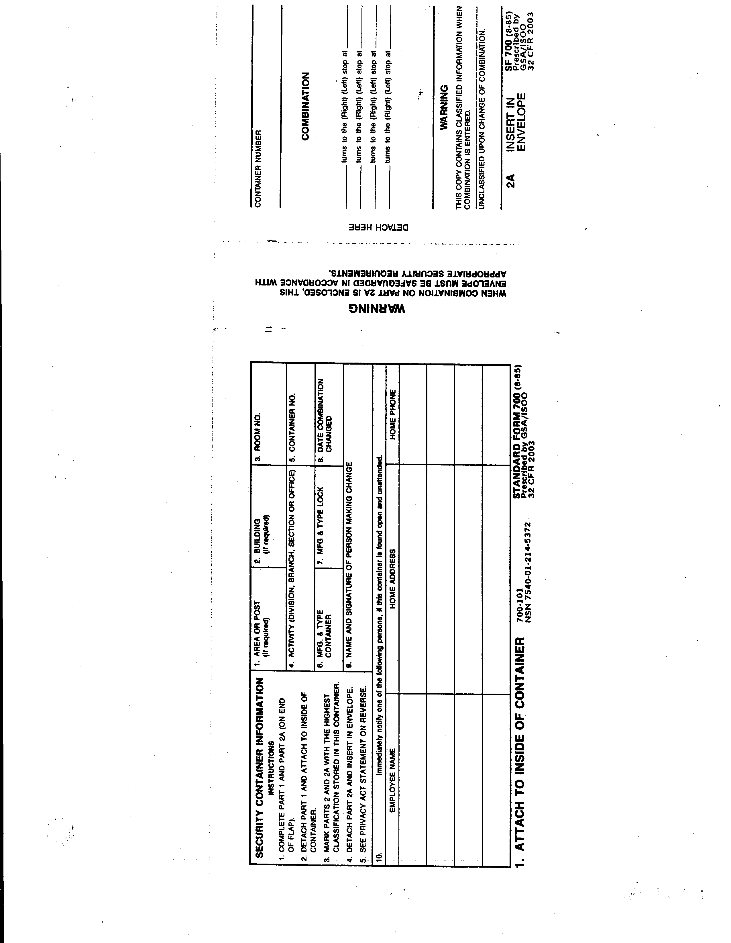

Encl 5-1

Encl 5-2
Chapter 6

Cash Register Operations
CASH REGISTER OPERATION

REFERENCE: AR 215-1, Appendix G
DFAS-IN Regulation 37-1

1. Where available, cash registers will be used to record all sales. Receipts voucher (DA Form 1992) will be used to record any sales not rung through a register (i.e. room rental fee).

2. The sales amount displayed on the register should be easily seen by the customer. For food and beverage operations, internal controls are satisfied by using a cash register that visually displays the sales amount and can be observed by the customer AND by providing the customer with a pre-numbered imprinted or written guest check. All sales transactions will be documented by providing the customer with a pre-numbered sales receipt, imprinted guest check, or with a register kick-out tape.

3. Register Change Fund Issue:

- Will be signed for by the register operator on DA Form 4082 (Daily Cashier’s Record - Encl 6-1, 6-2).

- Pre-numbered cash control documents (guest checks, tickets, etc.) will be issued to the register operator at the same time as the change fund using the Form Accountability portion of the DA Form 4082.

- Once the register operator’s signature is received, the DA Form 4082 will be placed in the safe as a receipt for the issued change fund.

4. Only one person will be assigned to a cash register drawer, except for head cashiers in the performance of their duties. If the cash register has more than one cash drawer, then each operator must have his or her own key to the register control for the drawer.

5. Over-rings (ringing up of more than the transaction amount) or under rings (ringing up of less than the transaction amount) are not to be adjusted by subtracting or adding to a later customer sale. They will be voided and verified on the cash register tape and initialed by the cashier’s supervisor. The correct sale will be subtracted from sales and explained on the DA Form 4082 (Daily Cashier’s Record) and forwarded along with the voided kick-out tape.

6. Cash registers will not be operated with the drawer left open.

7. At the close of business, cash registers will be emptied of cash. The drawers will be kept open with the register controls locked.

8. Cash register readings are essential to internal controls. It involves determining the cash register total recorded sales. Only the manager or his or her representative will take the reading. Cash register operators will not take readings. The cash register will be read at the change of each cash register operator’s shift.

9. Cash register totals are cleared by management only at the end of the month.

10. Register tape will be attached to the Daily Activity Report (DAR) as supporting documentation for the register sales. The DAR is filled out correctly, reviewed by management, and sent to NFS/FMD within 2 working days.

11. Register Change Fund Turn-In:

- Individual cashiers will account for change funds; pre-numbered cash control documents, and cash receipts. Cashiers are relieved of responsibility only upon a cash count.

- Register sales and pre-numbered cash control documents will be reconciled with cash collected.

- Unused pre-numbered cash control documents will be recorded in applicable blocks of DA form 4082.

- When cash accountability is transferred, the person accepting the cash will verify and document the amount on the DA Form 4082. This will be in the presence of the person who relinquishes control.

- Cashiers will not keep overages. Nor will anyone be required to make up shortages unless that person is held liable as a result of an investigation by proper authorities. Cash overages and shortages will be recorded on DA Form 4082.

- Recommend overage and shortage logs be maintained on all employees who handle cash. Entries will be made for every shift that the cashier completes. If there is no overage or shortage for that shift, it will be annotated as such (Encl 6-3, 6-4). Overage/shortage logs identify cashier trends. A cashier who balances every shift with no overage or shortage is just as suspect as one with constant fluctuations. Excessive cash overages/shortages may be grounds for termination.

- Overage/shortage logs should include:

a. Date.

b. Total Register Accountability (recorded sales).

c. Total Cashier Accountability (cash turned-in).

d. Overage/shortage in dollars and percentage.

e. Explanations for variances over 2%

f. Monthly Totals.

- Employees should sign their overage/shortage log at the end of every month. These documents should be kept on file for a minimum of one year.

.

Encl 6-1

Encl 6-2

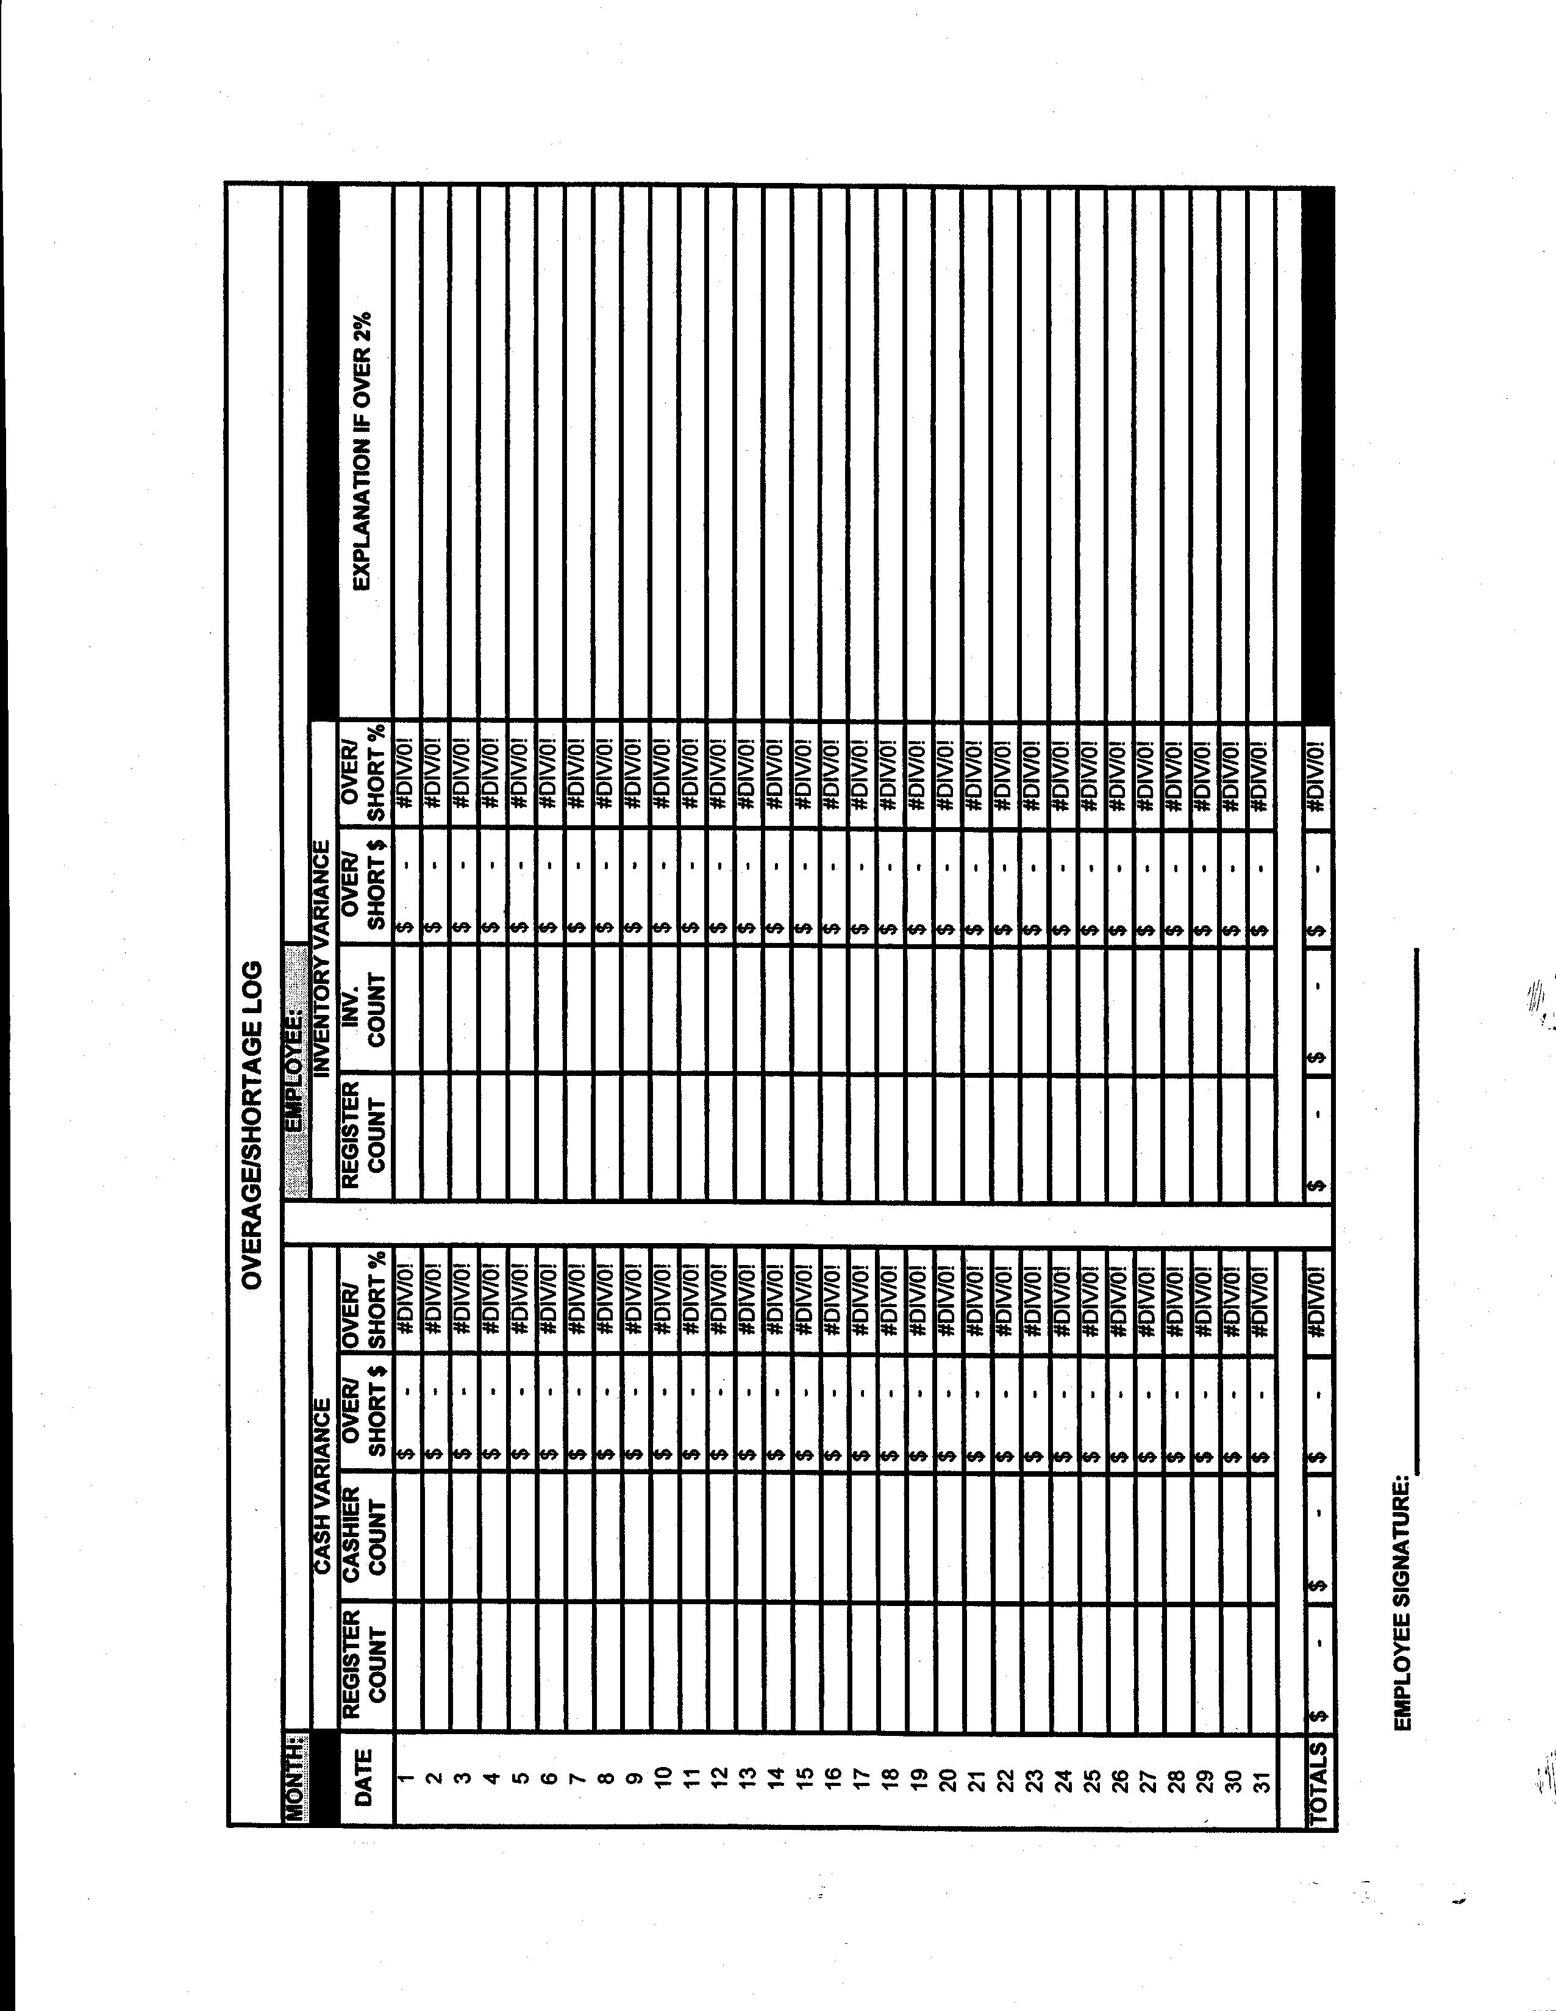

Encl 6-3

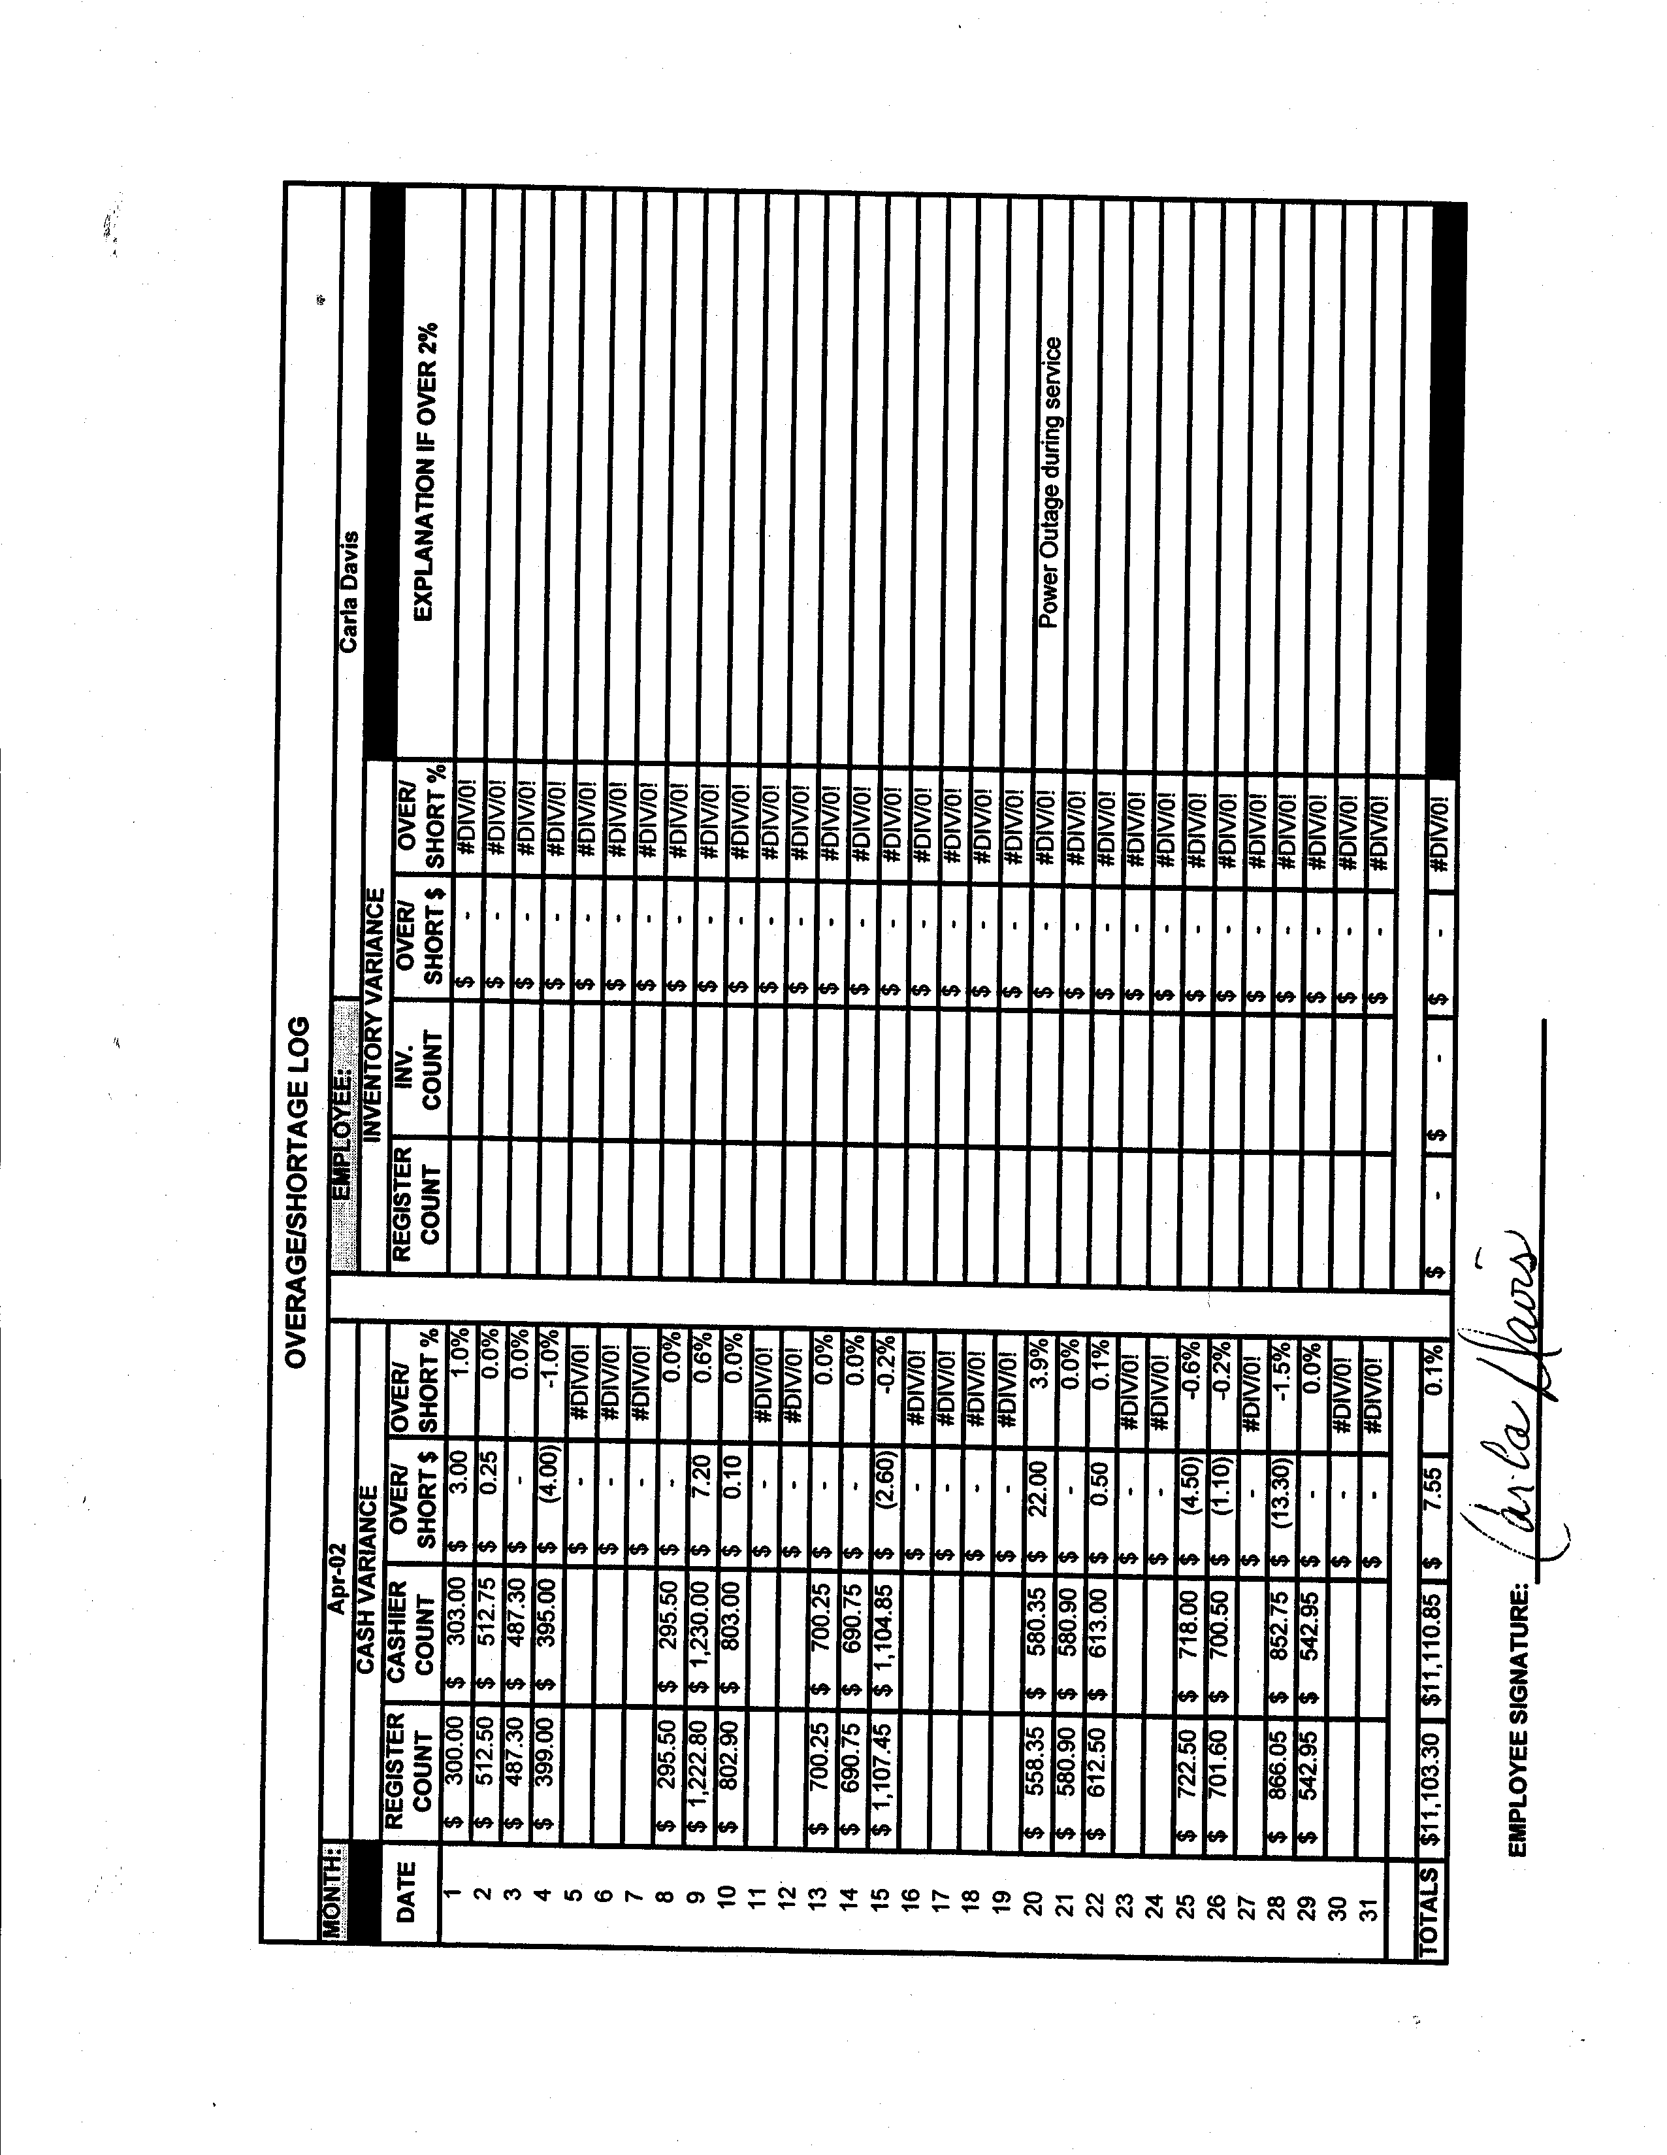

Encl 6-4
28

Encl 6-4
Chapter 7

Document Control

DOCUMENT CONTROL

REFERENCE: DFAS-IN Regulation 37-1

- Nonappropriated fund activities will send all source documents to The Central Accounting Officer (CAO) within two working days after receiptor issue.

- Sequentially-numbered daily transmittal letters (TLs) will be used. Transmittal letters conform receipt of all documents. The correct submission of a TL ensures timely delivery of each document as it is received in the CAO.

- Separate TLs will be prepared for DARs, accounts payable documents, and payroll documents.

- Each month’s business will begin with number “1” and each TL that follows will be numbered consecutively, with no skipped numbers or duplicated numbers within that fund’s/location’s series.

- The point of contact (POC) and the POC’s phone number will appear on each TL.

- The installation and fund or location names and/or codes must be on each TL.

- Multiple months’ business will not be combined on one TL.

- A TL must accompany every document sent to the CAO. A master TL is recommended but not required.

- Electronic Media:

- If electronic media is used to transmit DARs to the CAO, original documents do not have to be sent to the CAO unless the CAO asks for the documents.
- Electronic Document Management (EDM) is an imaging and workflow system that storage, and the displaying of documents submitted by the activities.
- The use of EDM is an authorized means of submitting documents. Scanned documents by other means are acceptable. However, the original documents must be kept on file for four years after the close of the fiscal year.

- Documents will be date stamped by NFS to track all late documents that are received by the activity. .

Chapter 8

Draft Beer Accountability

DRAFT BEER ACCOUNTABILITY

REFERENCE: AR 215-1 Appendix G-6

1. Sales Accountability for draught beer is based on the total number of glasses drawn from start to finish of a keg. There are many methods of accounting for draft beer; some are more labor intensive and some are more costly.

2. When determining draft beer accountability needs, several things need to be taken into consideration: size of facility, number of taps, and volume of draft beer. In a small operation, the cost of an accountability system may exceed the amount lost through waste and pilferage.

3. The methods listed below begin with the least expensive/most labor intensive to the most expensive/minimal labor expense.

EXPECTED SALES METHOD

1. Accountability factors:

- ½ barrel (usually referred to as a “keg”) = 15 ½ gallons = 1984 fluid ounces.

- Type of draft beer used: Brand A x $56.00

- Type of glassware:

  - 12-ounce glass with ½ inch foam head or 10 ounces of beer per glass.

  - 60-ounce pitcher with ¾ inch foam head or 50 fluid ounces of beer per pitcher.

- Waste Factor = 5%.

2. Computation of Expected Sales:

- Total expected fluid ounces from 1 keg:

95% yield x 1984 ounces/keg = 1885 ounces

- Expected glasses from 1 keg:

1885 fl. oz. = 1885 = 189 glasses
# fl. oz./glass 10

- If selling price of draft beer is $1.00 per 12oz glass,

Expected Revenue per keg = 189 glasses x 1.00/glass = $189.00

3. Sales accountability for draft beer will be based on the total number of glasses drawn from the total of beer kegs from start to finish of the keg. This is documented in a logbook for accountability. For daily retail sales accountability purposes, the draft beer sales per register will be compared to the total expected sales.

4. When a keg runs dry and a new keg is brought on line, the register will be rung out. The closing and opening readings for the draft beer key will be recorded in the logbook along with the date, time and manager’s initial. Draft beer sales will be rung up on the designated key. Each keg line will be separately tracked in the logbook. At the close of a shift, when the register is rung out, the closing reading for the draft beer key will be computed by taking the closing reading less the opening reading to determine draught beer sales. Total draft beer sales will be divided by the glass selling price for that shift to determine the number of glasses used for that shift. The total usage for the shift will be recorded in the usage column in the logbook.

KEG SCALES

1. A keg platform scale is needed for this process.

- Total weight of a full keg is approximately 162 lbs., including the weight of the container.

- Weight of beer only is 1984 fl. oz. = 124 lbs. Tare weight is approx. 38 lbs.
16 fl. oz.

- Expected revenue per lb. Of beer sold = $189 = $1.54
124 lbs.

2. The bar inventory clerk enters the weight of the keg beer tapped on beginning column.

3. Any additional full kegs that must be added to the inventory during the bartender’s shift will be recorded at 124 pounds received.

4. After the bar is closed, the bar inventory clerk will weigh the total number of pounds of draft beer tapped subtracting the weight of the container from the total weight.

5. The difference between the beginning inventory, plus kegs received, minus ending inventory, is the amount used. Multiply the number of pounds to the nearest ¼ pound by $1.54 to calculate the expected sales.

6. Compare the expected sales against the cash register total draft beer sales. The difference is the variance. If the variance exceeds 5% for draft beer sales, it must be explained in writing and appropriate disciplinary action taken.

DRAFT BEER COUNTERS

1. Draft Beer Counters can eliminate careless pouring, unauthorized free beer, and bartender theft. They are used to count the number of ounces dispensed rather than the number of beer containers dispensed. This does not require a bartender to hit a button prior to pouring. Whatever draft beer is poured and counted throughout the shift is what the bartender is accountable for. The draft beer counters replace the existing beer faucets and are easily installed.

2. Meter readings are taken manually at the end of the bartender’s shift and compare to actual sales using an automated spreadsheet (Encl 8-1, 8-2).

3. Once managers are aware of how much draft is poured every shift, they can compare it to how much draft beer is sold every shift. Any unacceptable variance between the cash register readings and the Draft Beer Counter readings should be cause for concern.

4. Managers are expected to determine if variances are by wild beer (foamy beer poured down the drain) or wild bartenders (sloppy pouring, unauthorized beers, cash skimming or personal consumption). If the problem is with foamy beer, have the beer distributor correct the problem. If the problem is with employees, they should be re-trained and disciplined appropriately to prevent similar occurrences in the future.

5. Draft Beer Counters work well for a direct draw dispensing system (cooler behind the bar with kegs stored below the taps) and are also recommended for facilities with eight or fewer taps that use a remote dispensing system.

6. Draft beer counters work very well in conjunction with draft foam control detectors for remote dispensing systems.

FLOW METERS

1. Small turbine-style flow meters are installed in the cooler onto the beer lines, out of sight from the customer. The meters accurately register the amount of beer dispensed through each faucet for every shift. Managers take cash readings and compare the amount of beer sold to the amount of beer poured from the reports generated by the control system.

2. A flow meter-based draft beer metering system is recommended for facilities with eight or more taps.

3. This system requires professional installation.

MECHANICAL BEER SYSTEM

1. This is probably the most accurate method for maintaining draft beer accountability. Each beer is portioned, controlled and metered. The meter records how many beers have been drawn and this can be compared with cash register reports to determine sales accountability. This system also allows management to determine the size of foam head to be poured with every size of glass or by pitchers. A turn of the key secures the device; preventing tampering by unauthorized personnel.

DRAFT FOAM CONTROL DETECTORS

1. The Draft Foam Control (DFC) prevents CO2 from entering the beer line at the end of a keg. This device will keep the line filled with beer when the keg becomes empty. When a new keg is tapped and the DFC is reset, liquid beer will pour foam-free as soon as the faucet is opened.

2. The DFC will stop beer from foaming when a new keg is tapped. It will not, however, cure foamy beer problems caused by warm temperatures, improper CO2 pressure, dirty beer lines, or worn parts.

DRAFT BEER TAP LOCKS

1. Draft beer tap locks are used to prevent the theft of draft beer when the bar is closed. Tap locks are recommended for any draft beer system that does not have the capabilities of turning the beer on and off and is not located in a secure area.

COOPERAGE

1. When kegs are delivered to a facility, a deposit is paid for the actual keg container. This fee varies from state to state, by distributor. When kegs are returned to the vendor, a credit is issued. This must be broken out when posting to the General Ledger Accounts (GLACs). If not, the cost of the deposit/credit is incorporated into the COGS.

2. Review the invoices carefully to determine amounts of charges and credits in connection with returnable containers (Encl 8-3).

- Debit GLAC 128 (Deposit receivable) with the charges of deposits.

- Credit GLAC 128 (Deposit receivable) with returns to vendors.

- Credit GLAC 128 (Deposit receivable) for any containers sold to customers.

- Debit GLAC 128 (Deposit receivable) for any returns by customers.

3. At month end, NAF Financial Services (NFS) will adjust the ending balance to the dollar value of the physical inventory of containers taken by the NAFI. GLAC 741, Deposits Lost Expense, will be debited for any amount lost on containers due to breakage or loss.

SPORTS USA
DRAFT BEER ANALYSIS

Date: Sunday, March 22, 2011 Bartender(s): Julie

Total Actual Poured Report
BRAND | BEER SYSTEM READINGS  1 2 |  | OUNCES POURED | COST  Per Ounce | COST of  Beer Poured
TOTAL | 86 | 0 | 860 |  | 26.78
Budweiser – A | 55 | 0 | 550 | 0.0307 | 16.91
Budweiser – B | 0 | 0 | 0 | 0.0307 | 0.00
Miller Lite - A | 24 | 0 | 240 | 0.0307 | 7.38
Miller Lite - B | 0 | 0 | 0 | 0.0307 | 0.00
Coors Light | 3 | 0 | 30 | 0.0297 | 0.89
Genuine Draft | 1 | 0 | 10 | 0.0313 | 0.31
Michelob | 0 | 0 | 0 | 0.0323 | 0.00
Guinness | 3 | 0 | 30 | 0.0428 | 1.29

Total Sales Report (from POS system or Cashier Register)
Container Size  (Ounces) | Beer Ounces | Quantity Sold | Total Beer  Ounces Sold
TOTAL |  |  | 781
12 | 11 | 35 | 385
23 | 20 | 9 | 180
60 | 54 | 4 | 216

Comparison Total Ounces Sold vs. Total Ounces Poured

Total Ounce Sold | Total Ounces Poured | Ounce Variance | Ounce Variance %
781 | 860 | -79 | -9.2%

Cost of Draft Beer Sold for March 22, 2011
Cost of Beer Poured | Actual Draft Beer Sales | Draft Beer Cost %
26.78 | 85.50 | 31.32%
Encl 8-1
SPORTS USA
WEEKLY DRAFT BEER RE-CAP

Date/Shift | Bartender(s) | Ounce Variance Percentage | Cost Percentage
Mon, Mar 7, 2011 1st Shift | Jack | -2.8% | 24.34%
Tue, Mar 8, 2011  1st Shift | Julie | -10.0% | 32.39%
Wed, Mar 9, 2011  1st Shift | Jack | -3.4% | 25.10%
Thu. Mar 10, 2011  1st Shift | Jack | -2.9% | 24.42%
Fri. Mar 11, 2011  1st Shift | Jack | -4.4% | 25.64%
Fri. Mar 11, 2011  2nd Shift | Bill, Julie | -8.0% | 30.76%
Sat. Mar 12, 2011  1st Shift | Marty | -2.5% | 24.17%
Sat. Mar 12, 2011  2nd Shift | Bill, Susie | -5.3% | 24.67%
Sun. Mar 13, 2011  1st Shift | Marty | -5.3% | 26.45%
Sun. Mar 13, 2011  2nd Shift | Julie | -9.2% | 31.32%
 | Averages: | -5.4% | 26.93%

Encl 8-2

Encl 8-3
Chapter 9

Employee Meals
EMPLOYEE MEALS

REFERENCE: AR 215-1, Chapter 13
DFAS-IN Regulation 37-1

- Program managers may offer an employee meal program to NAF employees working in a food service environment (MWR programs that sell food). If this is a condition of employment, the employee must be paid for the meal period. In any case, the meal period is specified within the employee’s scheduled work hours.

- Meals will be retail price, wholesale cost, or no cost to the employee.

- Employee meals may be provide as a convenience to employees within a facility and are not intended to be a benefit of employment.

- Each installation should develop a detailed internal employee meal SOP prescribing proper procedures to include amount of employee discount. Recommended employee meal discount is one authorized meal per shift, at 50% of the retail price, providing it does not go below the cost of the preparation of the meal.

- Employees must be on the clock to be eligible for a discounted meal. Carryout meals are not authorized.

- Appropriated fund employees are not authorized employee meals.

- Local form similar to Employee Meal Register form at Encl 9-1 will be used to record the amount of cash collected for employee meals and provide departmental accounting data to NAF Financial Services (NFS).

- Employee Meal Register form:

- Is prepared by the cashier.

- The head cashier or activity manager is the control point.

- The number block should be completed using a sequential number for each day of the accounting period. This enables a tracking process to account for all days of the month.

- Each employee will print their name, enter the full cost of the meal, enter the exact amount they are paying, and sign their name on Employee Meal Register Form.

- The cashier operating the register will ensure that the information the employee enters is correct, total both columns and print his/her name at the bottom and sign the form.

- The cashier will ring up the full amount on the cash register and the discounted amount will be deducted on DA Form 4082 (Daily Cashier Record). Operating department in Section C of the form should break out total money received.
- The completed form will be forwarded with the Daily Activity Report to NFS.

- A copy will be retained by the activity until the next audit.

9. If the cash register has the capability to record employee meals and reflect the amounts discounted on the register tape. Employee Meal Register Form is still required by NFS to determine the employee meal expense by department. It is recommended that management review these records to validate that employees taking a discounted meal are authorized and on the clock.

Encl 9-1
Chapter 10

Fixed Assets

FIXED ASSETS

REFERENCE: AR 215-1, Chapter 17, Chapter 18
DFAS-IN Regulation 37-1

- Nonappropriated fund fixed assets are defined as tangible properties purchased or donated to a NAFI that have a life expectancy of two or more years and cost $2,500 or more. Examples are land improvements, building alterations, renovations, and furniture, fixtures and equipment.

- Fixed assets are recorded at cost plus any fees that are incurred to put the asset in place such as installation, freight, testing, etc.

- Purchase discounts should be applied to reduce the costs, however, interest charges should not be capitalized

- Like items that are purchased in multiple units, with an individual cost of at least $100, and a total cost that exceeds $2,500 or more may be treated as fixed assets. This decision is made at the time the CPMC budget is prepared or revised; not at the time of purchase. For the items in this paragraph, the budget treatment of the purchase will control the accounting treatment. If the assets were budgeted as CPMC, they will be capitalized; otherwise they will be expensed. The term “like items” is defined to mean identical items.
An example would be the purchase of three vacuum cleaners at $400 each. These items may be immediately expensed or determined to be fixed assets since they meet the two-year/$1,000 minimum requirement.

- Use of the straight-line method of depreciation is mandatory. Salvage value will not be considered, i.e., the total cost of the asset will be depreciated. Depreciation of fixed assets will begin the month after receipt and continue through the month of 100 percent depreciation. When a fixed asset that is not fully depreciated is removed from property control records, a full month's depreciation will be recorded. Depreciation expense should be recorded in the using department code.

- Depreciation is a systematic method of charging operations with the cost of a fixed asset over its estimated useful life. Estimates of the useful life of assets are seldom accurate since obsolescence or other factors may abbreviate or elongate its usefulness. Because of the uncertainty, the guideline life expectancies shown in Table 4-1 are to be used for establishing the maximum expectancy for each category listed.

Since salvage values are almost impossible to predict and restrictions are placed on disposal of military property, salvage values will be ignored in depreciation computations for NAFI-owned fixed assets. Although there are several depreciation methods in general use, Army NAFIs will use only the straight-line method except that aircraft may be depreciated based on hours flown (see below). Under the straight-line method, the cost of the fixed asset is spread in equal periodic portions over its estimated useful life.

Monthly depreciation is calculated simply by dividing the total depreciable value of the fixed asset by the estimated months of life. An asset will not be depreciated in the month in which it is placed in use. If an asset is not fully depreciated, a full month's depreciation will be recorded when disposition is made. If the fund manager desires, aircraft may be depreciated based on hours flown. The estimated flying-hours the aircraft is expected to last are divided into the cost to arrive at depreciation per hour.

Each month the fund manager must report to the CAO the number of hours flown so that depreciation may be calculated and recorded. This must be done manually. NAFISS supports only straight-line depreciation.

- The straight-line method of depreciation is used for determining the monthly depreciation expense. This method takes the total value of the asset and evenly divides it by the anticipated useful life of the asset. Salvage value will not be considered. A reliable source for determining the useful life of the asset is the experience with similar assets.

$22,520 = $2,815/year = $234.58/month
8 year useful life depreciation expense

Depreciation Periods

Description | Life Expectancy
Buildings | 15-40 years
Building Improvements | 5-30 years
Furniture, Fixtures, and Equipment | 2-10 years
Vehicles, Aircraft, and Boats | 2-7 years
Computer Hardware and Software | 2-3 years
Land Improvements | 5-25 years

- NAF Fund Administrators serve as accountable officers for all NAF property and will:

- Receive or confirm receipt of purchased items through receiving reports in accordance with the terms of purchase.
- Establish fixed asset inventory system of identification in coordination with NAF Financial Services (NFS).
- Redistribute or dispose of excess NAF property in the most effective way.
- Report losses in writing to NFS and cooperate in, or conduct, necessary investigations.

- Property loss includes all NAF property that is lost, damaged, or destroyed by cause other than fair wear and tear. Properly completed physical inventory documentation is considered notification in writing. As soon as NFS is notified, the shortages will be removed from the property control records. This does not constitute relief from property accountability.

- Property items or combinations of items valued in excess of $2,000 that have been lost, damaged, or destroyed for causes other than fair wear and tear are dropped from accountability records only after an investigation is conducted.

- Minor operating losses require no investigation and inventory levels are adjusted as required. If losses of low-cost items are repeated, there is cause for a review of inventory controls and an investigation, if appropriate.

- All NAF property is inventoried annually and upon change of fund administrator or accounting officer.

CHAPTER 11

INVENTORY CONTROL
INVENTORY CONTROL

REFERENCE: AR 215-1, Chapter 18, Appendix G
DFAS-IN Regulation 37-1

- Fund employees under the direct supervision of the activity manager or a designated representative perform physical inventories monthly for merchandise purchased for resale and consumable supplies (Encl. 11-1).

- All other NAF property is inventoried annually and upon change of fund managers or accountable officers.

- All other NAF property is inventoried annually and upon change of fund managers or accountable officers.

- Physical inventories are required as of the last business day of each month.

- The members will work in pairs. One person will inspect and count the items; the other will enter the count on the list. The person designated to inventory should be someone other than the responsible person; i.e. bar inventories should be taken by someone other than the bartender. However, the bartender should help conduct the inventory in his or her respective area of responsibility.

- Inventory counts should be conducted wall to wall, left to right, and top to bottom.

- Cutoff dates for sales, issues, returns adjustments, and transfers between departments must be established so the inventory lists will be accurate.

- Merchandise delivered during the inventory will not be counted unless the purchase and payment have been or will be recorded as of the inventory cutoff date.

- Merchandise sold or transferred out during the inventory will be included in the inventory count unless the related sale and receivable or money received have been or will be recorded as the inventory cutoff date.

- Inventory will be conducted and listed separately for each department.

- Each inventory includes a visual count of merchandise and comparison of the results to the balances carried forward on accounting records.

- Open and partial containers (such as coffee, spices, etc.) in the kitchen production areas will not be included on the monthly inventory. However, processed cuts of meat will be inventoried regardless of their location.

- Bar condiments and garnishes are charged to cost of goods at the time of issue.

- To arrive at unit prices, use the moving average method or the first-in, first-out method. The cost averaging method is the preferred method for NAFI activities.

- A person or persons selected by NAF Financial Services (NFS) will observe the physical inventory at least annually at each location. Since it is frequently impractical to perform physical inventories of all the departments within a NAFI, physical inventories may be scheduled and conducted by location code. Physical inventories of location codes with similar missions should be conducted at the same time, i.e. all food, beverage and entertainment activities at one time.

- A Central Storeroom Requisition sheet is used to issue all food and bar items from the appropriate storeroom (Encl. 11-2). Personnel authorized to issue food and bar items should be limited.

- All issues should be posted to DA Form 1991 (Stock Record Card) or to Food Trak on a daily basis. This will create a perpetual inventory. While merchandise is in the storeroom, it will be maintained and documented by Food Trak, or on Stock Record Cards (Encl. 11-3).

- Perpetual inventories of sensitive and high-dollar value items including food, liquor, beer, wine, and tobacco products will be maintained. Specifically:
- A physical inventory is performed daily.
- DA Form 1991 (Stock Record Card) or an approved mechanized system (Food Trak) will be used to maintain perpetual inventory stock records.
- Inventory documents are posted daily to reflect opening inventory, transfers in and out, and ending inventory.
- Quantities sold are reconciled with the cashier’s scatter sheet, or summary of sales recorded for that cashier.
- Variations are explained in writing.

- Sensitive item inventories are used to control high cost or high use items. This method of daily record keeping will give the current balance for a particular item or items. An automated sensitive item worksheet (Encl. 11-4) is available at www.businessplan.armymwr.com website.

- The number of items controlled should be between 5 and 15 within a food operation.

- Inventory documents must be reviewed daily.

- Variance must be investigated and explained in writing. The Manager must sign the form and indicate the type of corrective action take when applicable.
- The form should be completed by kitchen personnel and reconciled with the scatter sheet by administrative personnel.

- The manager should make a physical count at least once per week.

- Retain on file the completed form and explanations of significant variances until the next audit.

20. The acceptable inventory turnover rate for food and beverage is 1 to 1. This measures the efficiency of inventory control. A ratio of 1 to 1 means that the entire inventory is turned over once within the month. High inventories unnecessarily tie up operating funds, because excessive storage costs make monthly inventories more difficult and may result in stock becoming outdated.

Inventory Turnover Ratio = Cost of Goods Sold
Average Inventory

Average Inventory = Beginning Inventory + Ending Inventory
2

21. Recommend FM calculate inventory ratios in all activities at least annually; monthly for activities with significant variances.

Encl 11-1

Encl 11-2
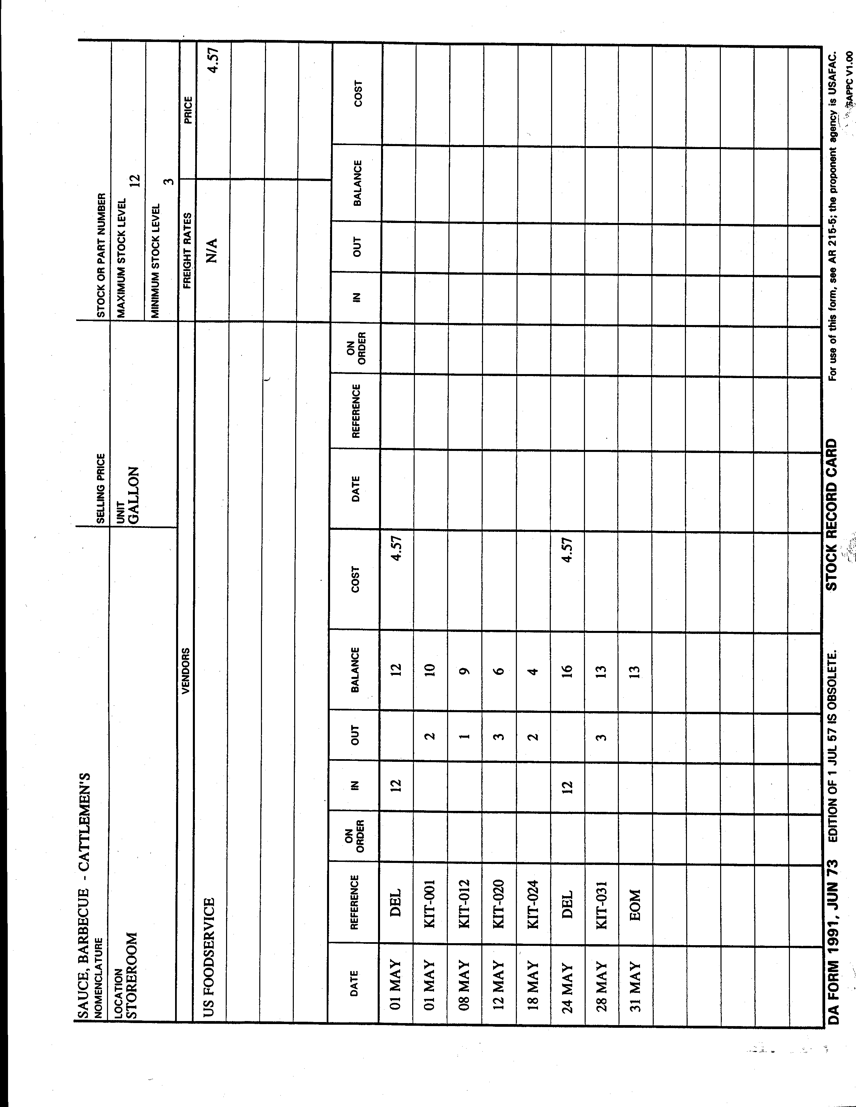

Encl 11-3

Daily Sensitive Item Inventory Sheet
LOCATION: | Day: | Mon - Tue - Wed - Thur - Fri - Sat - Sun
Enter Outlet's Name | Shift: | AM - MID - PM - 3RD
Item | Pack | Count/ Unit | Begin Inv | Transfer In | Waste | Counted End Inv
Bf Steak Top Butt Filet
Bf Ribeye Lip On
Bf Flank Streak
0
0
0
0
0
0
0
0
0
0
0
0
0
0
0
0
0
0
0
0
0
0
0
0
0
0
0
0
0
INVENTORY COMPLETED BY (SIGNED): _________________________________________________________________. DATE: ____________________.

Encl 11-4

Chapter 12

Key Control
KEY CONTROL

REFERENCE: AR 190-51, Appendix D
AR 190-11

1. Key and lock control is an important element to an activity’s crime prevention. Poor key and lock control gives the impression that no one cares and invites theft. All keys and locks MUST be controlled, inventoried, and issued to the user if they are to be an effective device for protecting property and controlling access to work areas. Key control is the most basic of internal controls and the requirements are as follows:

- Appointment of key and lock custodian.

- Physical control of all keys and locks.

- Continuous inventory of all keys and locks.

- Periodic inventory verification.

2. KEY AND LOCK CUSTODIAN:

- Each activity must have a primary key and lock custodian. An alternate custodian is not mandatory but is recommended and should be considered. The key custodians will be:

  - Appointed in writing to receive, issue, and maintain accountability for activity keys.

  - Educated in proper local key control procedures.

  - Held responsible for maintaining a key control register at all times to ensure continuous accountability for keys of locks.

  - Listed on an access roster.

- The key and lock custodian must control all keys and locks. These include:

  - Padlocks and keys securing government property or facilities.
  - Door keys (offices, supply areas, warehouses, lockers, etc.).
  - Vehicle keys (ignition and door).
  - Combination locks are NOT included.

- The use of any master key system or multiple systems is PROHIBITED. U.S. Government key-operated, pin-locking deadbolts that project at least one(1) inch into the doorframe or tumbler type padlocks will be used.

- Padlocks and keys not in use will be secured in a locked container.

- Every locking device will have a duplicate key stored in the key box. The key custodian will maintain one key to every locking device on hand at all times (all keys to a lock will not be issued).

3. KEY DEPOSITORY:

- A lockable container is required to secure all keys. This could be a filing cabinet, safe, or a key depository made of at least 26-guage steel, equipped with a tumbler type-locking device; and permanently affixed to a wall. The key depository will be located in a room where it is kept under 24-hour surveillance or in a room that is locked when unoccupied.

- Access to the key depository must be stringently controlled. An access roster, signed by the key custodian, listing all personnel authorized to issue/receive keys will be posted on the exterior of the key depository.

Only those personnel on the access roster will access the key depository. The fewer the number of personnel with access to the key depository, the better the security.

4. FORMS: MASTER INVENTORY LIST (Encl. 12-1, 12-2).

- The most difficult task of key and lock control is to identify all locks, locking devices, and keys. The key custodian must know how many keys and locking devices are in the activity, where they are located, and how many keys or combinations are in the system. A master inventory list is prepared to include the following:

  - Serial number of the key or lock.
  - Location of the lock (be specific).
  - Total number of keys maintained for the lock.
  - Hook number (optional).

- There is no required format for this inventory list. Use whatever form is easiest for you as long as the required information is included. All changes must be annotated on the key/lock inventory list each time a lock is changed/added or keys increase/decrease in number. A key custodian must know at all times how many locks/keys there are on hand.

If a key has no serial number, assign one to it. Mark the keys with an engraver or use a metal die stamp. Do not use embossing tape, masking tape or similar type removable material.

- DO NOT FORGET to include the keys to the key depository.

5. FORMS: DA FORM 5513-R (KEY CONTROL REGISTER).

- A key register is now needed to establish accountability. Keys will be signed out only to the authorized personnel, as needed, on a key control register. DA Form 5513-R is approved for use to meet the requirements (Encl. 12-3, 12-4). This form will accommodate 40 different locking devices, record issue and turn in of keys, and can be used to record required periodic show basis and semiannual key inventories.

  - An activity may have as many key control registers as needed to logically accomplish key and lock control.
  - All 40 key control numbers do not need to be filled out. Unused lines are simply lined through. If more lines are needed, continue on a second form changing the number 1 to 41.
  - The “Unit” block should indicate the activity name and could include other identifying information such as “Bar Set 1”, “Night Manger’s Keys”, “Vehicle Keys” (Encl. 12-5, 12-6).
  - The “Date(s)” block will show the 1st date this particular register was used (beginning date) and the final date closing the form or transferring information on the sheet to a new register.
  - The “Key Control Number(s)” block will contain the serial number of each key being controlled on that specific form.
  - Key control registers are to be kept in a locked container with controlled access when not in use.
  - DA Form 5513-R should be retained for a period of 90 days after the completion of the last entry.

- Keys on a key ring will be assigned a separate DA Form 5513-R. Each serial number on the key ring will be listed under the column “Key Control Register and Inventory”. When the ring is signed out, all numbers must be signed out.

- Prior to issuing keys on the DA Form 5513-R, copy it. This prevents having to complete the top portion each time you need a new form for the keys listed.

- Control all your keys on your established key control records. Do not control part of the keys on hand receipts. Mixing systems of control leads to confusion and loss of accountability.

6. PERMANENTLY ISSUED KEYS:

- The next task in the key and lock control is to decide who needs to keep the keys on a permanently signed-out basis. Managers would obviously need a key to the front door, but they should seriously consider who else would personally need to retain a key to the front door or supply area, kitchens, etc. For good physical security, personally retained keys should be kept to the minimum necessary for operational efficiency.

- Issuing of keys is documented on the DA Form 5513-R “Key Issue and Turn-in” block (Encl. 12-7). The following information must be annotated:

  - “Key Number”: This is the first line number that contains the serial number of the key issued.
  - “Issued”: Include the date and time the key is being issued.
  - “Issued By”: Printed name and signature of the individual issuing the key.
  - “Issued To”: Printed name and signature of the individual receiving the key.
  - “Turned In”: Include the date and time the key is returned to key control personnel.
  - “Received By”: Printed name and signature of the individual receiving the returned key.

- Maintain separate DA Form 5513-R’s for personally retained keys. Keep a copy in the employee’s file and the original with your key control records.

7. INVENTORIES:

- A beginning inventory of all keys and locks must be documented. Only the key custodian or the alternate key custodian will inventory the keys. Several methods can be used. Select the easiest method for you:

  - Sign and date the “Inventories (Monthly/Semiannual)” block of each DA Form 5513 (Encl. 12-8).
  - Add “Keys on hand” and “Keys Issued” categories to your key and lock master inventory list and sign and date it.
  - Prepare a memorandum stating all keys were inventoried and what, if any discrepancies were found and sign and date it.

- When to conduct inventory verifications:

  - Keys issued on a daily basis will be checked at the end of the duty day. Difference between keys on hand and the key control register will be reconciled.
  - Personally retained keys will be inventoried on a “show basis” periodically. Recommend “show basis” inventories be conducted at least quarterly.

    - Ask each individual, who has been issued personally retained key(s), to show their key(s).
    - Compare the serial number on the key(s) to the serial number on the key control register (DA Form 5513-R).
    - Document the “show basis” inventory by one of the methods addressed above.

  - All keys will be inventoried by serial number at least semiannually. The keys on hand and the keys issued must equal the total number of keys maintained for each locking device. Documentation of the semiannual key inventory will be by one of the methods addressed above.

- All inventory documentation will be maintained on file for a minimum of one (1) year.

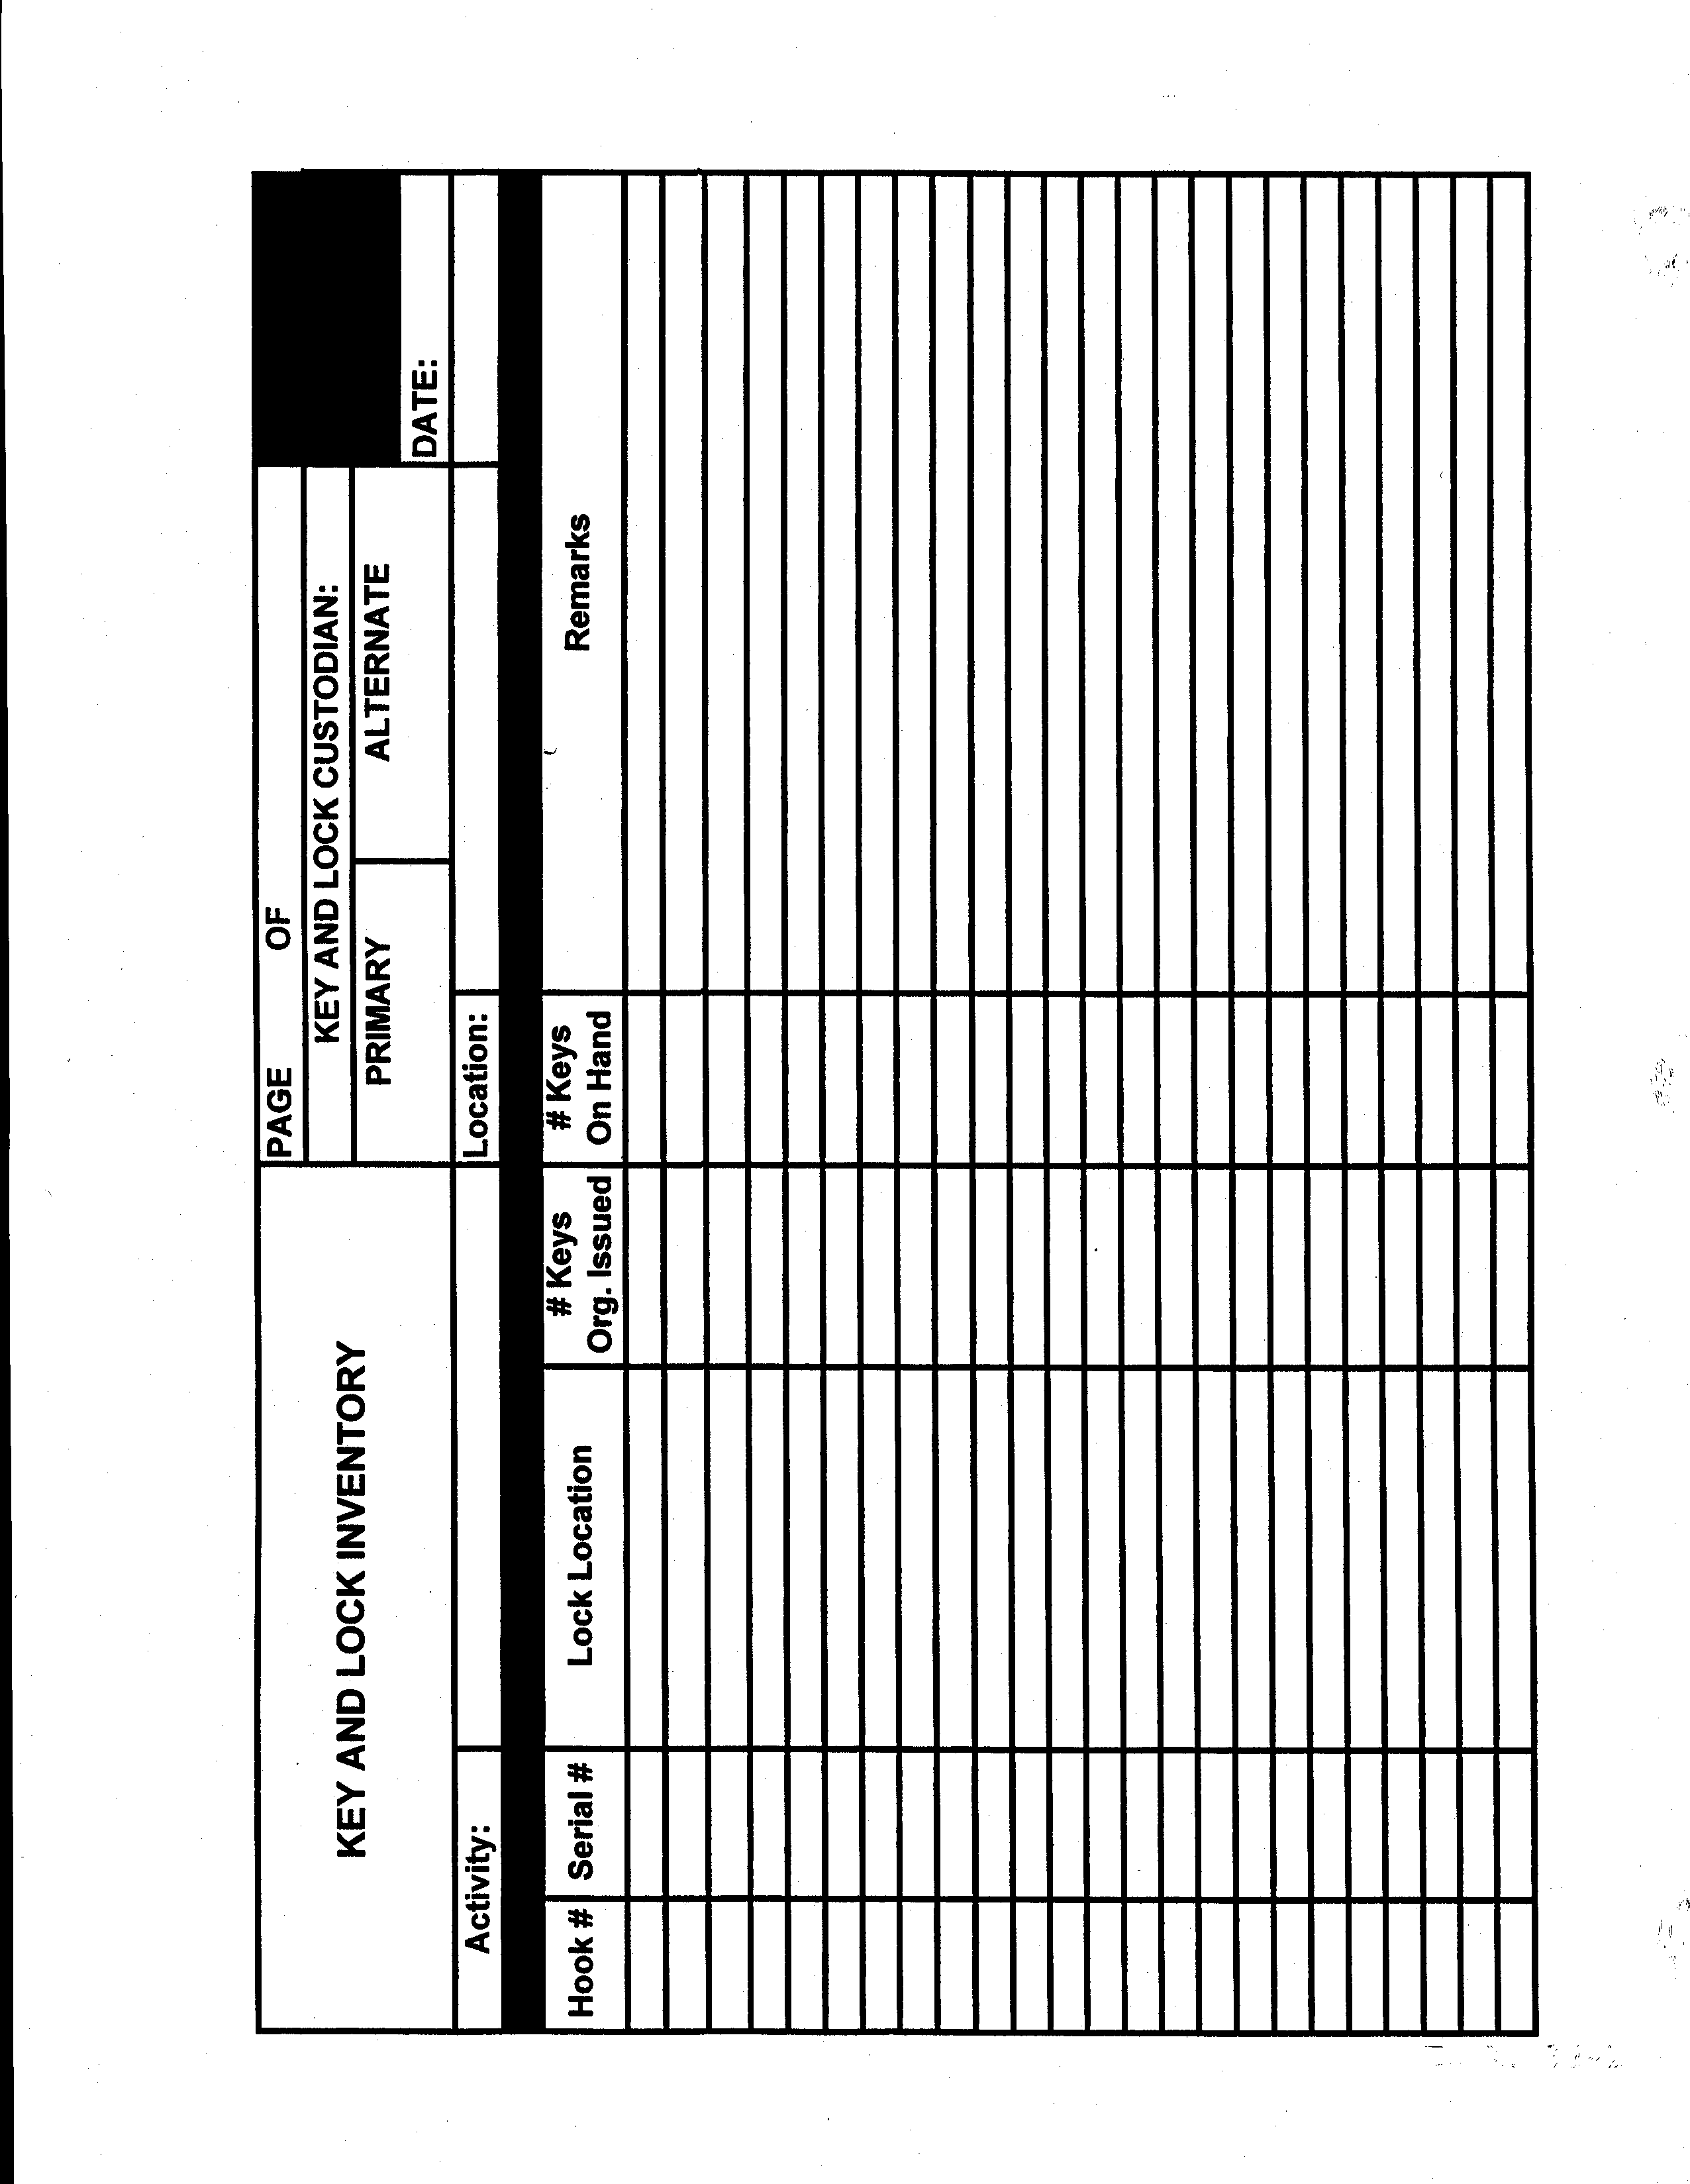
Encl 12-1
59

Encl 12-1
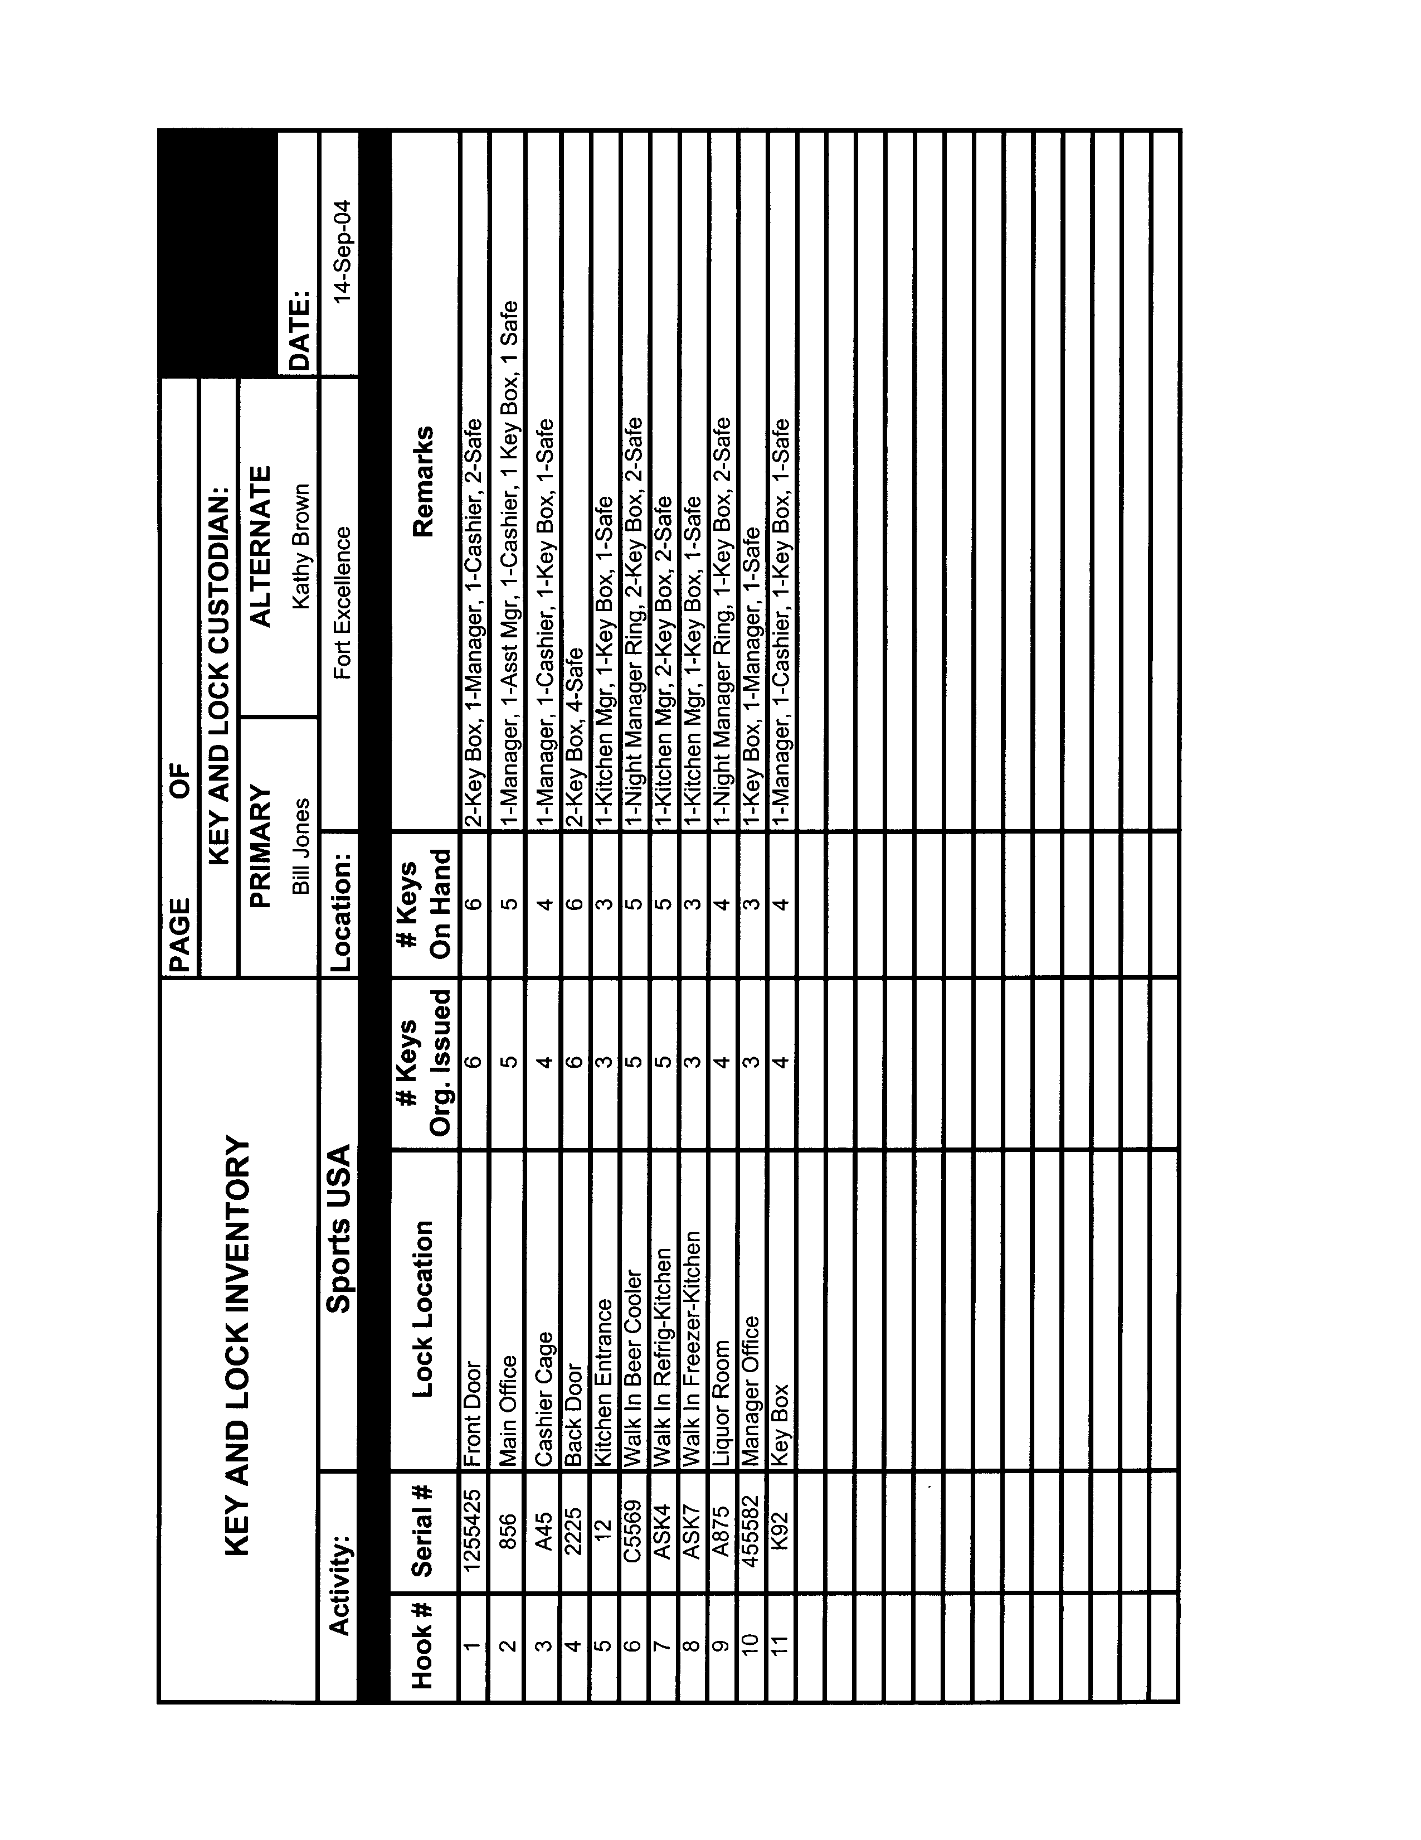

Encl 12-2

Encl 12-3
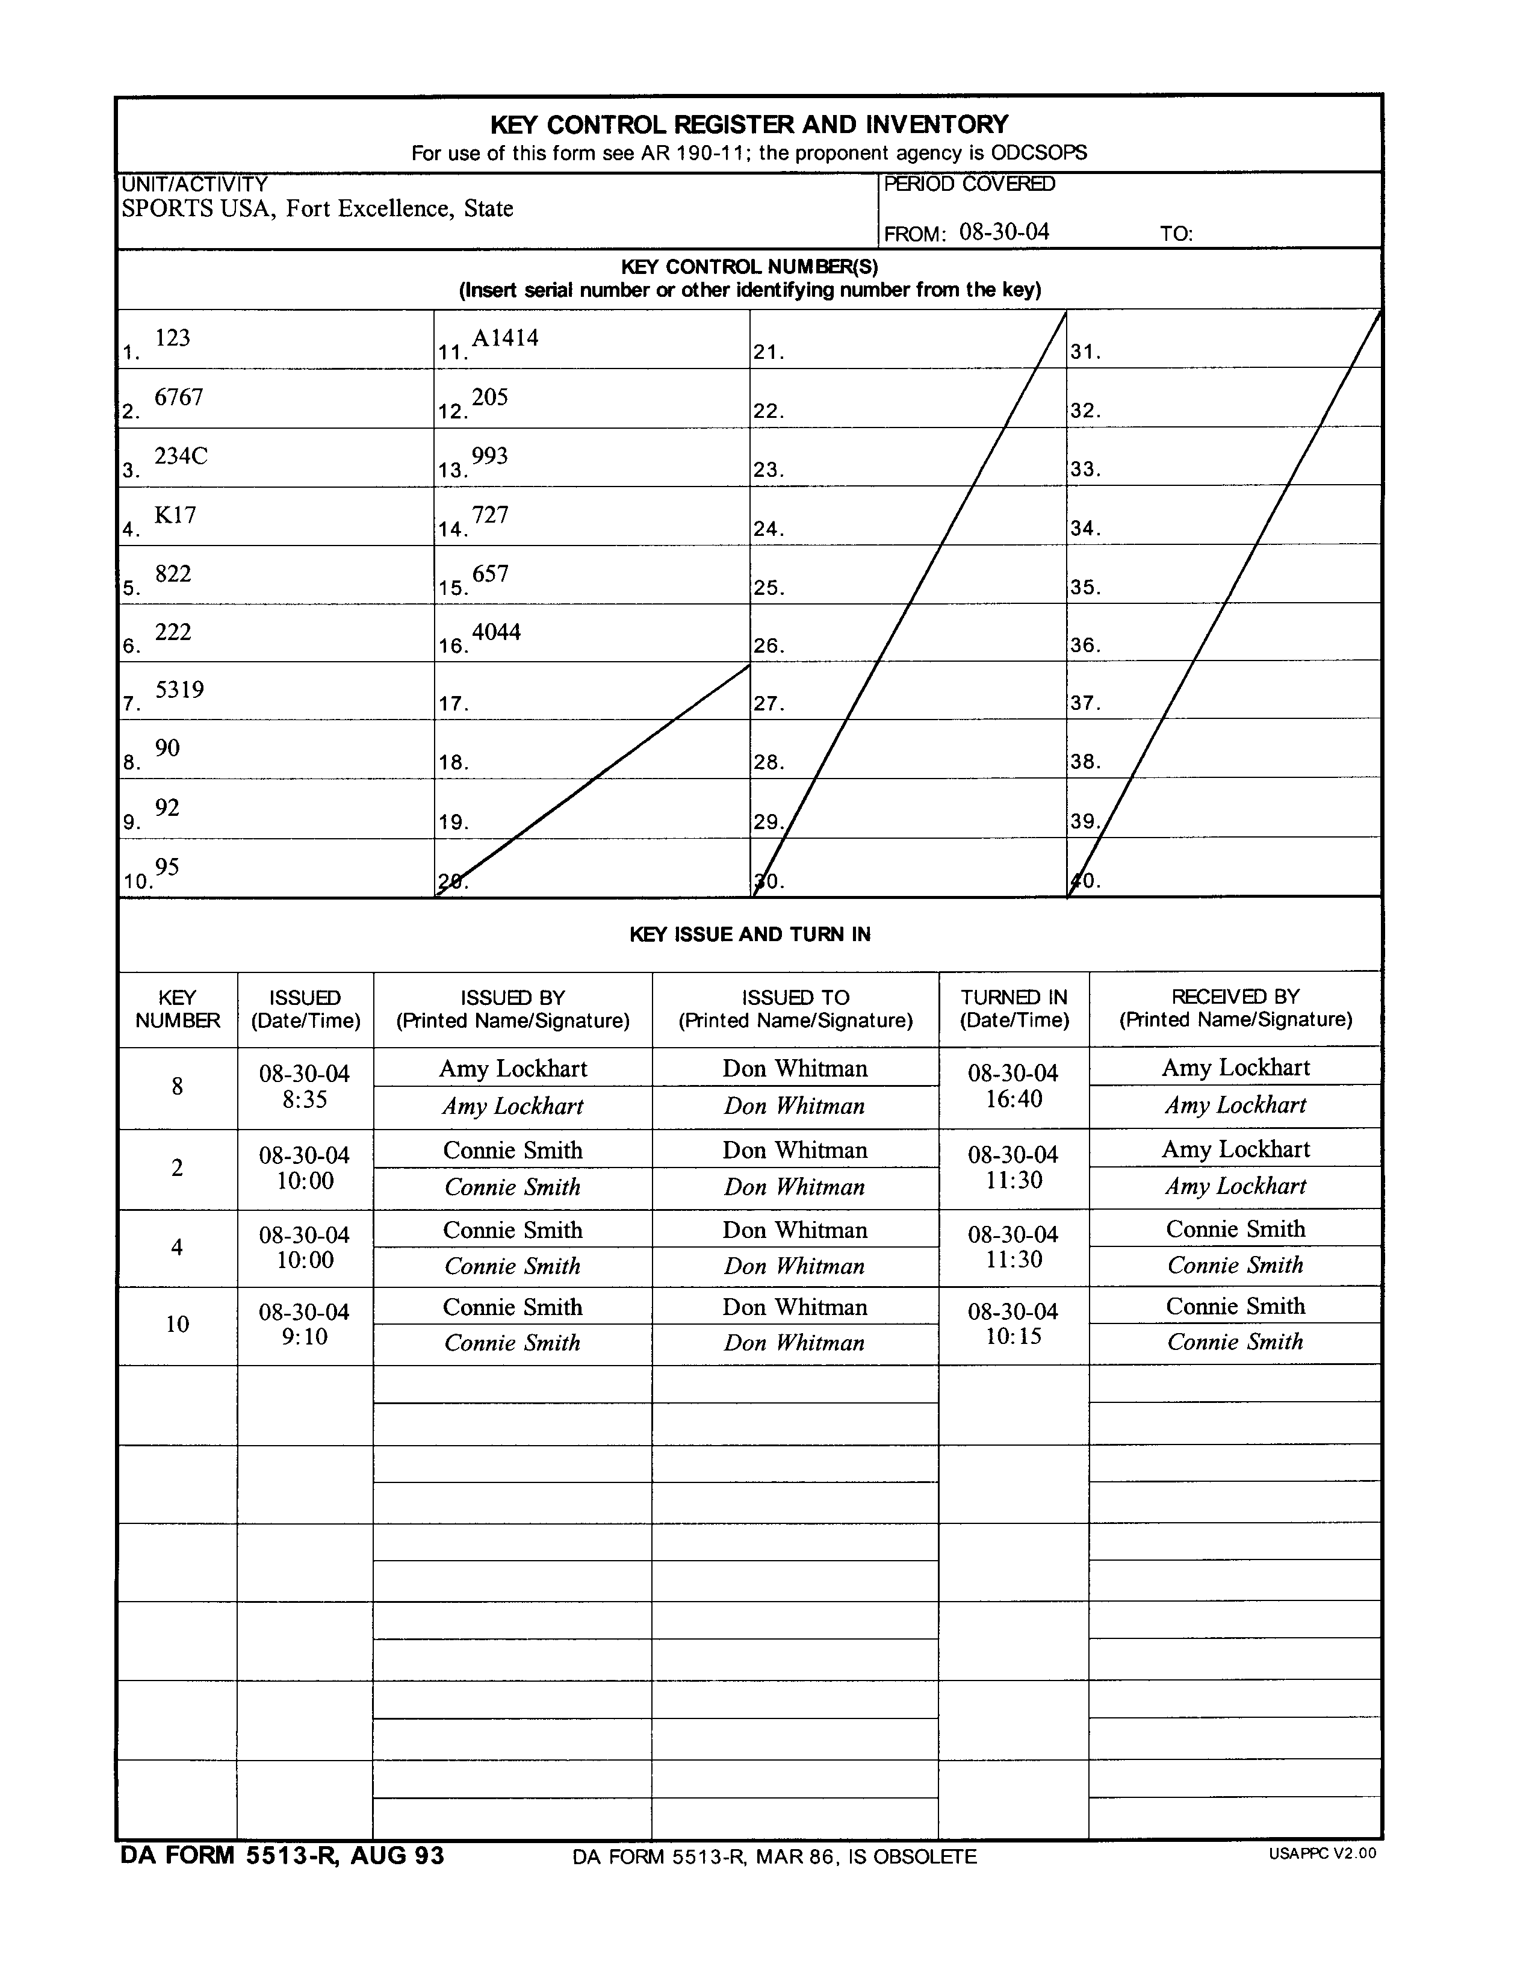

Encl 12-4
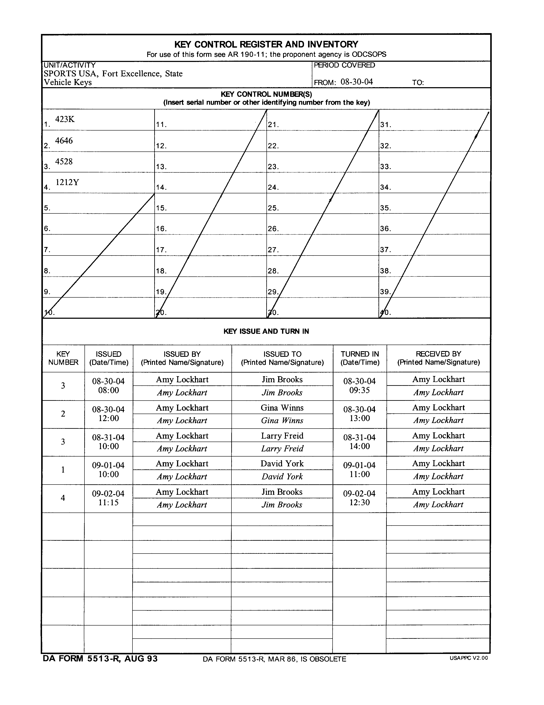

Encl 12-5
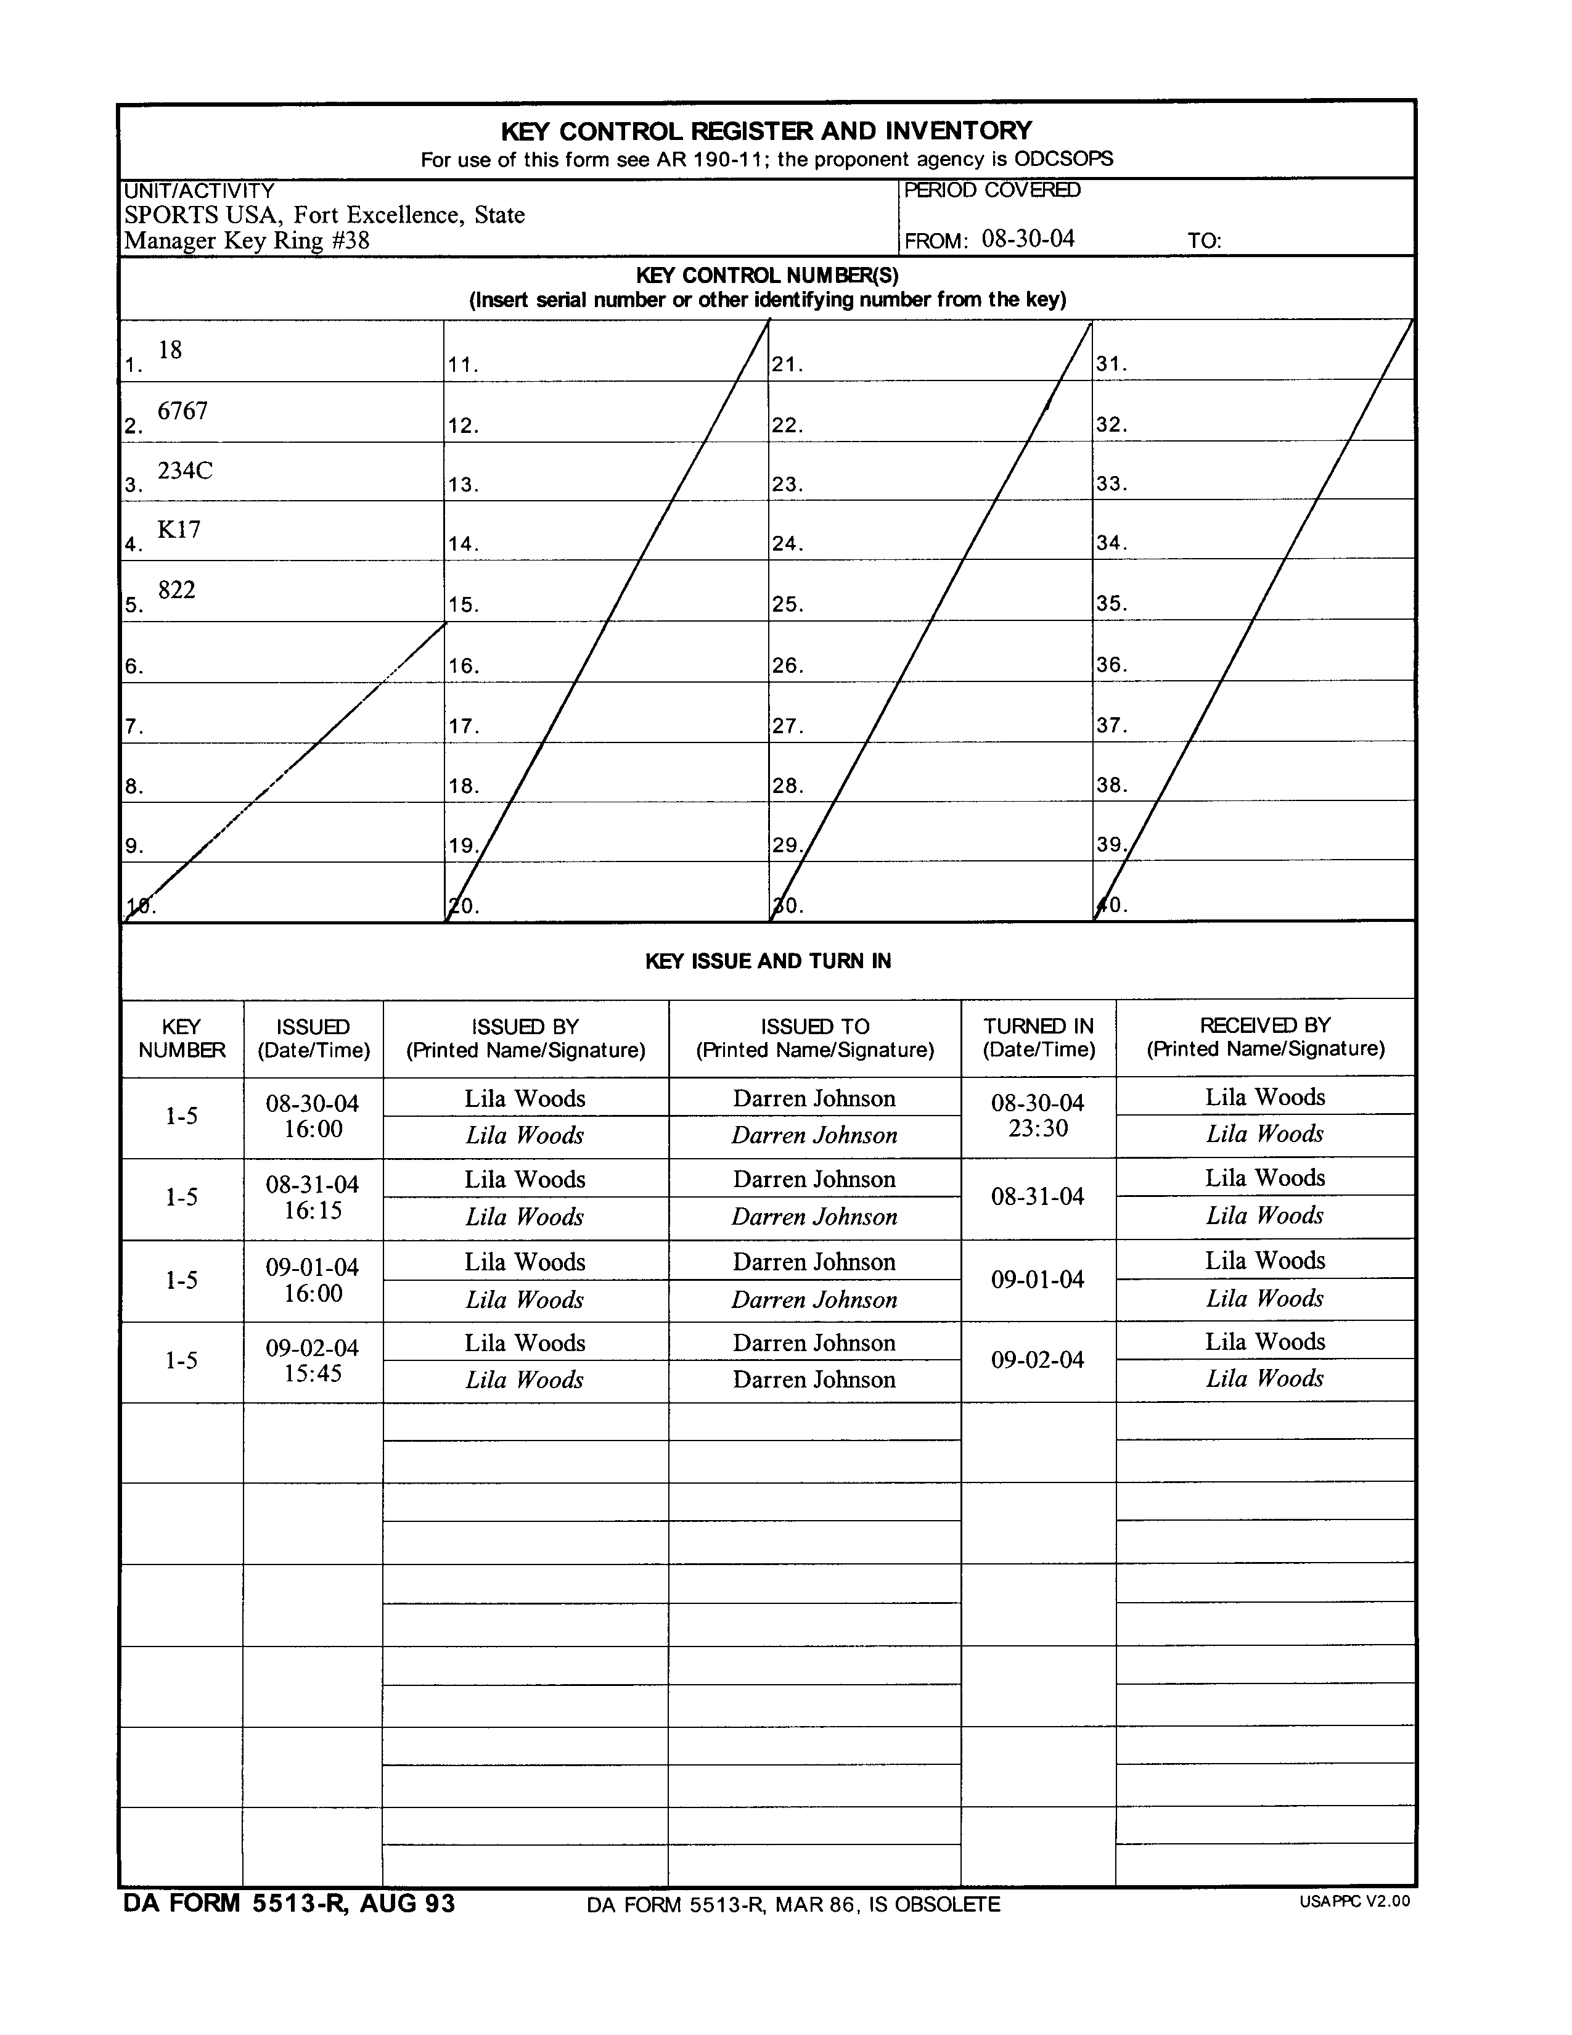

Encl 12-6
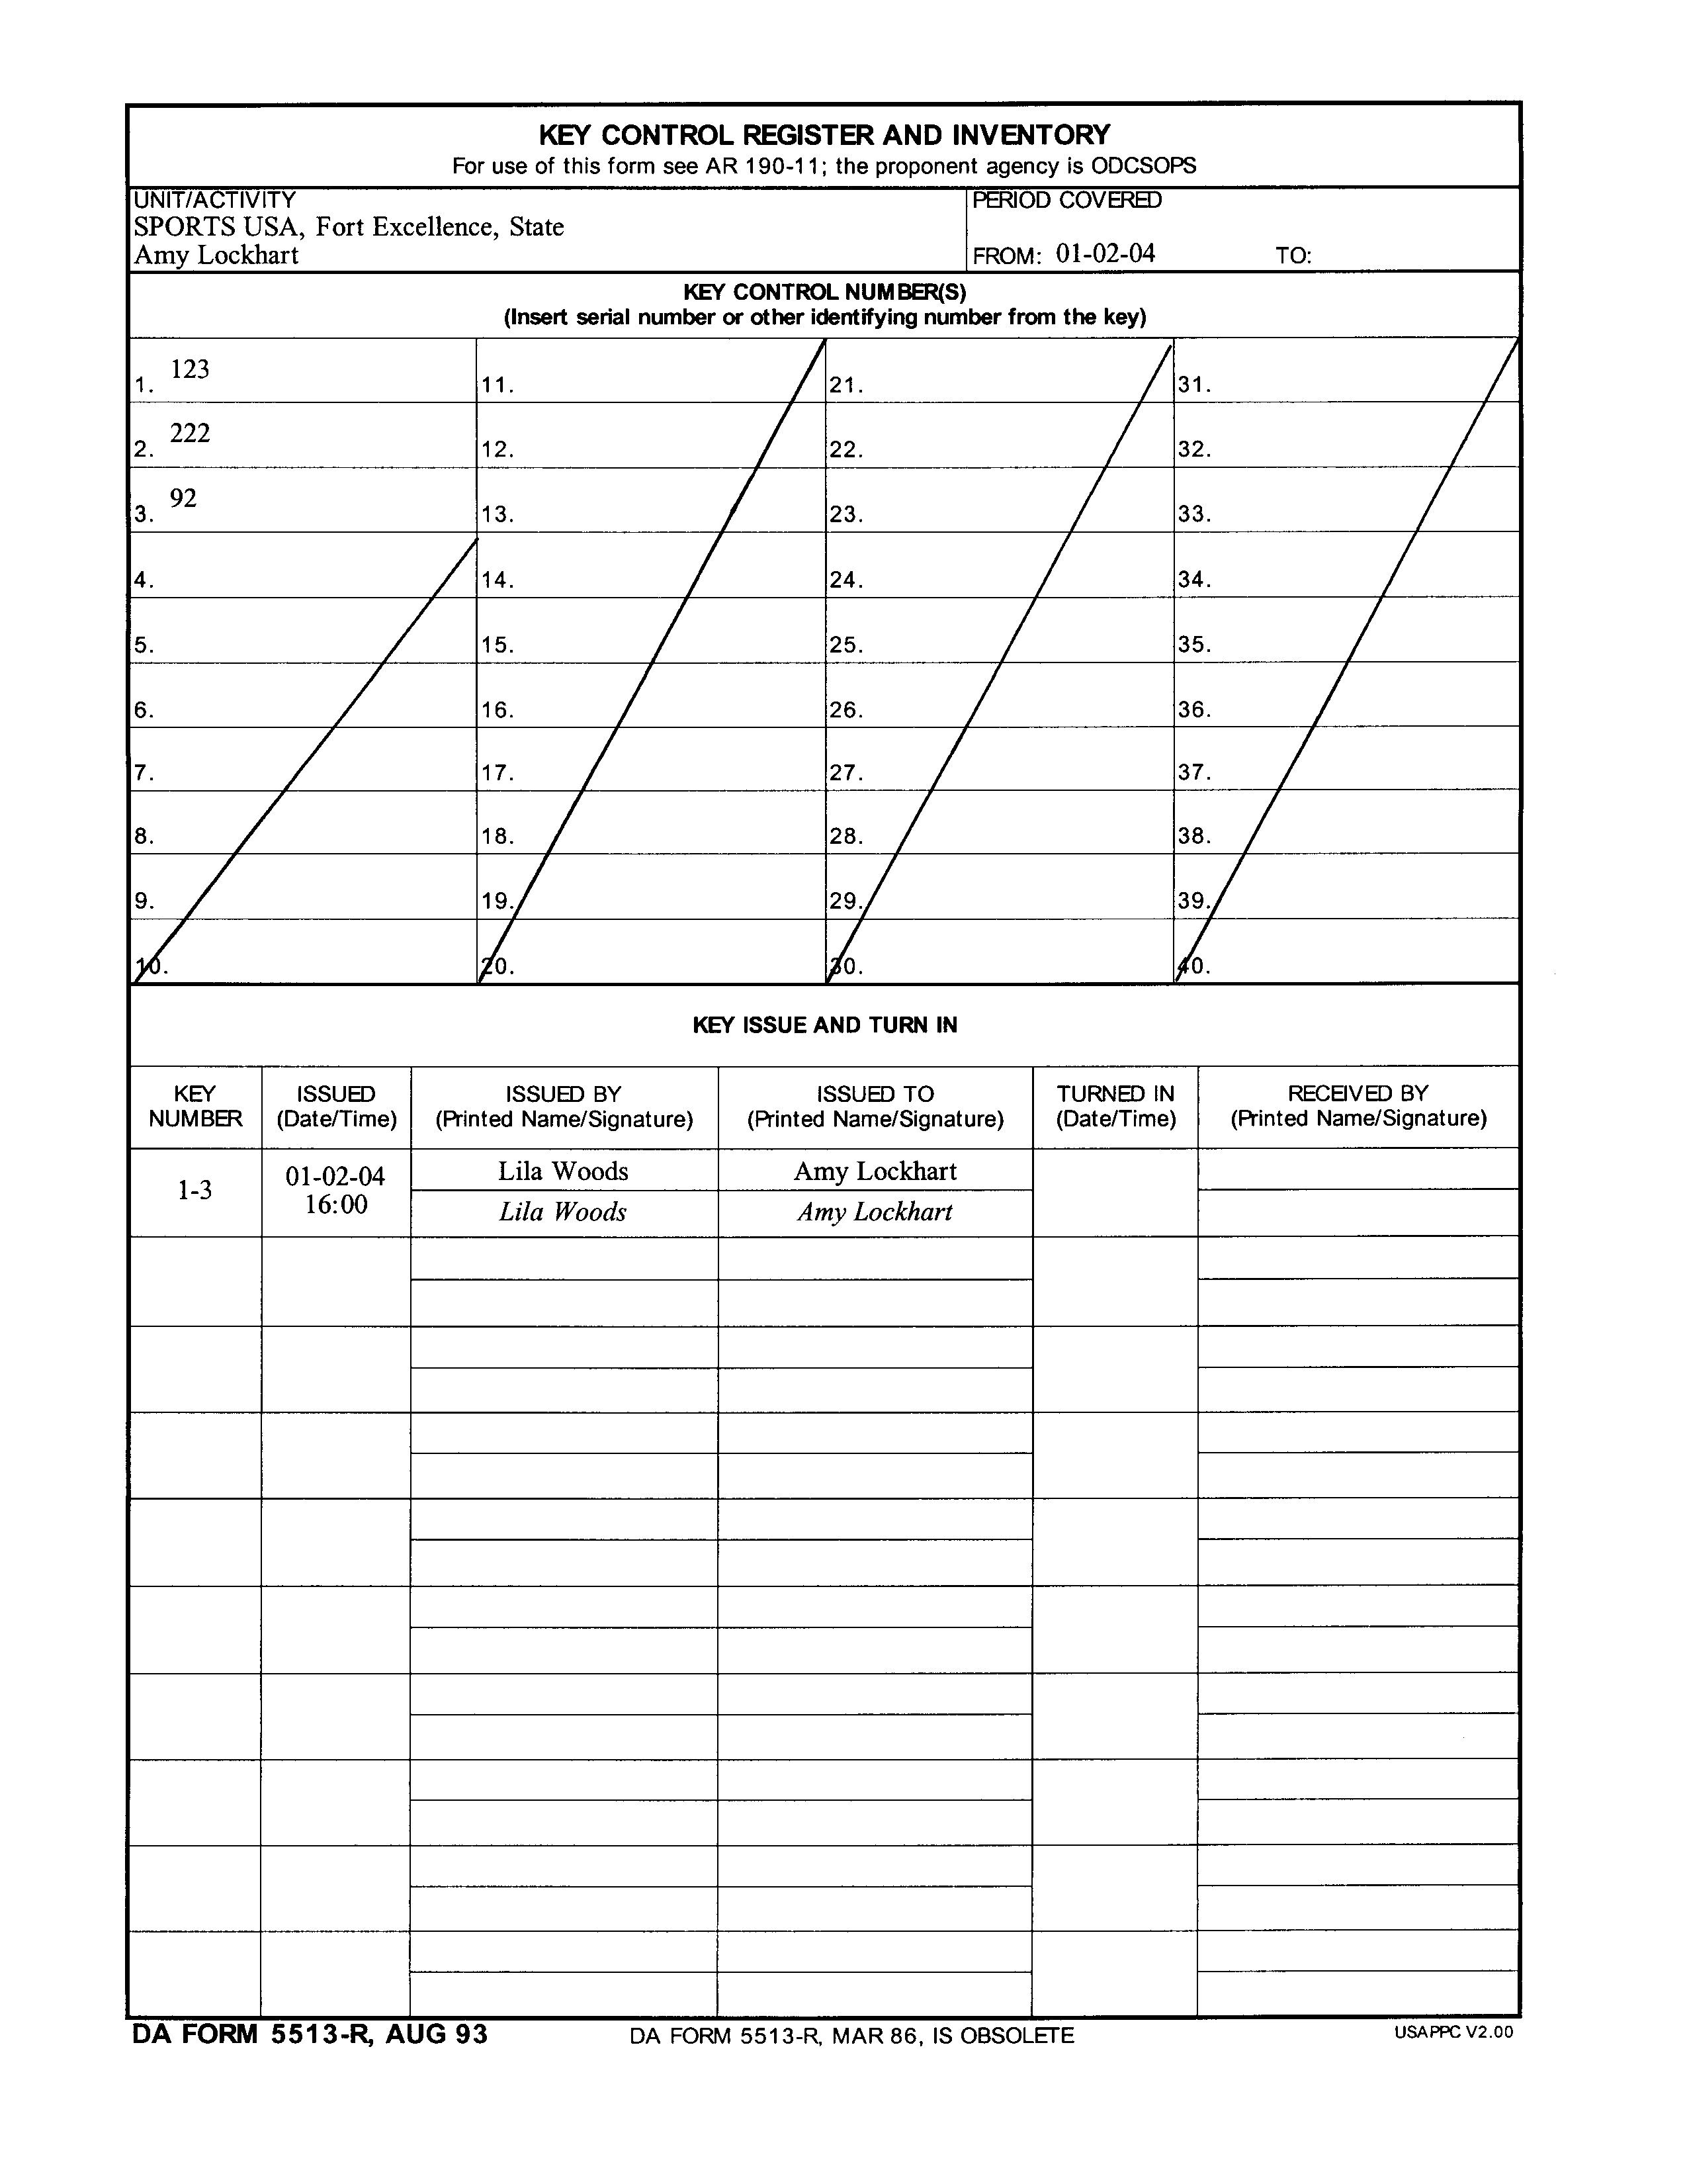

Encl 12-7
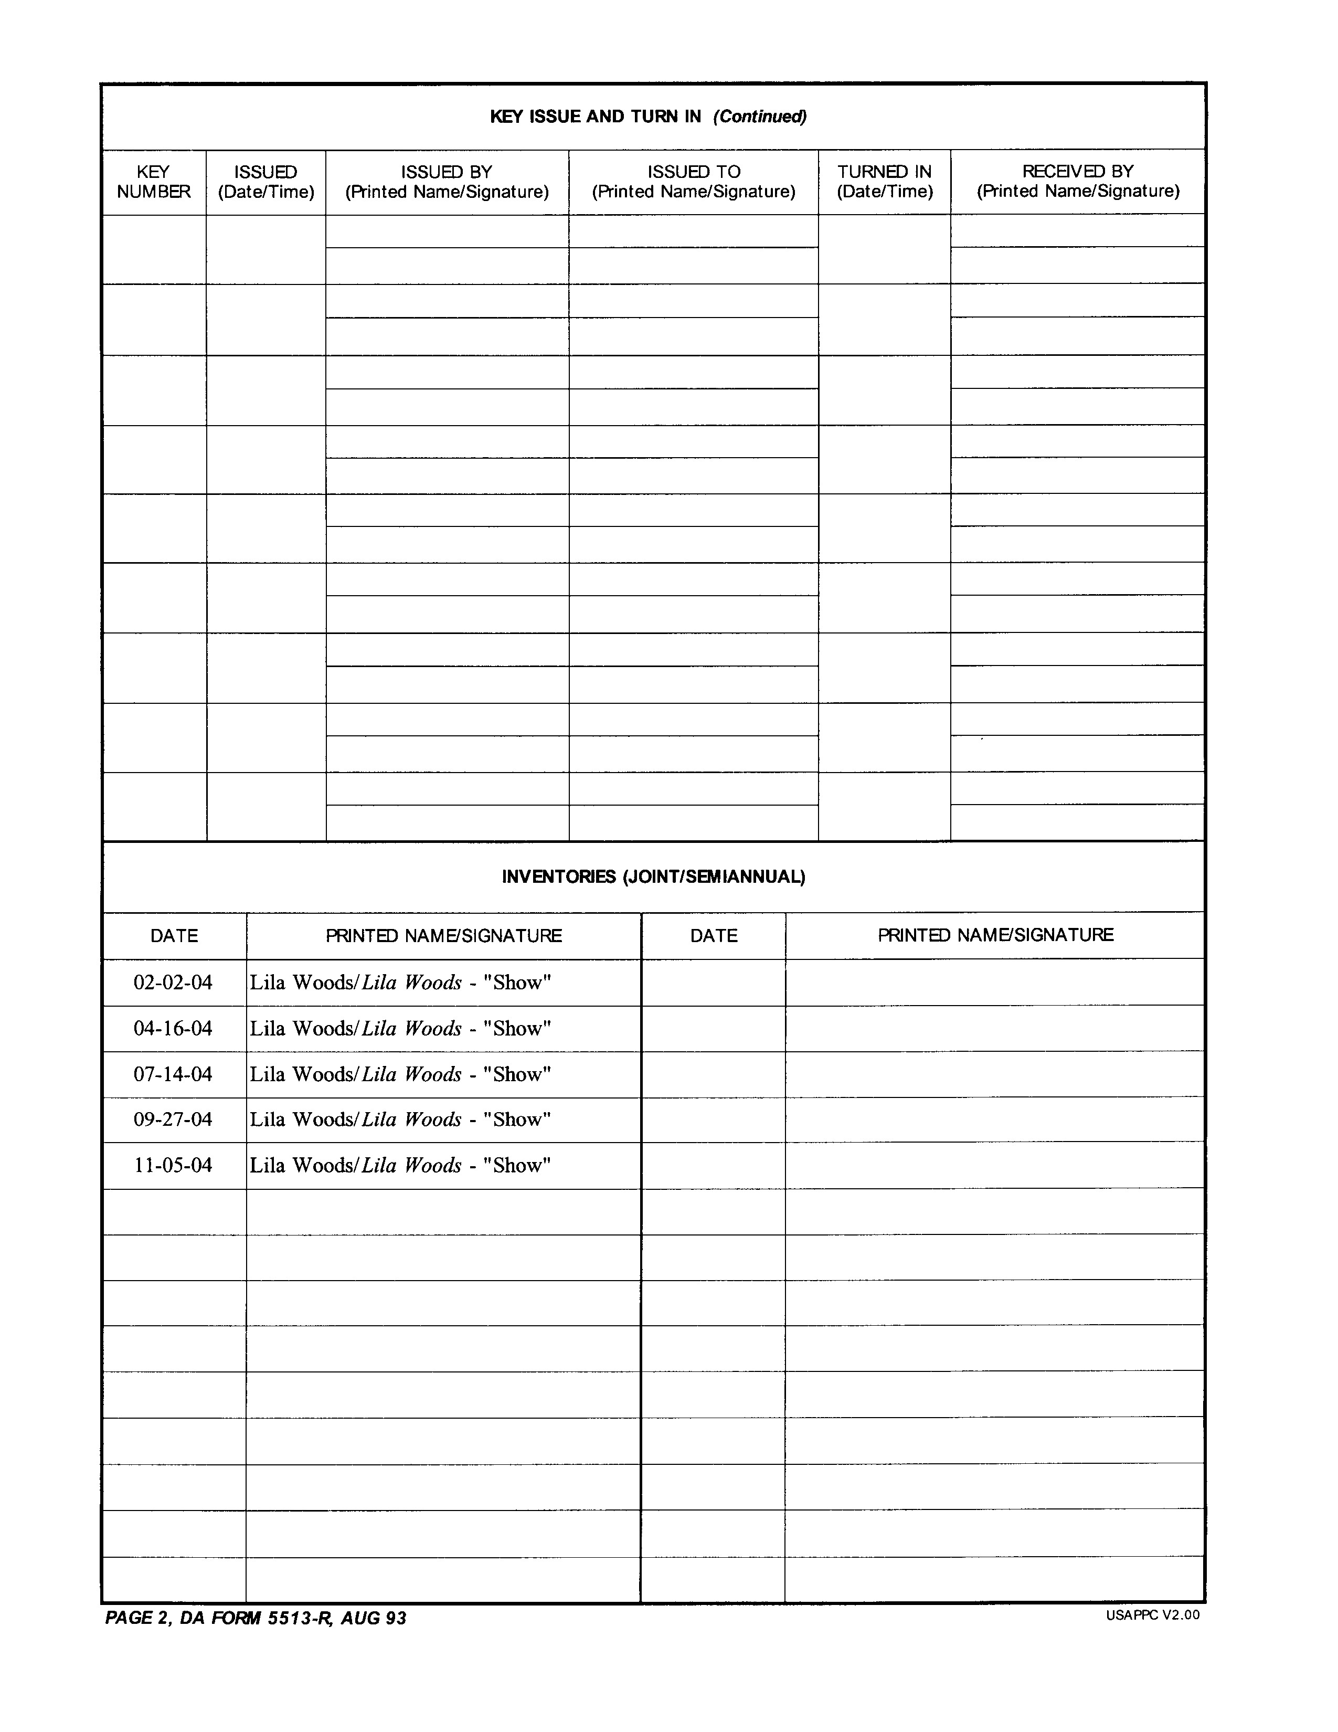

Encl 12-8

CHAPTER 13

The Operational Data Collection

and Flash Reports
The Operational Data Collection and Flash Reports

- Operational data is primarily non-financial in nature. Examples of operational data are; rounds of golf played, covers served, hours worked, and etc. This data, when combined with basic financial data, can provide very useful business measurements; such as revenue per man hour (productivity), Average Cover, Lines per Lane per Day, and Usage of Capacity percentage. Reviewing key measurements helps management assess the current status of operation and allow managers to take a corrective action for an unfavorable variance or result.

- The Operational Data Collection and Flash Reporting Web-site is available to accept data entered on a daily basis. The program store, performs calculation, and print pre-determined reports based on user defined specifications.

- Data collection and reporting website is built at the same login as www.businessplan.armymwr.com (BPDW). After logging in the user is given the option of entering the BPDW, the Data Collection website, or Flash Report. The Data collection is accept manually entered activity level data on a daily basis, and the Flash Report is able to print out different type of reports as you desired.

- Managers need to designate one person who enters the data daily, or each operation manager or supervisor require to input data at the end of his/her shift. Based on the operational situation, the manager needs to establish standard procedure.

- Daily Input Page (Enclosure 13-1) and sample report format (Enclosure 13-2) are shown.

Encl 13-1

Encl 13-2
Chapter 14

PETTY CASH

PETTY CASH

REFERENCE: AR 215-1, Appendix G
DFAS-IN Regulation 37-1

- Petty cash funds are used to pay for items, services, or incidental expenses where payment by check or credit card is not feasible. This fund is not to be used to circumvent normal procurement procedures.

- The fund administrator establishes petty cash funds and the amount designated for each activity in writing.

- The amount of the petty cash fund will not exceed one month’s requirements.

- Any one transaction will not exceed $500 or a lower amount if so directed by the fund administrator. Petty cash transactions will not be split to avoid the limitation set on the fund.

- If cash is given as bingo prizes, use a separate petty cash fund.

- Petty cash will not be used to cash checks, pay salaries or wages, travel payments, or travel advances.

- DA Form 1994 (Petty Cash Voucher) will be used to validate each petty cash transaction (Encl. 14-1, 14-2). They will be numbered sequentially and controlled by maintaining a record showing to whom they were issued.

- Disbursing Petty Cash Funds:

- The person receiving monies from the petty cash fund to make a purchase must sign a temporary receipt for the cash. DA Form 4082 (Daily Cashier’s Record) is recommended. The top portion of the form is filled out to include: activity, date, dollar amount and signature of individual receiving the cash. When the transaction is complete, the receipt of purchase and remaining cash is reconciled with the DA Form 4082. If there are no discrepancies, the DA Form 4082 may be destroyed. A similar type form is acceptable but DO NOT use the DA Form 1994 (Petty Cash Voucher) to sign out funds.

- Use a pre-numbered DA Form 1994 (Petty Cash Voucher) for disbursements from petty cash funds when the transaction is completed.

- Use a separate voucher for each disbursement from the fund.

- Fill out the DA Form 1994 in ink.

- The following blocks should be filled out accordingly (Encl. 14-2):

  - The “Activity” is the location submitting the petty cash voucher.
  - The “Pay To” line is for the activity to which the payment was made (i.e., Home Depot, AAFES PX, Commissary, etc.).
  - The “Receipt of Above Amount is Acknowledged” is signed by the individual making the purchase. This is necessary to determine who actually bought the items listed on the receipt in case there are questions pertaining to the purchase.
  - The “Approved By” signature block is completed by an authorized individual, usually the activity manager or in some cases the COD/BOD.

- Use supporting documentation such as invoices, freight bills, receipts as supplements to the voucher, not in place of the voucher.

- Paid vouchers and supporting documents are clearly marked “PAID”, dated and initialed by the person making the distribution.

- Attach supporting data to the DA Form 1994 when vouchers are turned in for reimbursement.

- DA Form 1994’s are controlled by maintaining a log showing to whom they were issued to, where they were used and the dollar amount spent. Copies of completed DA Form 1994’s kept on file are also acceptable.

- Account for all voucher serial numbers when replenishing petty cash.

- Original DA Form 1994’s (Petty Cash Voucher), including all voided forms, will be accounted for and submitted to NAF Financial Services (NFS) when seeking reimbursement. The MWR Fund Administrator or designated representative will approve replenishment of petty cash funds prior to NFS preparing a check for replenishment.

- DA Form 1993 (Nonappropriated Fund Petty Cash Summary Voucher) will be used to summarize the DA Form 1994’s and serve as a cover voucher when seeking reimbursement from NFS. The DA Form 1993 is an envelope form and the applicable DA Form 1994’s and supporting documents will be enclosed in the DA Form 1993.

- When needed, requests to reimburse the petty cash fund are sent to NFS from the NAFI. At a minimum, a request to reimburse petty cash must be sent as of the last day of each month. NFS issues a check payable to the Fund Custodian by name to reimburse the petty cash fund and the vouchers are charged to the appropriate expense accounts.

- Managers or their representatives will make unannounced counts of petty cash funds at least quarterly.

- At least annually, a complete analysis of all petty cash funds of a NAFI will be conducted by the garrison FM. Recommendations for increasing, decreasing, dissolving, or continuing each fund authorized will be made and sent to the Region MWR Office. Things to be considered include use or non-use, number of times per month reimbursed and questionable practices of the agent.

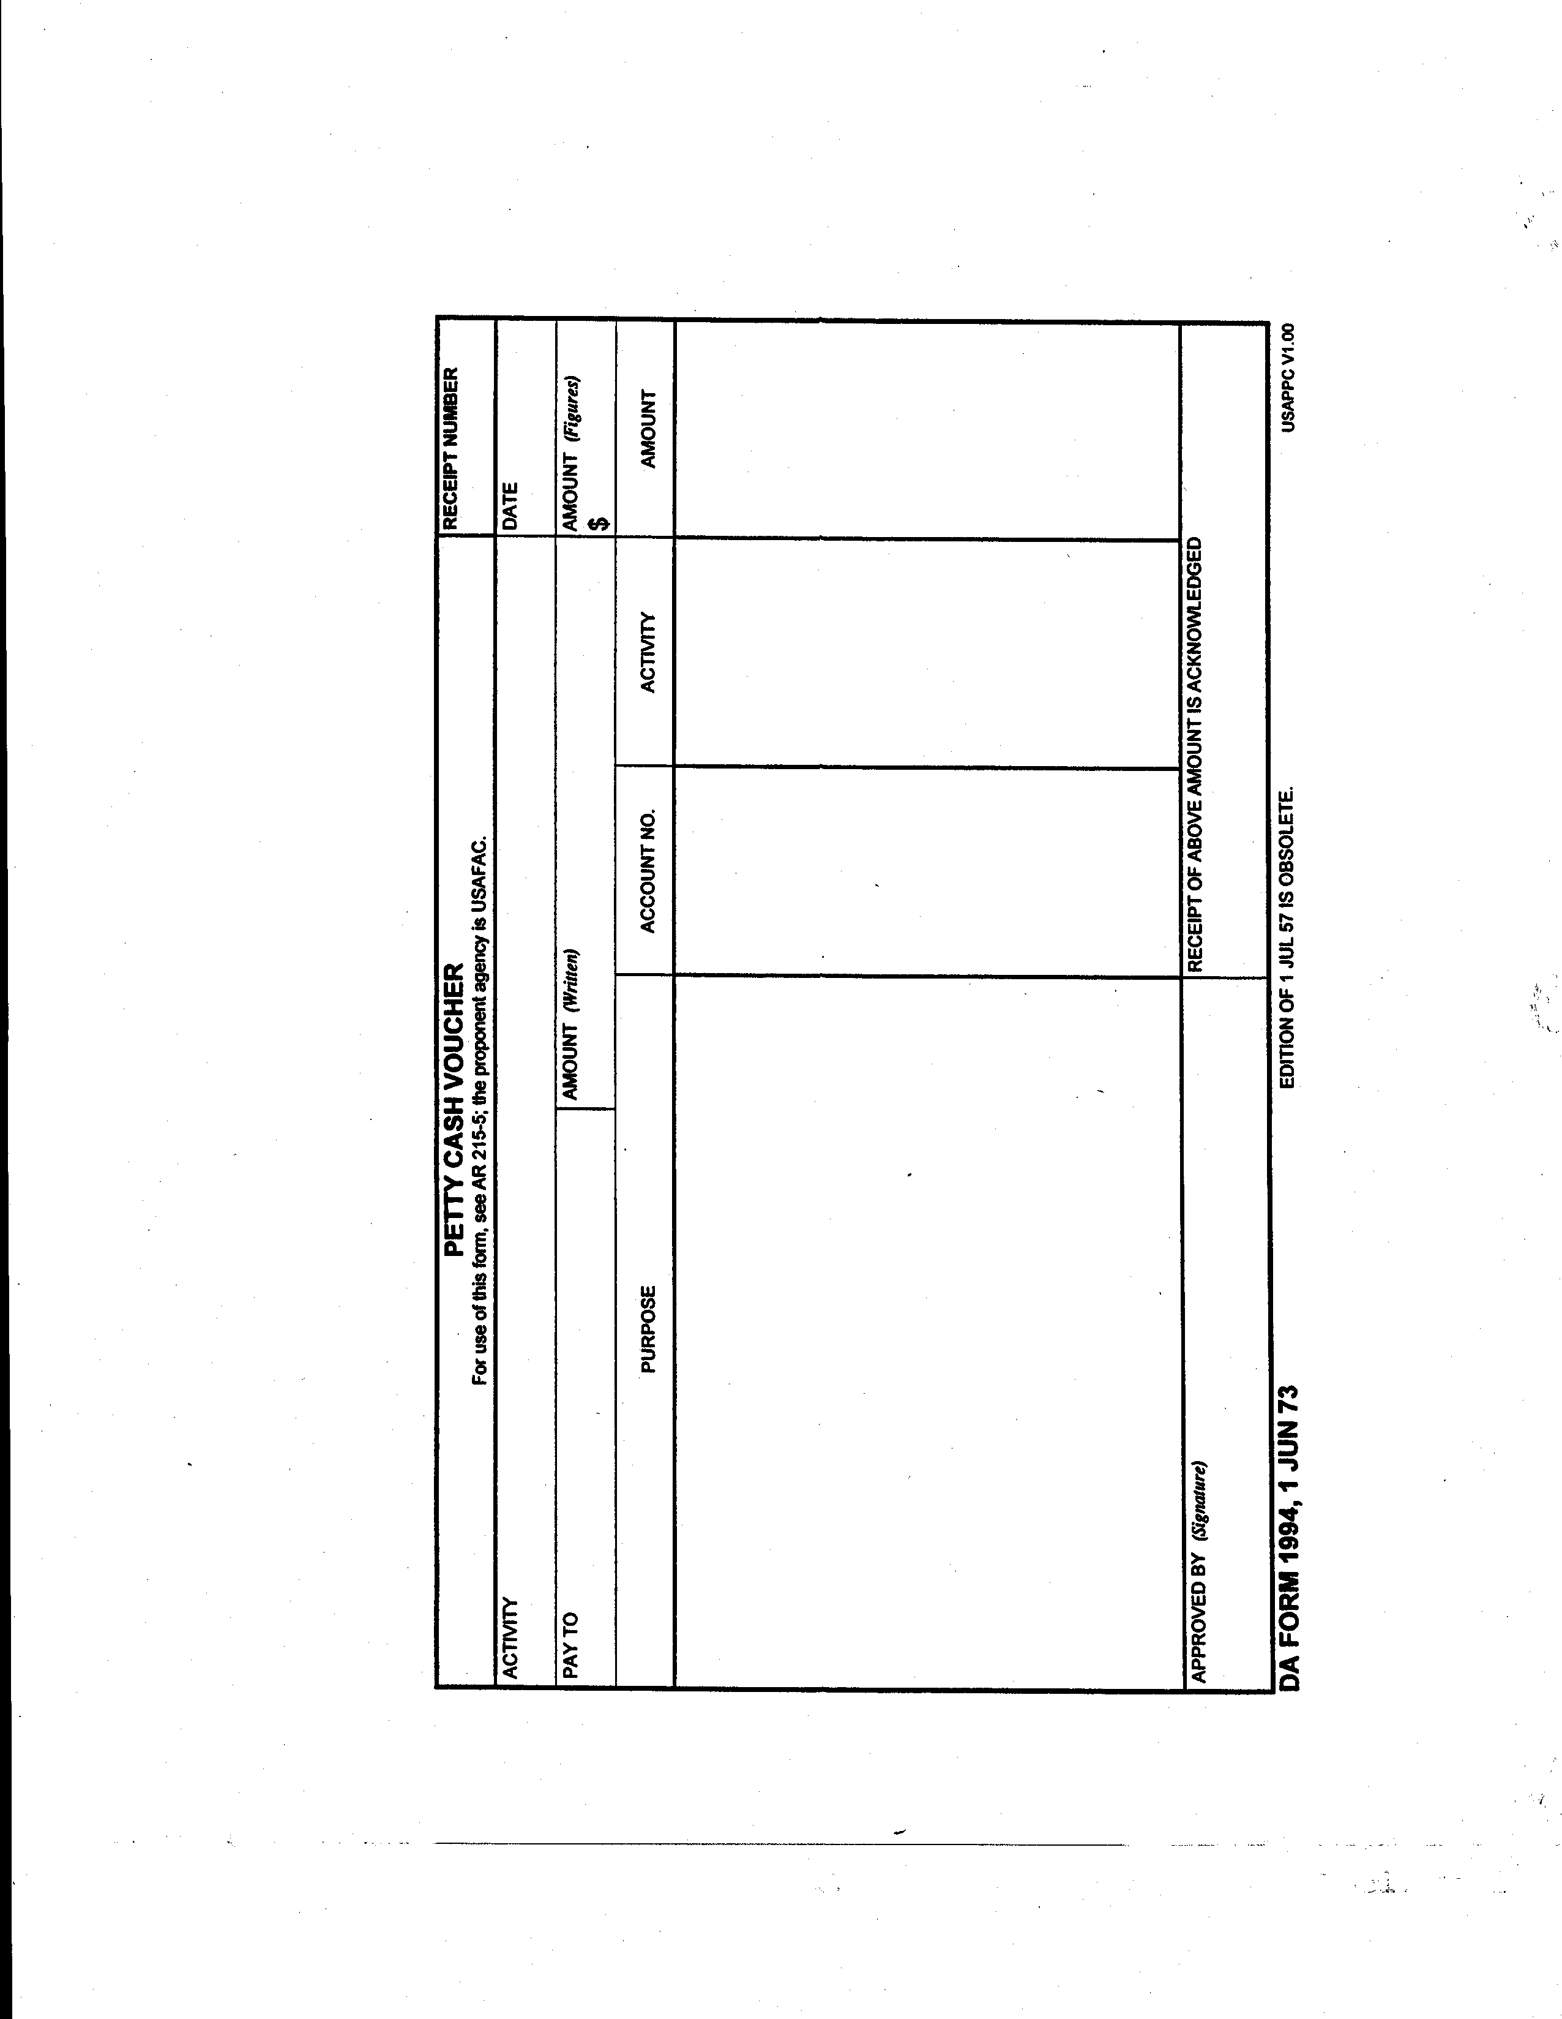

Encl 14-1
74
Encl

Encl 14-1

Encl 14-2
Chapter 15

Quick Shot Bonanza Bingo
(24# Bingo)


QUICK SHOT BONANZA BINGO

REFERENCE: AR 215-1 Chapter 8 (Section 8-12) (Sep 2010)
DFAS-IN Regulation 37-1, Chapter 32

1. Quick Shot Bonanza Bingo is similar to instant win games, but it is played much like regular bingo. The numbers are called and verified prior to each session. Quick Shot Bonanza Bingo is played with folded bingo cards printed on special paper, perforated along the edges and sealed at the top. Only 24 numbers are called prior to each session and there be 12 different winning patterns, each with a prize assigned to it. All bingo cards are sequentially numbered within a series of 9,000 and are available in several different colors.

2. Who can play?

- Authorized patrons: all military members (regardless of rank), installation civilian personnel and their families 18 years of age and older.

- Bona fide guests 18 years of age and older.

- Employees working in a MWR activity may participate in bingo sponsored by an unrelated activity, if they are otherwise eligible.

3. Who cannot play?

- MWR managers.

- The DMWR (or equivalent)

- All employees of the sponsoring activity and their immediate family members.

- Volunteers serving as callers or monitors at the sponsoring activity.

- Commanders may impose additional local restrictions as considered appropriate.

4. How the game is played:

- Determine the length of your session: daily, weekly, or monthly. Daily sessions add more excitement with new numbers being posted each day, while monthly sessions may become stale for the players. Weekly sessions are the most common.

- Before the regular session starts, post 24 numbers, the first five numbers called for each of the letters “B”, “I”, “G”, and “O” and the first four numbers for the letter “N”. The numbers are verified by the Bingo Manager and a disinterested party (customer) and annotated on a Bingo Verification Sheet with signatures from both parties (Encl. 15-1).

- Once the numbers are verified, the next session of Quick Shot Bonanza Bingo session can commence. The numbers are posted on a bingo board and/or flyer with the pattern/prize schedule for the bingo player to easily see and use (Encl. 15-2).

- Begin the next session of Quick Shot Bonanza Bingo.

- Quick Shot Bonanza Bingo cards may be purchased and redeemed each day during normal operating hours. All card sales are final.

- Employees will sell Quick Shot Bonanza Bingo cards in numerical order, starting from the beginning serial number.

- All cards must be date stamped at the time of sale.

- The player, with a Dauber, ink pen or similar item, MUST permanently mark Quick Shot Bonanza Bingo cards. No bingo chips may be used to mark the Quick Shot Bonanza Bingo cards.

- No player can use the same number to make more than one pattern on a card. If multiple patterns can be made without using the same number, it is a multiple winning card and should be awarded the appropriate prize for each winning pattern.

- When a player has a winning pattern, he or she can cash it in for the prize, once the card has been verified.

- Players have seven (7) calendar days from the day a card been date stamped to collect their prize.

5. Internal Controls:

- All Quick Shot Bonanza Bingo cards will be kept in a secure location and treated as if they were money.

- Management of each location with Quick Shot Bonanza Bingo will maintain a perpetual inventory of all cards received, all cards transferred out, all cards at point of sale (on DA Form 4082), and all cards sold (Encl. 15-3, 15-4).

- All cards sales are final. This is for the customer’s protection as well as the facility. The customer will count the cards before he/she leaves the point of sale. The facility is not responsible for discrepancies after the customer leaves the point of sale.

- Only personnel employed by the sponsoring activity may control and sell Quick Shot Bonanza Bingo.

- Bingo cards will be pre-numbered.

- Quick Shot Bonanza Bingo cards will be date stamped at the time of sale.

- At the start of the shift, the cashier will sign for the starting and ending number of the Quick Shot Bonanza Bingo cards and the total number thereof verifying that all cards in between are in place on DA Form 4082. At the end of the shift, management will review the numbers of the bingo cards. The difference between the starting number and the ending number is the total number of cards sold. This number should match the number of cards that were rung up on the cash register and the cash received (Encl. 15-5, 15-6).

- If multiple activities at the same installation are sponsoring Quick Shot Bonanza Bingo, different colors should be used by each activity to determine where it was purchased.

- Variances must be tracked by individual cashier; any variance must be explained in writing and employee counseling initiated. Documentation of variance explanation and employee counseling maintained in employee file.

6. Quick Shot Bonanza Bingo Winners:

- When a bingo card is turned in by the customer for a prize award, the card must be validated. Cards are not valid if any number is torn out or if the card is mutilated to the point where the numbers cannot be read.

- Bingo cards may only be awarded a prize payout at the activity in which it was purchased.

- Players have seven (7) calendar days from the day a card been date stamped to collect their prize. Winning tickets are no longer valid and cannot be redeemed after seven (7) days.

- If the above criteria are met, confirm that the right bingo numbers and prize sheet are being used to validate the numbers in the winning pattern on the given card. Facility personnel will verify the winning pattern.

- A prize sheet is filled out and signed by the winner (Encl. 15-7).

- Winning cards are attached to the daily paperwork and retained with the Daily Activity Report (DAR) by the facility for three years.

- Copies of winning cards will be made available upon request.

7. Central Region’s Strategies for Quick Shot Bonanza Bingo:

- The Region’s objective for Quick Shot Bonanza Bingo is 20% NIBD.

- Multiple patterns with prize schedules are provided with each case of Quick Shot Bonanza Bingo cards that are ordered. The Region’s recommendation is to utilize the program with a 20% return versus a 30-35% return. With higher and more frequent payouts, more cards will be sold and a higher overall bottom line can be achieved.

- Management must monitor their program at least monthly for average plays and for frequency of prize giveaways. Different bingo patterns may be substituted to renew the energy of the game or if the current prize patterns are being given away too frequently.

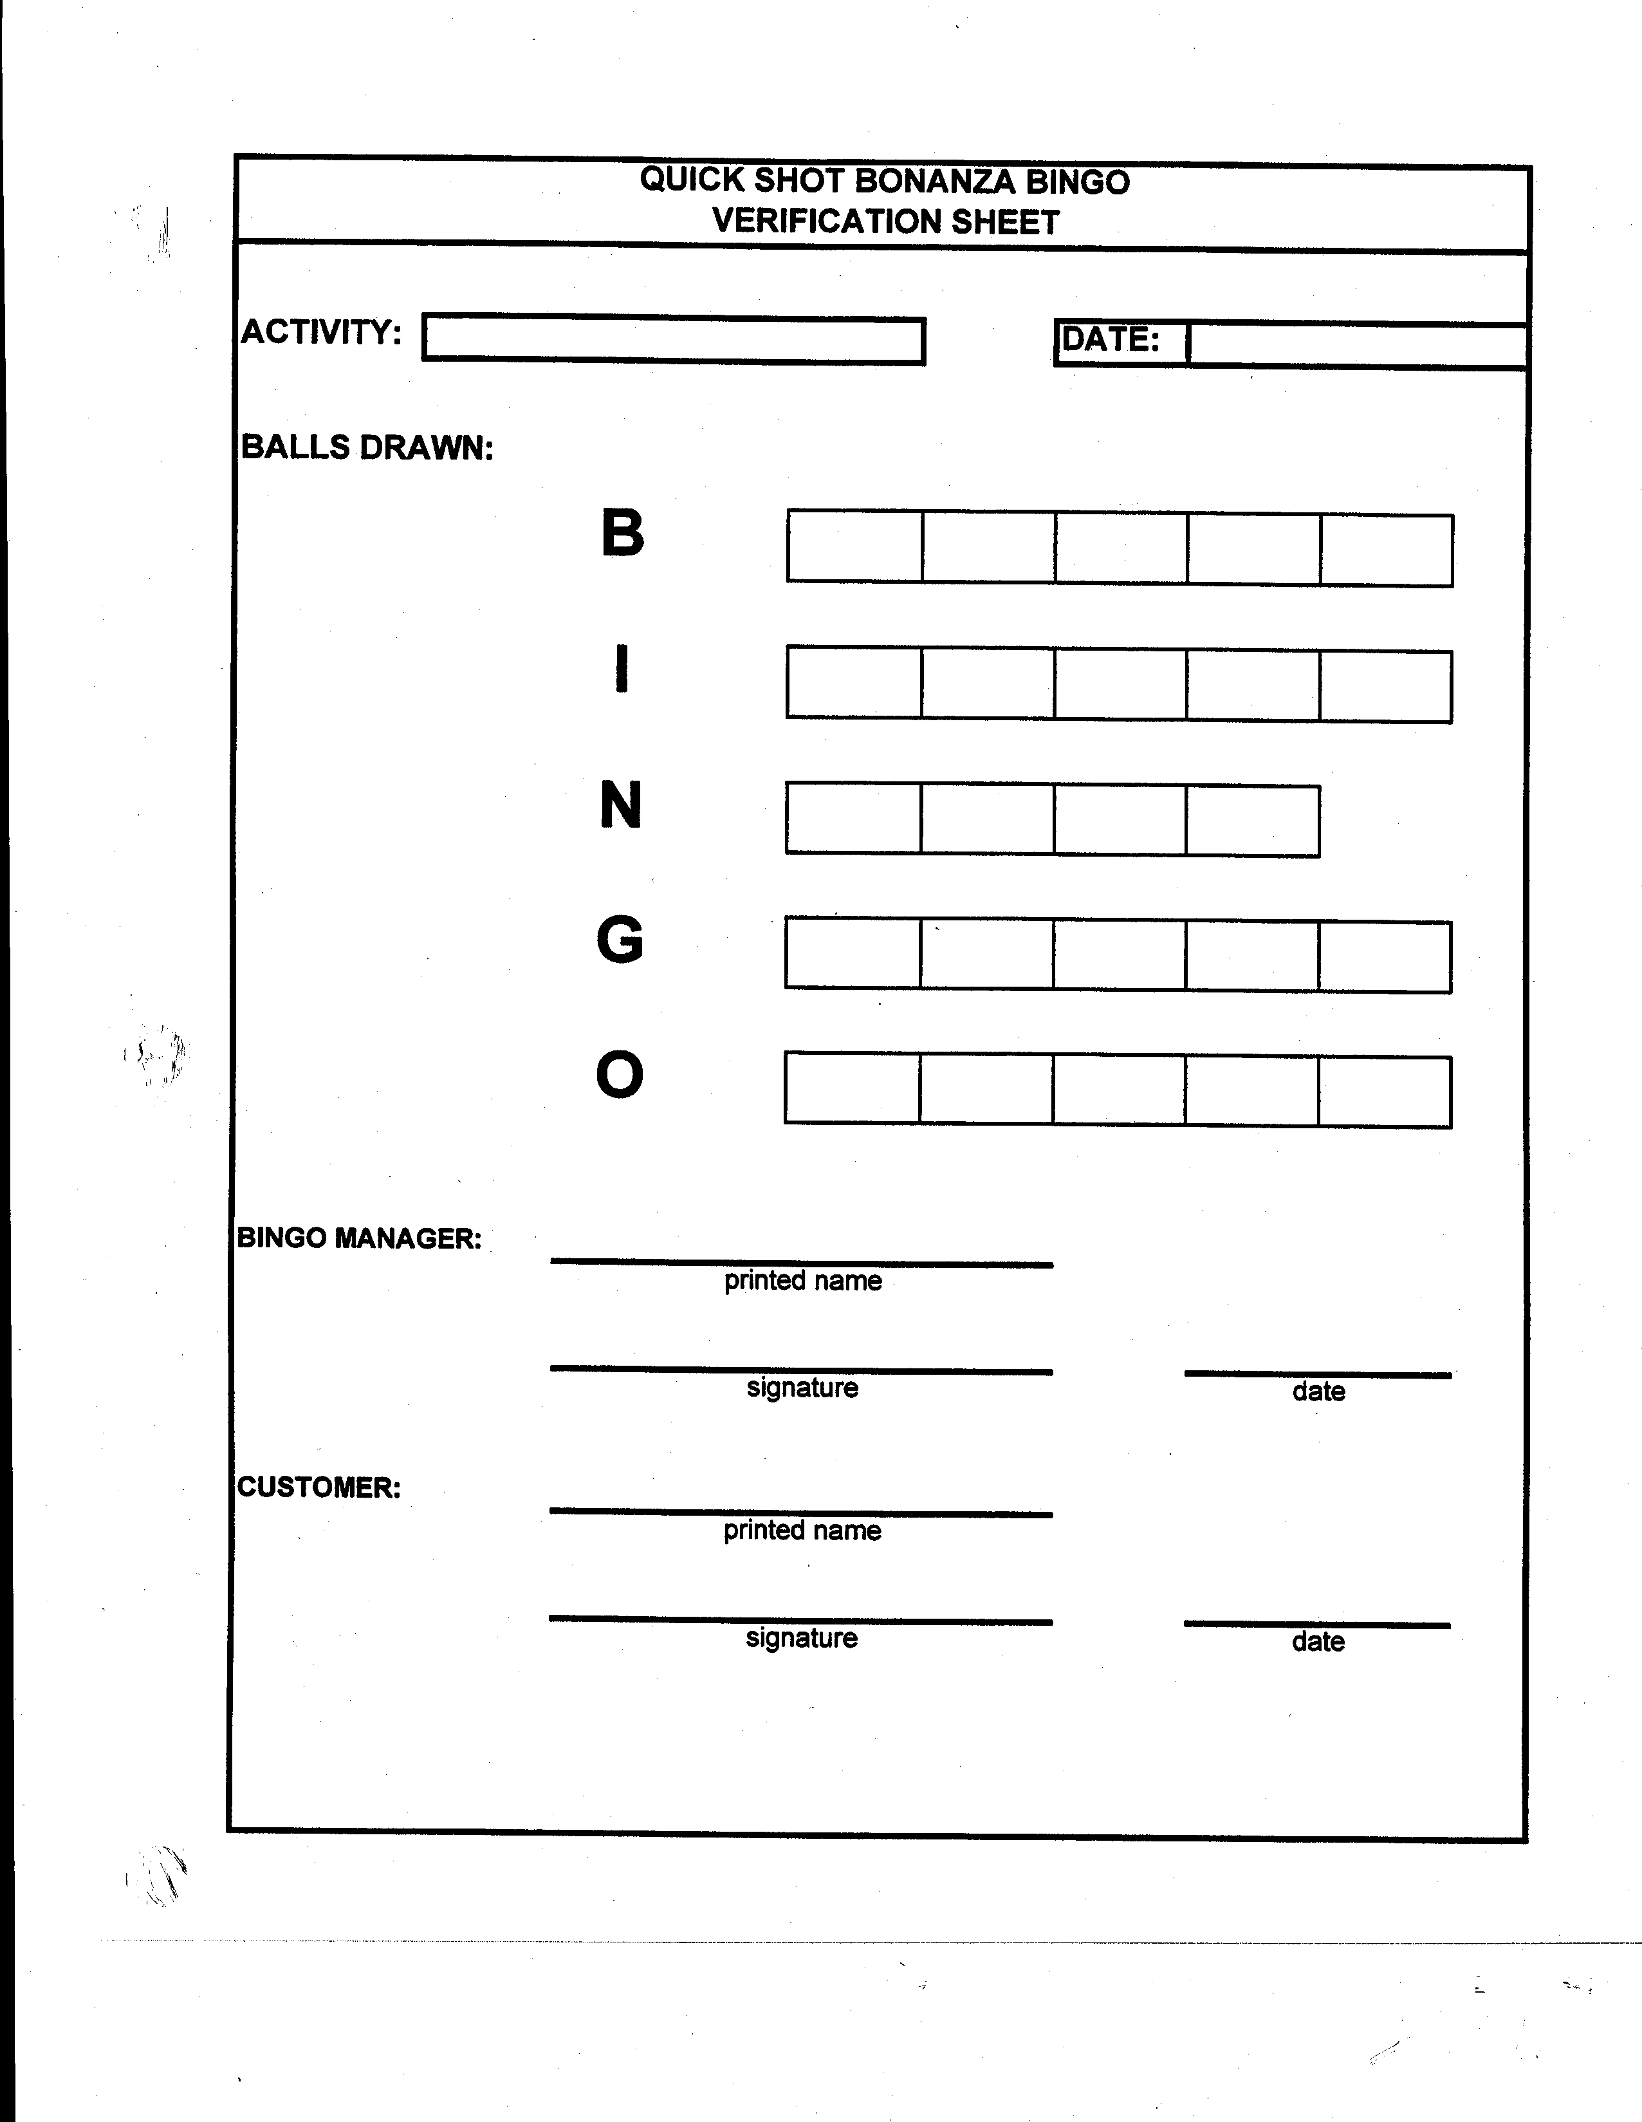

Encl 15-1

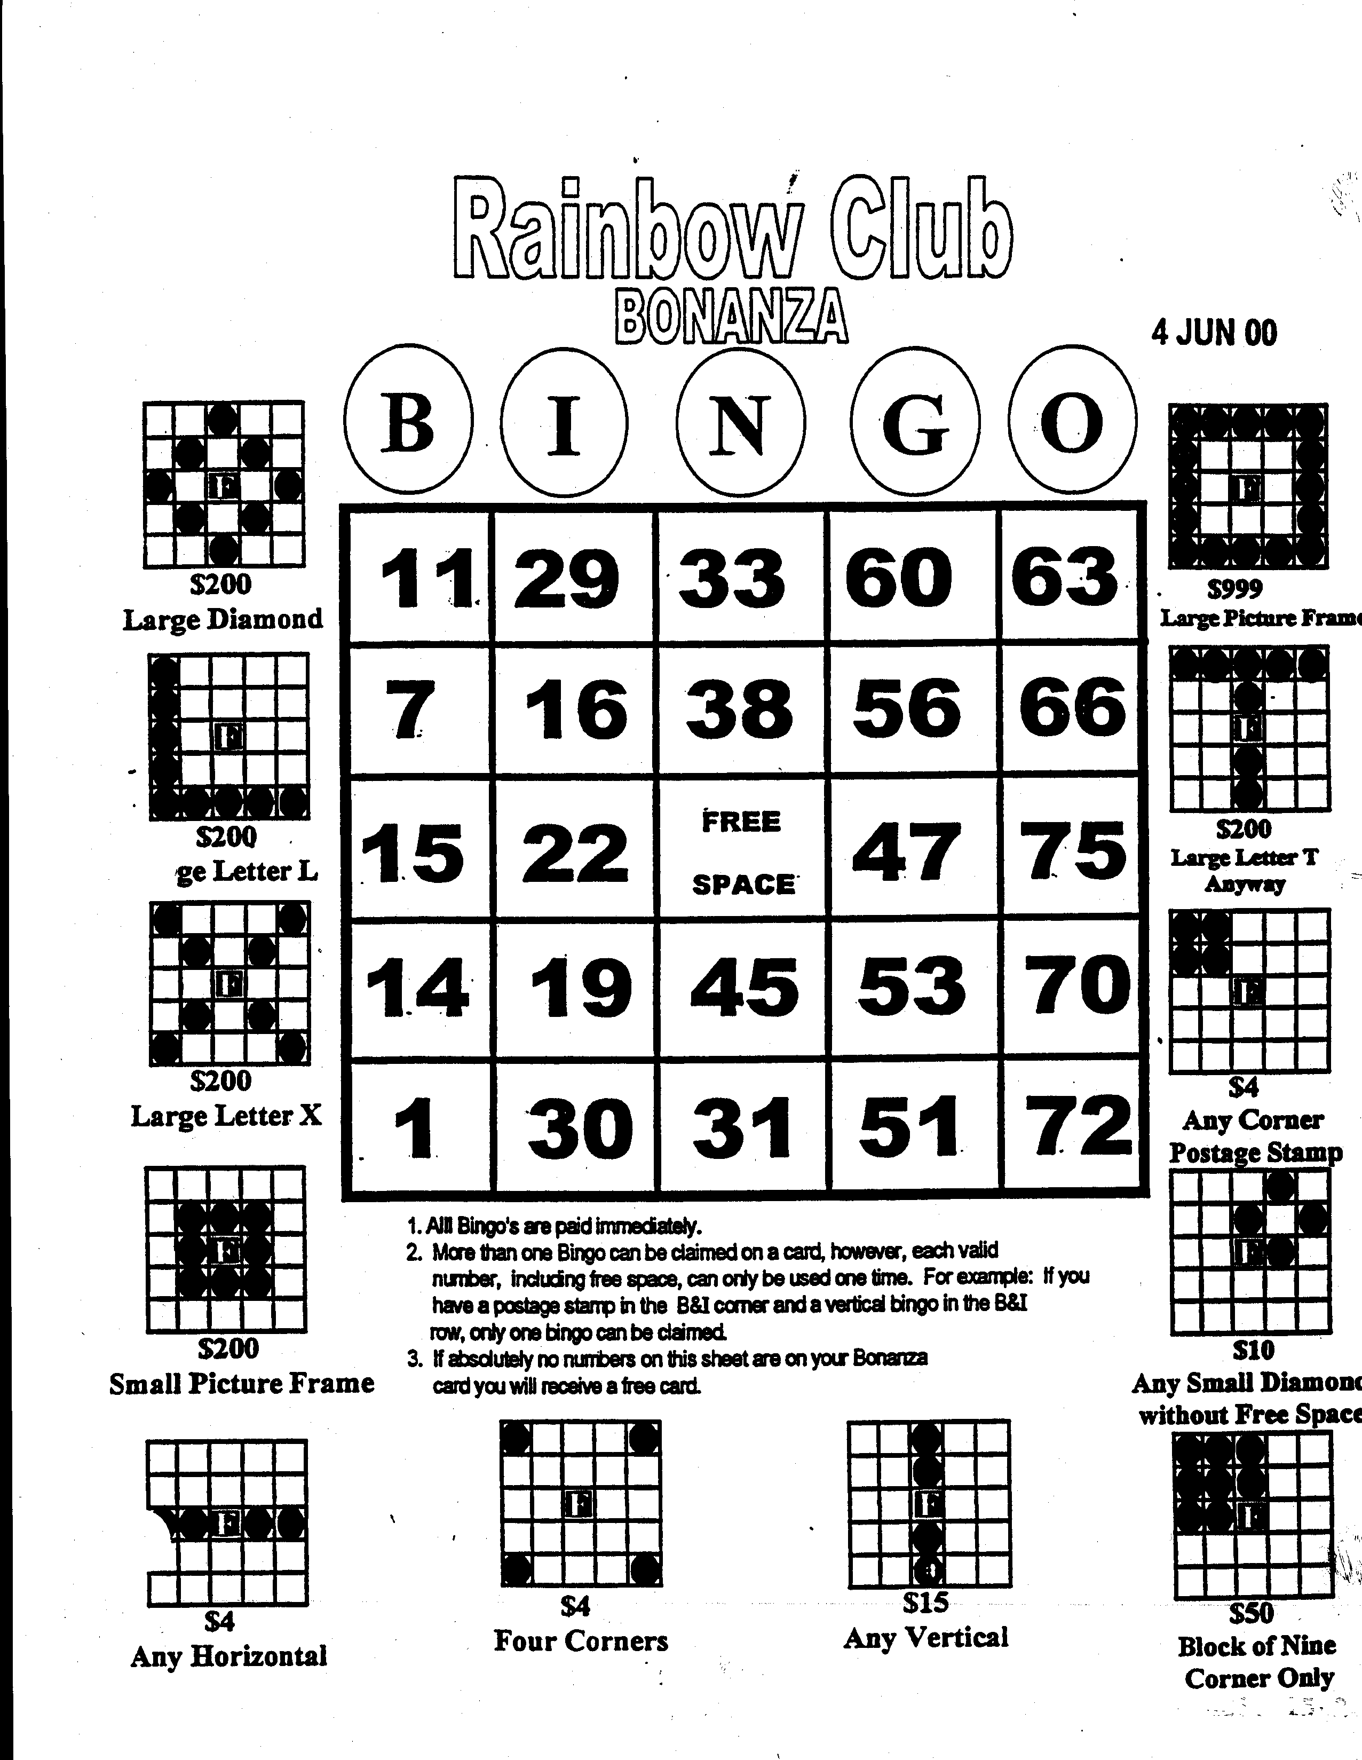

Encl 15-2
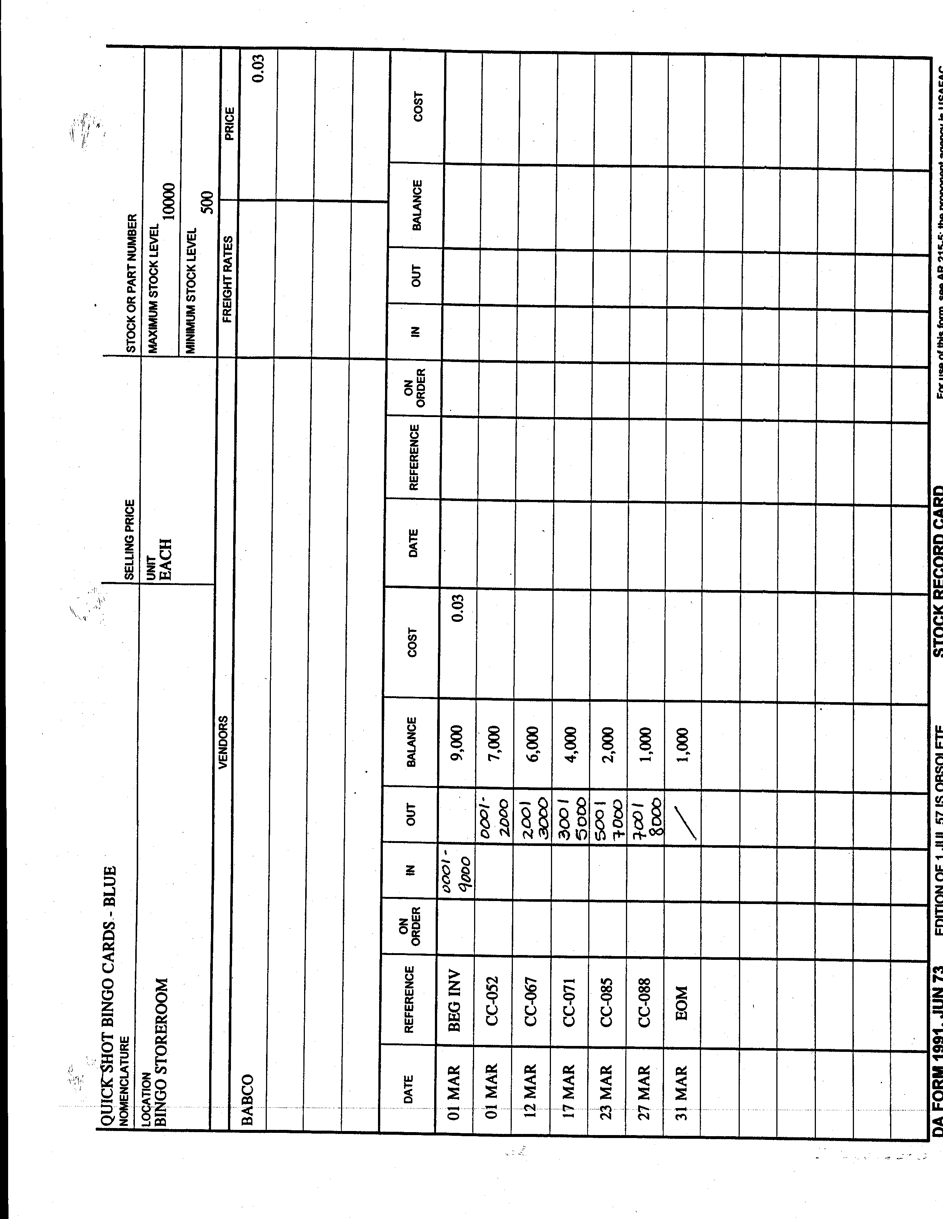

Encl 15-2

Encl 15-3
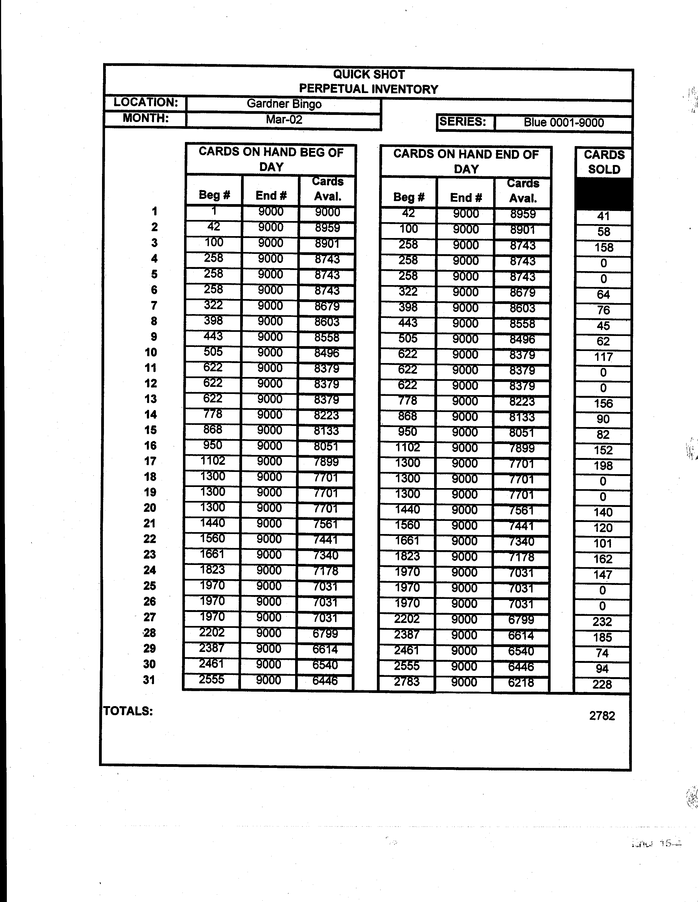

Encl 15-3

Encl 15-4

Encl 15-5
Encl 15-6

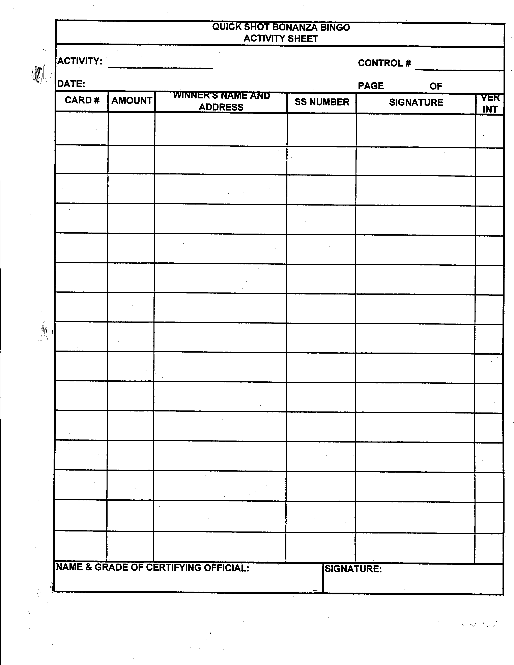

Encl 15- 7
Chapter 16

Retail Sales Accountability For Areas Other Than Food and Beverages

RETAIL SALES ACCOUNTABILITY FOR AREAS
OTHER THAN FOOD AND BEVERAGE

REFERENCE: AR 215-1 Appendix G
DFAS-IN Regulation 37-1

1. Fund employees under the direct supervision of the activity manager or a designated representative perform physical inventories for resale merchandise and consumable supplies. Physical resale inventories are required as of the last business day of each month.

2. Stock Record Cards (DA Form 1991) or an approved mechanized system will be used to maintain perpetual inventory stock records. Automated perpetual inventory systems are preferred; if none is available, retail sales accountability processes apply.

3. Two people working in pairs will conduct inventories. One person will inspect and count the items; the other will enter the count on the list. The person designated to inventory should be someone other than a responsible person in the department being inventoried: i.e., pro shop inventory should be taken by someone other than the clerk who works in the shop daily. However, the clerk should help conduct the inventory in his or her respective area of responsibility. Inventory counts should be conducted wall to wall, left to right, and top to bottom.

4. Cutoff dates for sales, issues, returns, adjustments, and transfers between departments must be established so the inventory lists will be accurate.

5. Merchandise delivered during the inventory will not be counted unless the purchase and payment have been or will be recorded as of the inventory cutoff dates.

6. Merchandise sold or transferred out during the inventory will be included in the inventory count unless the related sale and receivable or money received have been or will be recorded as of the inventory cutoff date.

7. Inventories will be conducted and listed separately for each department.

8. Each inventory includes a visual count of merchandise and comparison of the results to the balances carried forward on accounting records.

9. Shortages and overages will be recorded in accounting records separately. For example, a $200 overage and a $150 shortage will be recorded individually instead of a collective or net $50 overage. Overages and shortages should be posted to the Stock Record Cards or approved automated system.

10. If the net difference between the visual count and the recorded balances on hand is 5% of the total stock record merchandise value or exceeds $2,500, physical inventories of the merchandise being maintained on stock records must be taken as of the last business day of each month until the difference is within 1% for two consecutive months.

11. If the allowable variance (1%) or a total of $450 is exceeded, a report is forwarded through the appropriate division chief or DMWR to the activity manager for explanation and correction.

12. Monthly variances greater than $500 require an investigation in accordance with AR 15-6.

13. To determine variances within resale inventory, retail sales accountability tests are required. Retail sales accountability is comparing actual sales to expected sales based on inventory usage on a daily, weekly, or monthly basis. These tests are necessary to monitor and manage retail/resale operations and ensure proper security and accountability for resale merchandise.

14. Retail Sales Accountability Form (Encl. 16-1) is available form at www.armymwr.org / business program / Standard forms, or it can be designed by the local activity to include:

- Item Name for each item for sale in the activity.

- Beginning Inventory of each item.

- Purchases from vendors. Record the quantity of items received from receiving reports or vendor invoices.

- Transferred In items are those that have been transferred in from other activities or departments using the Transfer Between Activities form (DA Form 4080) during that specific operating period.

- Transferred Out items are those that have been transferred out of the resale activity or used for other than retail sales (i.e., items transferred out from program use) using the Transfer Between Activities form (DA Form 4080) during that specific operating period.

- Total Available Units = Beginning Inventory + Purchases + Transfers In – Transfers Out.

- Ending Inventory of the items. This is taken from physical inventory count recorded at the end of the sales period.
- Units Sold.

Beg Inv + Purchases + Transfers In – Transfers Out – End Inv = Expected Sales

- Unit Cost.

- Total Cost = Unit Cost X Units Sold.

- Retail Price.

- Retail Sales Total = Sales Price X Units Sold.

- Sales Per Register.

- Inventory Overage is the difference between sales per register and expected sales per inventory when sales per register exceed the expected sales per inventory.

- Inventory Shortage is the difference between sales per register and expected sales per inventory when expected sales per inventory exceed sales per register.

- Total Cost = the sum of Column J.

- Total Retail Sales = the sum of Column L.

- Total Inventory Overage = the sum of Column N.

- Total Inventory Shortage = the sum of Column O.

- COGS % is determined by dividing Total Cost (Column P) by Total Retail Sales (Column Q).

Encl 16-1
Chapter 17

Sales Accountability
SALES ACCOUNTABILITY

REFERENCE: AR 215-1, Appendix G-7

1. Sales accountability tests are an important element of the system of management controls to protect resale merchandise and sales receipts. Sales accountability tests involve:

- Determining expected sales based on inventory usage.

- Determining actual sales based on sales records.

- Comparing expected sales with actual sales and identifying any variances.

2. If expected sales exceed actual sales by a significant margin, managers must investigate the circumstances and take the appropriate corrective actions. Some reasons for significant differences are:

- Inaccurate beginning or ending physical inventories.

- Theft or other loss of merchandise.

- Failure to record sales or other manipulation of sales documentation and the diversion of cash proceeds.

3. Sales accountability tests compare actual sales recorded in the cash control system with expected sales that are calculated based on inventory usages. Variances between actual and expected sales are considered significant when they exceed:

- Two (2) percent of alcoholic beverages.

- Two (2) percent for food or food and beverage service.

c. One (1) percent on all other items.

- $450 of any food and beverage or alcoholic product.

4. When sales accountability tests show significant variances between actual and expected sales, managers must thoroughly investigate the causes for the variance and take all necessary corrective actions.

5. Bar Sales Accountability:

- Allows management to monitor each bartender’s effectiveness in maintaining established standards.

- Bar inventory usage figures determine expected sales:

Beg Inv + Issues In – Transfers Out – End Inv = Expected Sales (Encl. 17-1)

- The dollar difference between expected sales and actual sales is considered an overage or shortage.

- Each bar should be considered as a separate operation with its own sales accountability control.

- As a part of a bartender’s performance evaluation, management will use the standard of a 2% variance in dollars between actual recorded sales and expected sales. The bartender’s performance evaluations serve a dual purpose: while enforcing desired quality standards, it also provides a form of inventory and sales accountability on beverage sales.

- Bartender performance evaluations will be done on an unannounced or “surprise” basis.

- Each bartender will be checked at least once during an accounting period (monthly).

- To ensure an accurate, fair evaluation, the manager or designee will inventory the beverage stock to be used prior to the start of the shift being evaluated. The inventory will be verified by another disinterested individual (not the bartender who is to be checked). At the end of the evaluation period, the manager or his/her representative will inventory the beverage stock a second time. The bartender being evaluated will verify this ending inventory. Results of this usage inventory will be compared to actual sales. The 2% variance standard will be applied.

- The requirement to ensure that bartenders meet minimum performance standards achieves the same goal as daily bar inventories and replaces that previous requirement. THIS CHECK DOES NOT PREVENT THE MANAGER FROM PERFORMING MORE FREQUENT INVENTORIES IF HE/SHE DESIRES TO PERFORM THEM.

- If, however, the cost of goods in the bar exceeds the Army benchmark, or there is a monthly fluctuation of 2% or greater in the COGS, daily sales accountability tests will be required to determine the cause. These tests will be performed until variances are not exceeded for two months.

- Cost of goods percentages that are abnormally high or constantly fluctuating month to month is an indication to management of a potentially serious condition. Management should conduct an investigation to determine possible causes such as theft or incorrect pricing.

6. Food Sales Accountability:

- To account for the amount of food that leaves the kitchen to be served to the guests and to account for sales that are realized from the food served, guest checks or registers with detailed reporting capabilities are used.

- When guest checks are used, they will be issued in numerical sequence to the servers on DA Form 4082 (Daily Cashier’s Record) as accountable forms.

- On completion of their shift, servers will turn in unused guest checks to the manager on duty, who will record them on the DA Form 4082. To account for all copies of the guest checks, an independent person will reconcile the duplicate copy submitted to the kitchen to order a meal with the original copy (cashier’s copy). This ensures that the food orders that left the kitchen were the same as those paid for by the guest.

- Detailed register reports will give this information as well. If using the register for reports, also run a void report at the end of the shift.

- DA Form 5053 (Scatter Sheet) (Encl. 17-2) or a Point-of-Sale (POS) Daily Item Sales report is used to record the number of menu items sold, to determine the portion count, to measure menu trends and to forecast sales.

- When DA Form 5053 is filled out, the total sales column should be compared to the cash register and sales variances explained.

- After the cashier completes the DA Form 5053, it is furnished to the manager. The numbers are transferred to DA Form 5053-1 (Scatter Sheet Recap) (Encl. 17-3). This will give you daily, monthly, and yearly totals for menu items.

- Registers with detailed reporting capabilities can compile the required data and eliminate the need for a manual scatter sheet.

7. Cover Charge Accountability:

- When charging an entrance fee to a facility for a special event or regular programming, sales accountability testing must be completed.

- One method is to use double-sided tickets. Someone other than the cashier will sign for the pre-numbered tickets on the DA Form 4082 as an accountable form. As a guest enters the facility, the cashier will ring in the cover charge and the other employee will give the guest one half of the double sided ticket. The remaining half will be placed into a container for a door prize drawing (T-shirt, key chain, free pizza, etc.).

- At the end of the shift, the cashier is responsible for the funds that were collected while the individual who signed for the tickets will return all that were not used. The manager on duty will reconcile these on the DA Form 4082. The number of tickets that were given out should match the amount of money that was received.

Encl 17-1

Encl 17-2

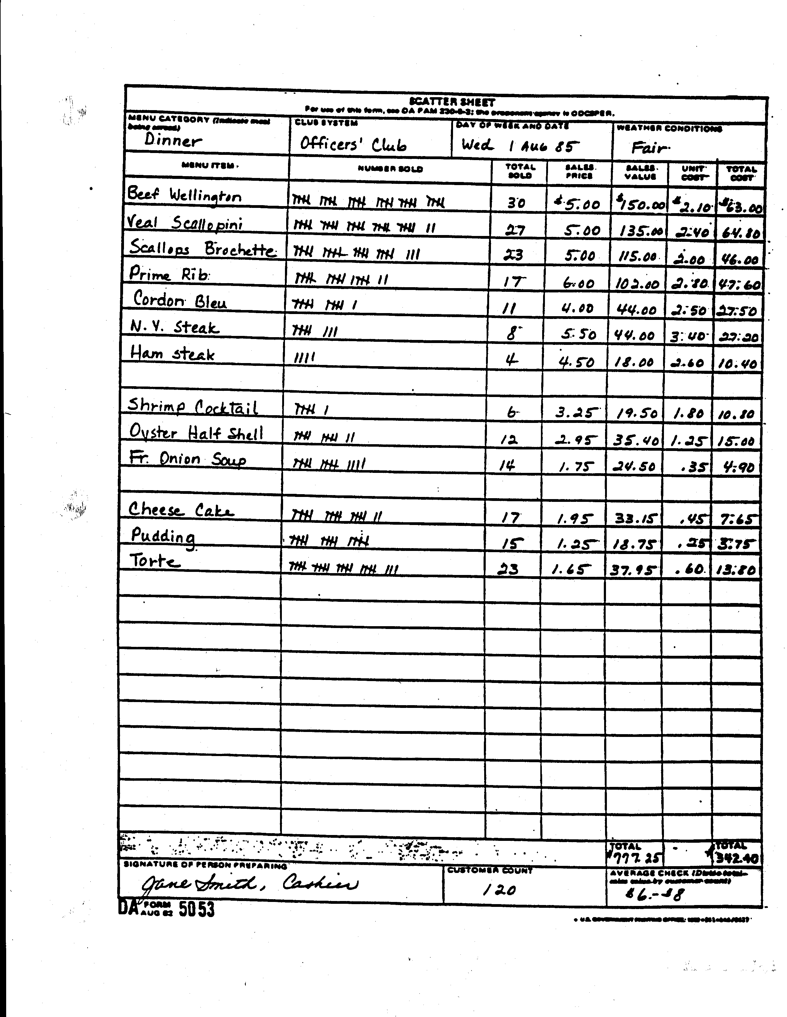

Encl 17-3

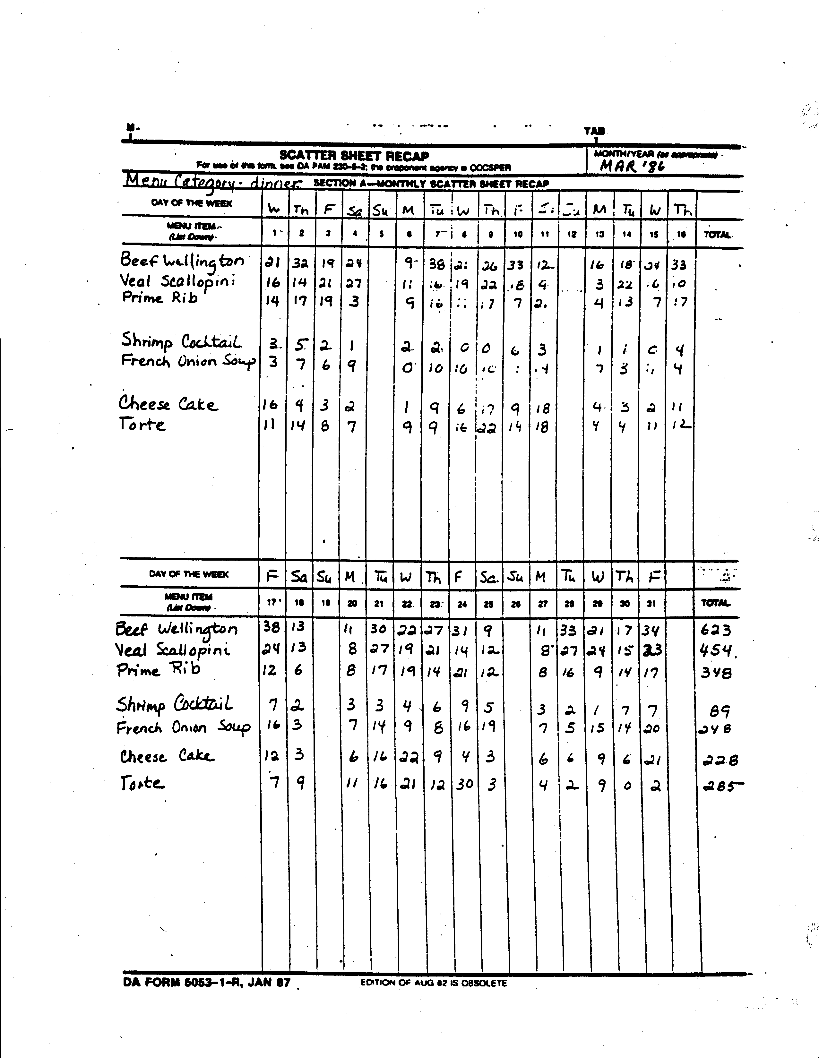

Encl 17-4
Chapter 18

Surprise Inventory/Cash Counts

SURPRISE INVENTORY/CASH COUNTS

REFERENCE: AR 215-1, Appendix G

1. Managers or their representatives will make unannounced counts of petty cash and change funds at least quarterly. The counts will be documented to show:

- The date and time of the count.

- The total amount of cash counted by denomination.

- The cash register or change fund identity.

- The names of the person(s) in control of the cash and who made the count.

2. Surprise cash counts may be recorded on a DA Form 4082 or similar type form and kept on file for at least 3 years.

3. Managers or their representatives will make unannounced counts on bartenders/cashiers at least monthly. This surprise cash count is taken at random, by position. One position should be counted each month, and varying shifts should be counted.

4. Managers should conduct, at a minimum, one surprise spot inventory of at least 15 items in the beverage storeroom on an unannounced basis each month. This is in addition to the end-of month (EOM) inventory. The unannounced inventory should be made to verify that the balance on hand as indicated on the bin cards or perpetual inventory is, in fact, the amount physically on hand in the beverage storeroom.

5. Management should spot check the food inventory accountability to the bin card or perpetual inventory at least weekly. Overages and shortages must be investigated, documented, and reconciled.

6. As often as is feasible, the chief of the business division or representative thereof should perform surprise unannounced inventories on the beverage and food storerooms at each facility. This inventory should include at least
15 items, randomly selected.

Chapter 19

Standardized Recipes and
Cost Cards

STANDARDIZED RECIPES AND COST CARDS

REFERENCE: DA PAM 30-22
AR 30-22

1. Preparing involves the development of a food production system that guarantees the conversion of raw food ingredients to menu items.

2. An efficient food production system can be maintained only with careful management planning and constant review of menu items served to meet and exceed the patrons’ needs and wants. The major elements of the production system include the following:

a. Standardized Recipes

(1) To ensure that patrons are served a uniform, high quality food product, standardized recipes for each menu item must be prepared, tested to fit the operation, and used consistently. Standard Recipes Card (Enclosure 19-1) is used to record standard recipes preparation instructions.

(2) Standardized recipes are also important from a cost standpoint since they regulate production, control portion sizes, and minimize waste.

(3) Standardized recipes eliminates guesswork and waste, and assists in food cost control by providing a means of determining accurate food costs and yields, checking losses and making adjustments, and minimizing leftovers.

b. Costing Recipes

(1) Once the standardized recipes have been developed, it is necessary to calculate the cost of the ingredients and establish selling prices.

(2) In order to calculate proper selling price, Raw Food Yield Test (Enclosure 19-2 ) and Recipe Cost Form (Enclosure 19- 5) are used to calculate the selling price. It is highly recommended that the cost cards are prepared using an Excel template to accommodate frequent changes as necessary. The food cost percentage of a menu item equals the raw food cost or portion cost divided by the menu price.

(3) When costing meat items, shrinkage in the cooking process must be considered so the cost of the raw product can be adjusted to the cost per serving after cooking. Raw Food Yield Test and Pricing (Enclosure 19-2) should be used to calculate both prices per portion and/or price per pound.

(4) In order to calculate portion costs of recipes, the chef must first determine the costs of food ingredients. For many ingredients, this is relatively easy. The chef just looks at his invoices or at price lists from his purveyors. However, many recipes specify trimmed weight rather than the weight you actually pay for. For example, a stew might call for 2 pounds of sliced onions. Let’s say you pay 24 cent a pound for onions, and to get 2 pounds of sliced onions, you need 2 ¼ lbs of untrimmed onions. In order to calculate the cost of the recipe correctly, you have to figure out what you actually paid for the onions. In this case, the true cost is 54 cents (2 1/4 lb times $.24 per lb), not 48 cents (2 lb times $.24 per lb). The following are two frequently used abbreviations that you must understand:

(a) AP stands for “as purchased.” This means the untrimmed quantity, in the same form in which it is purchased. This is the amount that you pay for.

(b) EP stands for “edible portion.” This means the raw, uncooked quantity after all trimming is done. This is the quantity that you actually cook.

(5) Costs must be based on AP amounts, even though recipes often give EP quantities. The chef must record the number of portions actually served, not just the number the recipe is intended to serve. If the roast shrank more than you expected during cooking, or if a cook accidentally dropped a piece of cake on the floor, those costs still have to be covered.

(6) A chart of percentage yield for vegetables and fruits is located at the back of this chapter (Enclosure 19-3).

c. Production Control

(1) To avoid overproduction and reduce leftovers, the manager must use historical usage data (DA Form 5053) as well as known requirements such as contracted party guarantees as a base for production.

(2) Once the necessary quantities for production have been established by management, a DA Form 5608-R (Production Worksheet) (Enclosure 19-4) must be prepared to maintain consistency and uniformity. DA Form 5608-R also provides the manager with an inventory of leftovers to be used or discarded. T his information should be referred to before selecting the menu for next day's meals. It should be noted that most leftovers should be recycled (within 24 hours) as new menu items are incorporated into other dished.

(3) DA Form 5608-R is prepared in advance by the chef or food manager. Using forecasted figures and the menu, separate sheets can be prepared for each meal period. At the end of each meal period, the form should be returned to the chef or food manager, who can use the information for comparing the amount produced versus the amount actually sold.

(4) When preparing DA Form 5608-R, ensure that all information should be timely and relevant. The information to the cooks must be reasonable, factual, and easy to understand.
Sample of Standard Recipe Preparation Instruction

Encl 19 -1
 |  |  | CATERING
 |  | RAW FOOD YIELD TEST AND PRICING
 |  |  | DATE:
 |  |  | PRODUCT DESCRIPTION
1 |  |  | TOTAL PURCHASE WEIGHT LBS |  | 15 |  |  |  | OUNCE | 0
2 |  |  | RAW COST PER ONCE |  | $0.29 |  |  |  | TOTAL OUNCE | 240.00
3 |  |  | RAW COST PER LBS |  | $4.58
4 |  |  | TOTAL PURCAHSE COST (AP) |  | $68.70
5 |  |  | PORTION SIZE |  | 14 |  |  |  | OUNCES
6 |  |  | RAW COST (AP) |  | $4.01 |  |  |  | PER PORTION
 |  |  | CALCULATION OF ITEMIZED PRODUCT WASTE
 |  |  | ITEM DESCRIPTION |  | WASTE/OUNCE |  |  |  | RAW COST PER OUNCE | EXTENDED RAW COST
7 |  |  | Waste |  | 32 |  |  |  | $0.29 | $9.16
8 |  |  | Shrinkage |  | 0 |  |  |  | $0.29 | $0.00
9 |  |  | Bone |  | 48 |  |  |  | $0.29 | $13.74
10 |  |  | Trimmings |  | 0 |  |  |  | $0.29 | $0.00
11 |  |  | Other |  | 0 |  |  |  | $0.29 | $0.00
12 |  |  | Other |  | 0 |  |  |  | $0.29 | $0.00
13 |  |  | Other |  | 0 |  |  |  | $0.29 | $0.00
14 |  |  | TOTAL WASTE IN OUNCES: |  | 80
15 |  |  | TOTAL RAW WASTE COST: |  | $22.90 |  |  |  |  | Total Shrinkage:
16 |  |  | TOTAL YIELD, EDIBLE WEIGHT IN OUNCES: |  |  |  |  |  | 160.00 | 33.33%
17 |  |  | EDIBLE COST PER OUNCE |  | $0.43
18 |  |  | EDIBLE COST PER PORTION |  | $6.01
 |  |  |  |  |  |  |  |  | Food Cost: | $6.01
 |  |  |  |  |  |  |  |  | Food Cost Percentage: | 30%
 |  |  |  |  |  |  |  |  | Selling Price: | $20.04
 |  |  |  |  |  |  |  |  |  | 3.33
 |  |  |  |  |  |  |  |  | Contribution to Profit %: | 70%
 |  |  |  |  |  |  |  |  | Contribution to Profit $: | $14.03
 |  |  |  |  |  |  |  | Encl 19-2
PERCENTAGE YIELD CHART
PRODUCT | PERCENTAGE YIELD
BEETS | 40-45%(75% if purchased without tops)
BROCCOLI | 65-75%
BRUSSELS SPROUTS | 80%
CABBAGE, WHITE, GREEN OR RED | 80%
CARROTS | 75-80%
CAULIFLOWER | 55%
CELERY | 75%
CELERY ROOT (knob celery or celeriac) | 75%
CORN (on cob) | 28% (after husking and cutting from cob)
CUCUMBERS (slicing type) | 75-95% depending on peeling
EGGPLANT | 90% (75% if peeled)
GARLIC | 88%
LEEKS | 50%
LETTUCE | 75%
MUSHROOMS | 90%
OKRA | 82%
ONIONS, DRY | 90%
ONIONS, GREEN (Scallions) | 60-70%
PARSLEY | 85%
PEAS (Green and Black-eyed) | 40%
PEAS, EDIBLE POD | 90%
PEPPERS, SWEET (Green or Red) | 82%
POTATOES, SWEET (Including Yams) | 80%
RADISHES | 90%
SPINACH AND OTHER GREENS | 50-70%
SQUASH, SUMMER (Including Zucchini) | 90%
TOTMATOES | 90% (Peeled)
WATERCRESS | 90%
APPLES | 75%
APRICOTS | 94%
AVOCADOS | 75%
BANANAS | 70%
BERRIES (ALL) | 92-95%
CHERRIES | 82% (Pitted)
COCONUTS | 50%
FIGS | 95%(80-85% if peeled)
GRAPEFRUIT | 45-50% (flesh without membrane)
GRAPES | 90%
LEMONS & LIMES | 40-45% (Juiced)
MELONS | Watermelons: 45% others 50-55%
ORANGES & MANDARINS | 60-65% (Sections with no membranes, 50% juiced)
PAPAYAS | 65%
PEACHES | 75%
PEARS | 75%
PINEAPPLE | 50%
PLUMS | 95%

Encl 19-3

PRODUCTION WORKSHEET
For use of this form, see DA PAM 230-5-2; the proponent agency is ODCSPER
ORGANIZATION |  |  | DEPARTMENT |  |  | DATE
COMMUNITY CLUB, CAMP CASEY |  |  | SALAD |  |  | 18-Nov-01
MENU ITEM | NUMBER PORTIONS | PORTION SIZE | TIME NEEDED | COOK ASSIGNED | REFERECE | REMARKS
SHRIMP COCKTAIL | 200 | 5 OZ | 1900 | GARY | SOP | BANQUET-BALLROOM
TOSSED SALAD | 25 | 6 OZ | 1130 | GARY | SOP | LUNCHEON-PARTY RM #1
BAKED ALASKA | 50 | 1 EA | 2030 | MARY | SOP | BANQUET-PARTY RM #1
DA FORM 5608-R, JAN 87

Encl 19-4

Sample of Standard Recipe Cost Card

Encl 19-5

Chapter 20

Catering Operations

CATERING OPERATIONS

REFERENCE: AR 215-1, Chapter 8, Chapter 10

- Catering is accounted for as departments within the appropriate MWR program. Catering sales and related expenses will be recorded in department 03 (Private Party Bar), department 13 (Private Party Food).

- Events held on Sundays and/or holidays will incur an additional per person charge to cover employees’ premium pay and benefits.

- Additional staff can be arranged for an additional minimum charge per hour per employee based on local wage rates plus benefits.

- Use of room is for a standard maximum of four hours. A reasonable amount of time in advance of the event will be allowed for the customer to provide their own decoration. Additional time may be added to the contract in consideration of additional fees.

- The guaranteed number is required at least 72 hours before the event. This is the number of attendees that the host is responsible to pay for. However, if participation is greater than the guarantee, the event host will be charged for the actual number of meals served.

- Standard room fees should be based on the capacity of the room.

- All reservation requests must be followed by a signed contract and applicable deposit within 72 hours of making the reservation. Reservations without deposit are subject to cancellation.

  - Party contracts will be produced by EventMaster.

  - Contracts will reserve the right for management to reassign the event to a smaller room or cancel the event if participant numbers decrease below established minimums.

  - The customer signing the contract is responsible for the event and is the only person authorized to make changes to the contract.

  - Customers are required to pay deposits for all private and unofficial events.

- A minimum 15% service charge will be applied to all food and beverage purchases.

Chapter 21

Tip Reporting/Allocation

TIP REPORTING/ALLOCATION

REFERENCE: AR 215-1, Chapter 4
AR 215-1, Appendix C

1. A Tip is any amount paid to an employee at the option of the customer. It may be paid in cash directly to the employee or entered as a separate item on a credit card sales slip. Tips charged on credit cards may either be paid to the employee immediately from available cash or reported to the payroll office and added to the next paycheck.

2. A Service Charge is a percentage of the total charge for food and beverage and automatically added to the customer’s bill. A service charge is not a customer option and is therefore considered cash wages for which the NAFI is liable for withholding and FICA taxes.

3. A Gratuity is either a tip or a service charge depending on whether the amount is given voluntarily by the customer or automatically added to the food and beverage charges.

4. Tip allocation procedures only apply to employees who receive tips directly from customers. They do not apply to employees who are indirectly tipped such as cooks, busboys, or dishwashers.

5. NAF employees receiving tips in the amount of $20 or more in any month are personally responsible for reporting tip income to the employing NAFI using Internal Revenue Service (IRS) Publication 1244 (Employee’s Daily Record of Tips and Report of Tips to Employers) and IRS Form 4070 (Employee’s Report of Tips to Employers) or a locally developed form. Reports are filed by the tenth (10th) of the month following the month in which tips were earned. The employee portions of the IRS Publication 1244 are generally sufficient to prove tip income in the event of a tax dispute.

6. Failure to declare tip income may subject to the employees to pay for interest, penalties, and/or an audit by the IRS.

7. Tip allocation is required if the total amount of tips reported does not equal or exceed 8% of gross sales.

8. There are two methods in determining tip allocation. Whichever method is chosen should be implemented at the beginning of the calendar year and not changed during the remainder of the year:

- TOTAL SALES METHOD: This is the preferred method and involves maintaining records of total sales by each affected employee.

- HOURS-WORKED METHOD: This method allocates tips proportionately among affected employees based on hours worked. This method is typically used by activities that do not have the capability of recording total sales by each employee.

9. DA Form 5462-R (Tip Allocation Worksheet) is used for the total sales method of allocation (Encl 21-1). This form can be used separately or in combination with a series of linked Tip Reporting worksheets that will assist in the preparation of the DA Form 5462-R. These forms, when filled out correctly, will transfer the data to the DA Form 5462-R automatically (Encl. 21-2, 21-3, 21-4, 21-5, 21-6). Tip Allocation and Tip Reporting worksheets can be found on website at:

www.businessplan.armymwr.com

10. Federal income and employment tax records are retained by the NAFI for four (4) years.

Encl 21-1

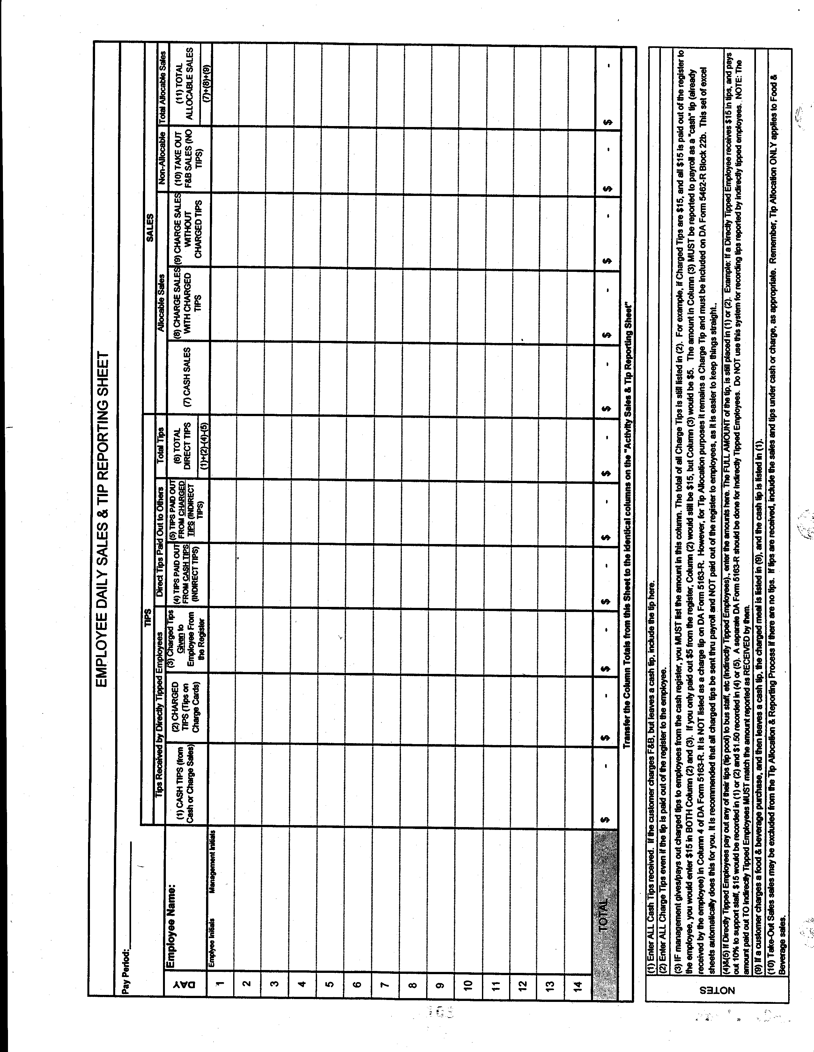

Encl 21-2
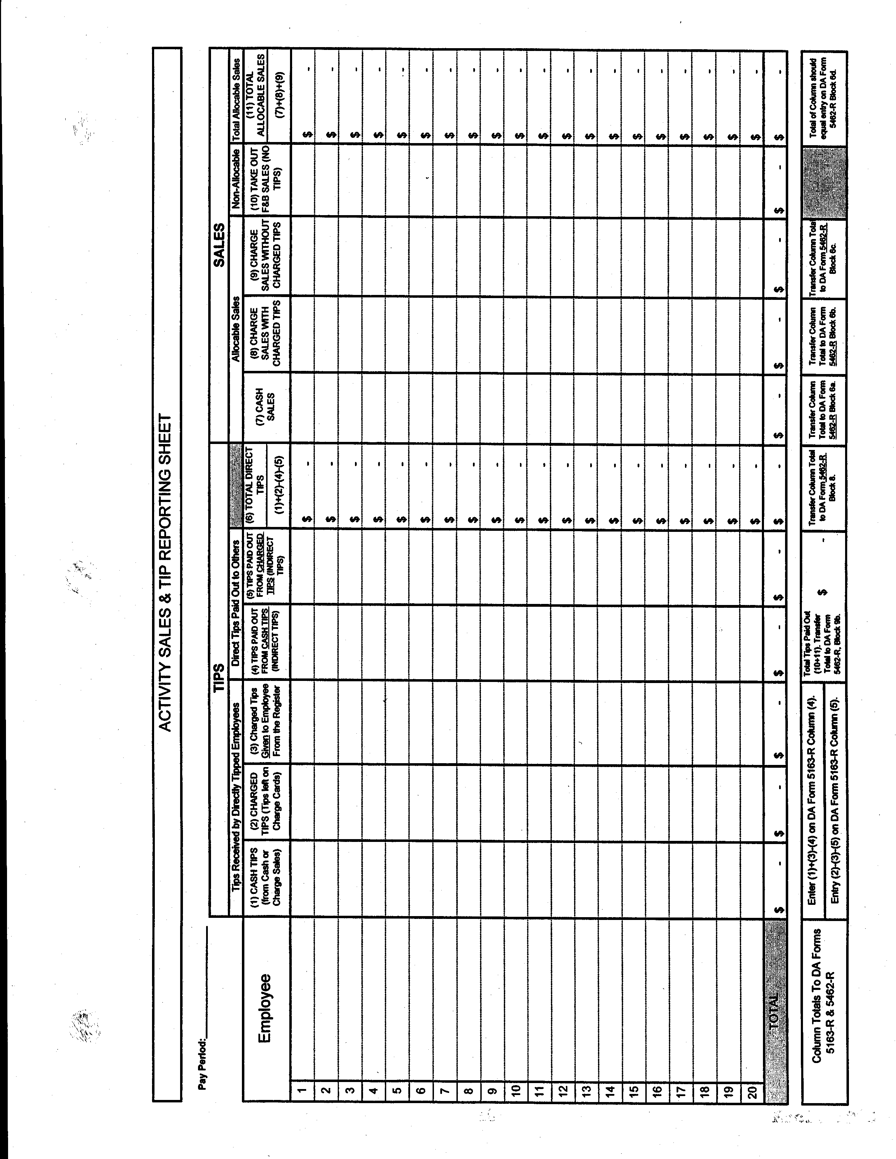

Encl 21-3
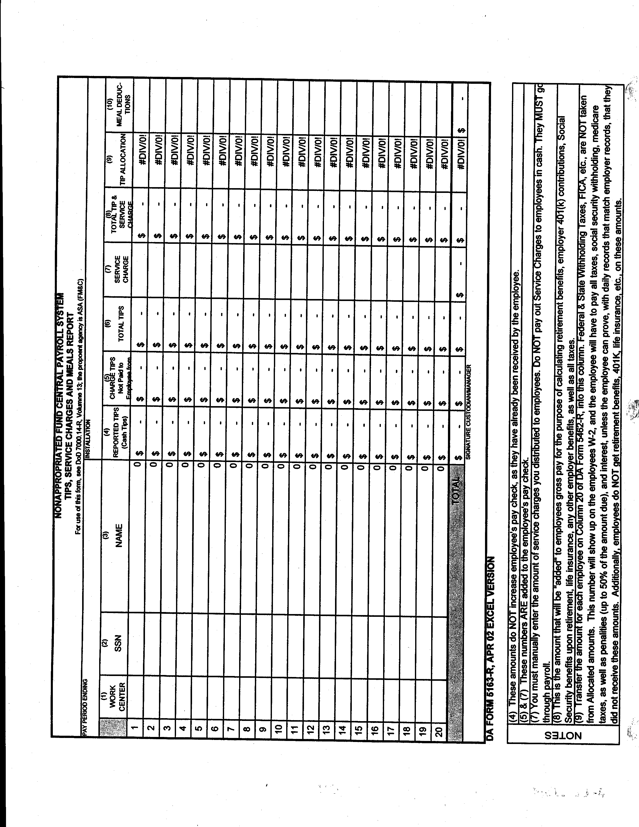

Encl 21-4

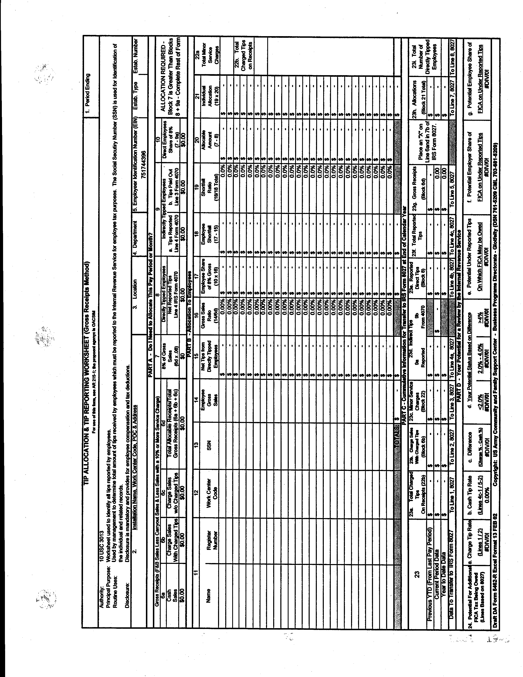

Encl 21-5
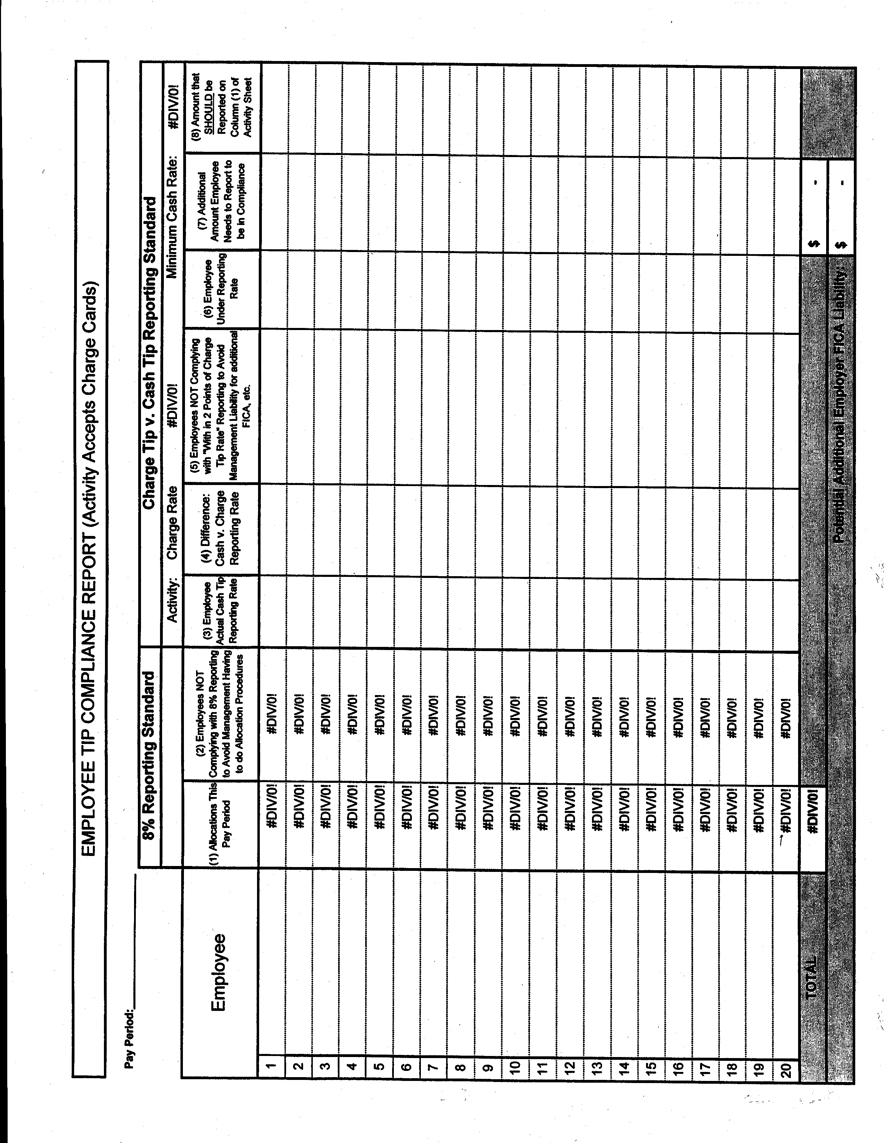

Encl 21- 6

Chapter 22

Vending And Amusement Machines

VENDING AND AMUSEMENT MACHINE

REFERENCE: AR 215-1 Chapter 8
DFAS-IN Regulation 37-1

1. Management controls for amusement and vending machines operations focus on control of access to the machines and cash boxes and cash collection procedures. Controlled access and collection applies when the MWR Fund receives a share of the revenue or the collection is done with MWR personnel. This Standing Operating Procedure (SOP) does not apply to any machines operated by the Army Recreation Machine Program (ARMP).

2. Under no circumstances are cash boxes or merchandise cabinets emptied or serviced without an impartial observer.

3. Concessionaire owned machines will have at least two (2) locks; one to access the machine and one NAFI owned lock to access the cash box.

4. Keys are controlled to restrict access to cash boxes and machine meters. Keys remain in the custody of the DMWR (or equivalent) or installation key control officer appointed in writing. Keys are assigned to an impartial observer when required for cash collections or service calls by the concessionaire. A key register will be used to issue and receive these keys.

5. Sales accountability tests will be used to determine amusement and vending machine receipts.

- One method is to use counter type metering devices on cash collection boxes.

- Another method is to inventory products placed in the machines at sales value. When machines are restocked, the value of the restocked merchandise at sales price is equal to the expected cash receipts. Actual cash collected, adjusted for refunds due to malfunctioning machines, is compared to expected receipts and any significant variances (15% or $4.50 exceeded) are investigated.

6. Collections are made at least once a week, unless sales are anticipated to be less than $50 per machine.

7. DA Form 4083-R (Vending or Amusement Machine Collections) is used to document cash collected (Encl. 22-1). It is prepared in duplicate each time cash is removed from a fund controlled vending or amusement machine.

It will be signed by the person representing the command plus the fund or vendor representative. The original DA Form 4083-R will be turned in with the cash and attached to the daily activity report (DAR). The fund administrator or the person designated by the fund administrator will send the duplicate of the form directly to NAF Financial Services (NFS). NFS will check it against the original coming in with the DAR.

Encl 22-1

Chapter 23

Internal Control Scorecard

1. Food, Beverage, Entertainment, and Catering internal control scorecard fillable form can be found at www.businessplan.armymwr.com

2. Bowling Internal control scorecard fillable form can be found at www.businessplan.armymwr.com

3. Golf Internal control scorecard fillable form can be found at www.businessplan.armymwr.com

4. Bingo Internal control scorecard fillable form can be found at www.businessplan.armymwr.com

Chapter 26

Blank Form Index

BLANK FORM INDEX

FORM ____ ____ ENCLOSURE # WHERE FORM CAN BE FOUND

- Automated Bar Inventory Encl 3-1 www.businessplan.armymwr.com

Thru 3-2

- Transfer Between Activities Encl 4-1 Forms Flow
DA Form 4080
- Security Container Information Encl 5-1 Installation
SF 700

4. Security Container Check Sheet Encl 5-2 Installation
SF 702

5. Daily Cashier’s Record Encl 6-1 Forms Flow
DA Form 4082 Thru 6-2

6. Overage/Shortage Log Encl 6-3 www.businessplan.armymwr.com
thru 6-4

7. Employee Meal Register Encl 9-1 Forms Flow
DA Form 5069

8. Property/Merchandise Inventory Encl 11-1 Forms Flow
DA Form 1759

9. Central Storeroom Requisition Form Encl 11-2 www.businessplan.armymwr.com

10. Stock Record Card Encl 11-3 Forms Flow
DA Form 1991

11. Daily Sensitive Item Inventory Encl 11-4 www.businessplan.armymwr.com

12. Key and Lock Inventory Encl 12-1 www.businessplan.armymwr.com
Thru 12-2

13. Key Register Encl 12-3 Forms Flow
DA Form 5513-R

14. Petty Cash Voucher Encl 14-1 Forms Flow
DA Form 1994

15. Quick Shot Bonanza Bingo Encl 15-1 www.businessplan.armymwr.com
Verification Sheet

16. Quick Shot Bonanza Bingo Encl 15-4 www.businessplan.armymwr.com
Perpetual Inventory

17. Quick Shot Bonanza Bingo Encl 15-7 www.businessplan.armymwr.com
Activity Sheet

- Retail Sales Accountability Encl 16-1 www.businessplan.armymwr.com

- Menu item recipe preparation Encl 19-1 www.businessplan.armymwr.com

- Portion Yield Worksheet Encl 19-2 www.businessplan.armymwr.com

- Percentage Yield Chart Encl 19-3 www.businessplan.armymwr.com

- Production Worksheet Encl 19-4
DA Form 5608-R Form Flow
Catering production Worksheet www.businessplan.armymwr.com.

- Recipe Cost Form Encl 19-5 www.businessplan.armymwr.com

- Standard Recipe Cost Card and
Preparation Instruction Encl 19-6 / 1&2 www.businessplan.armymwr.com

- Tip Reporting/Allocation Encl 21-1 www.businessplan.armymwr.com
Worksheets thru 21-5

- Vending or Amusement Encl 22-1 Forms Flow
Machine Collections
DA Form 4083 - R

