Appendix T-1 - Healthy Base Initiative (HBI)

HBI is designed to create an environment on military installations that encourages healthy lifestyles by borrowing from a wide range of best practices and modernization options both within and outside the DoD. It promotes alternative approaches for future food service delivery. The HBI is designed to be financially cost-neutral to the installation.

Together we (all military Services, the Exchange, Exchange food programs, DeCA food program, APF Dining facilities, DoDEA schools, and NAF FMWR food programs) will be working to promote and encourage healthier eating in the military community. Implementation should take place in a cycle of assessment, implementation, and evaluation.
The objectives are:

- Provide nutritionally balanced meal options
- Improve efficiency and reduce costs
- Enhance food quality, variety and availability
- Meet military member expectations for a quality food service program
- Provide “best in class” food service and event management programs

Why? The Centers for Disease Control and Prevention (CDC) estimates that more than 35 percent of adults and nearly 18 percent of children in the United States (U.S.) are obese. Obesity and tobacco use among U.S. military healthcare beneficiaries adds over three billion dollars per year to the Department of Defense (DoD) budget in healthcare costs and lost duty days. Failure to meet weight standards is a leading cause of involuntary separation from the military, and obesity in the civilian community may be limiting DoD’s ability to recruit qualified personnel. To help combat obesity, military installations should provide dining environments that encourage good nutrition and offer healthy eating choices.
As part of the Healthy Base Initiative (HBI), The Office of Military Community and Family Policy (MC&FP), Office of the Secretary of Defense (OSD) in coordination with Service-level Morale, Welfare and Recreation (MWR) representatives is recommending a “Better for You” (BFY) menu labeling system in MWR-operated food outlets to highlight healthier menu choices.
Two recent studies by the Hudson Institute, a nonpartisan policy research organization, show how “for profit” companies can succeed both in satisfying increased consumer demand for healthier foods and beverages while improving financial bottom lines. These studies found that, among leading consumer packaged goods companies and restaurant chains, those who have grown their better-for-you/lower-calorie foods and beverages over the past five years have delivered superior sales growth compared to those who were less aggressive in doing so. In short, the research demonstrates that selling lower-calorie, BFY foods and beverages is just good business.
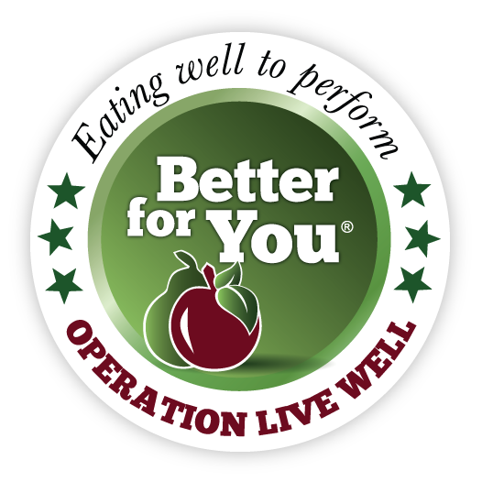 Menu items that meet the BFY criteria will be indicated with a physical marker on menu boards and printed menus as well as an icon on digital menu boards. The Better for You Criteria menu labeling system will highlight healthier menu items as “green” if they meet the nutrition criteria presented below. For comparison, nutrition criteria for “Go for Green”, a widely recognized and accepted DoD food labeling system for mission-essential feeding facilities, is presented in the following table.
Item | Better-for-You | Go-for-Green  “Eat Often/Engage at Will”
Center of the Plate (Full Dish) | ≤ 500 calories | < 500 calories
Entrée Single Item | N/A | <300 calories
Side | ≤ 150 calories | <200 calories
Appetizer | ≤ 150 calories | N/A
Vegetable | <100 calories | <100 calories
Dessert | ≤ 150 calories | < 150 calories
Beverage | ≤ 50 calories/8 oz. serving | Water/Calorie-free Flavored Water
Dairy | Skim or 0-1% Fat | Skim or 0-1% Fat
As indicated in the preceding table, caloric content is the only criterion for each item in the Better for You system. This does not imply that other nutritional characteristics are unimportant, but lower caloric content infers lower fat and sugar content in foods. The goal of the Better for You labeling is to keep the program simple and easy for the customer, foodservice staff and management to understand. Messaging for the program is also kept simple with the single criterion.

Department of Defense. 2008. Survey of Health Related Behaviors Among U.S. Military Personnel.
Mission Readiness: Still Too Fat to Fight. http://www.missionreadiness.org/2012/stilltoofattofight/
The Hudson Institute: Better-For-You-Foods: An Opportunity to Improve Public Health and Increase Food Industry Profits. http://www.hudson.org/files/publications/better_for_you_combinedFINAL.pdf

